Tomato Splash – A tutorial

Photographing fruit as an art form is a lot of fun! This tomato has a steady stream of water being thrown at it. The light reflection conveys the energy of the splash. Small drops of water spray from the tomato’s stem into the air. Tiny drops of water are sprinkled over the skin of the fruit. The color of the tomato against the water and the background are striking. The combination of these things is art in a basic form that is emotional.

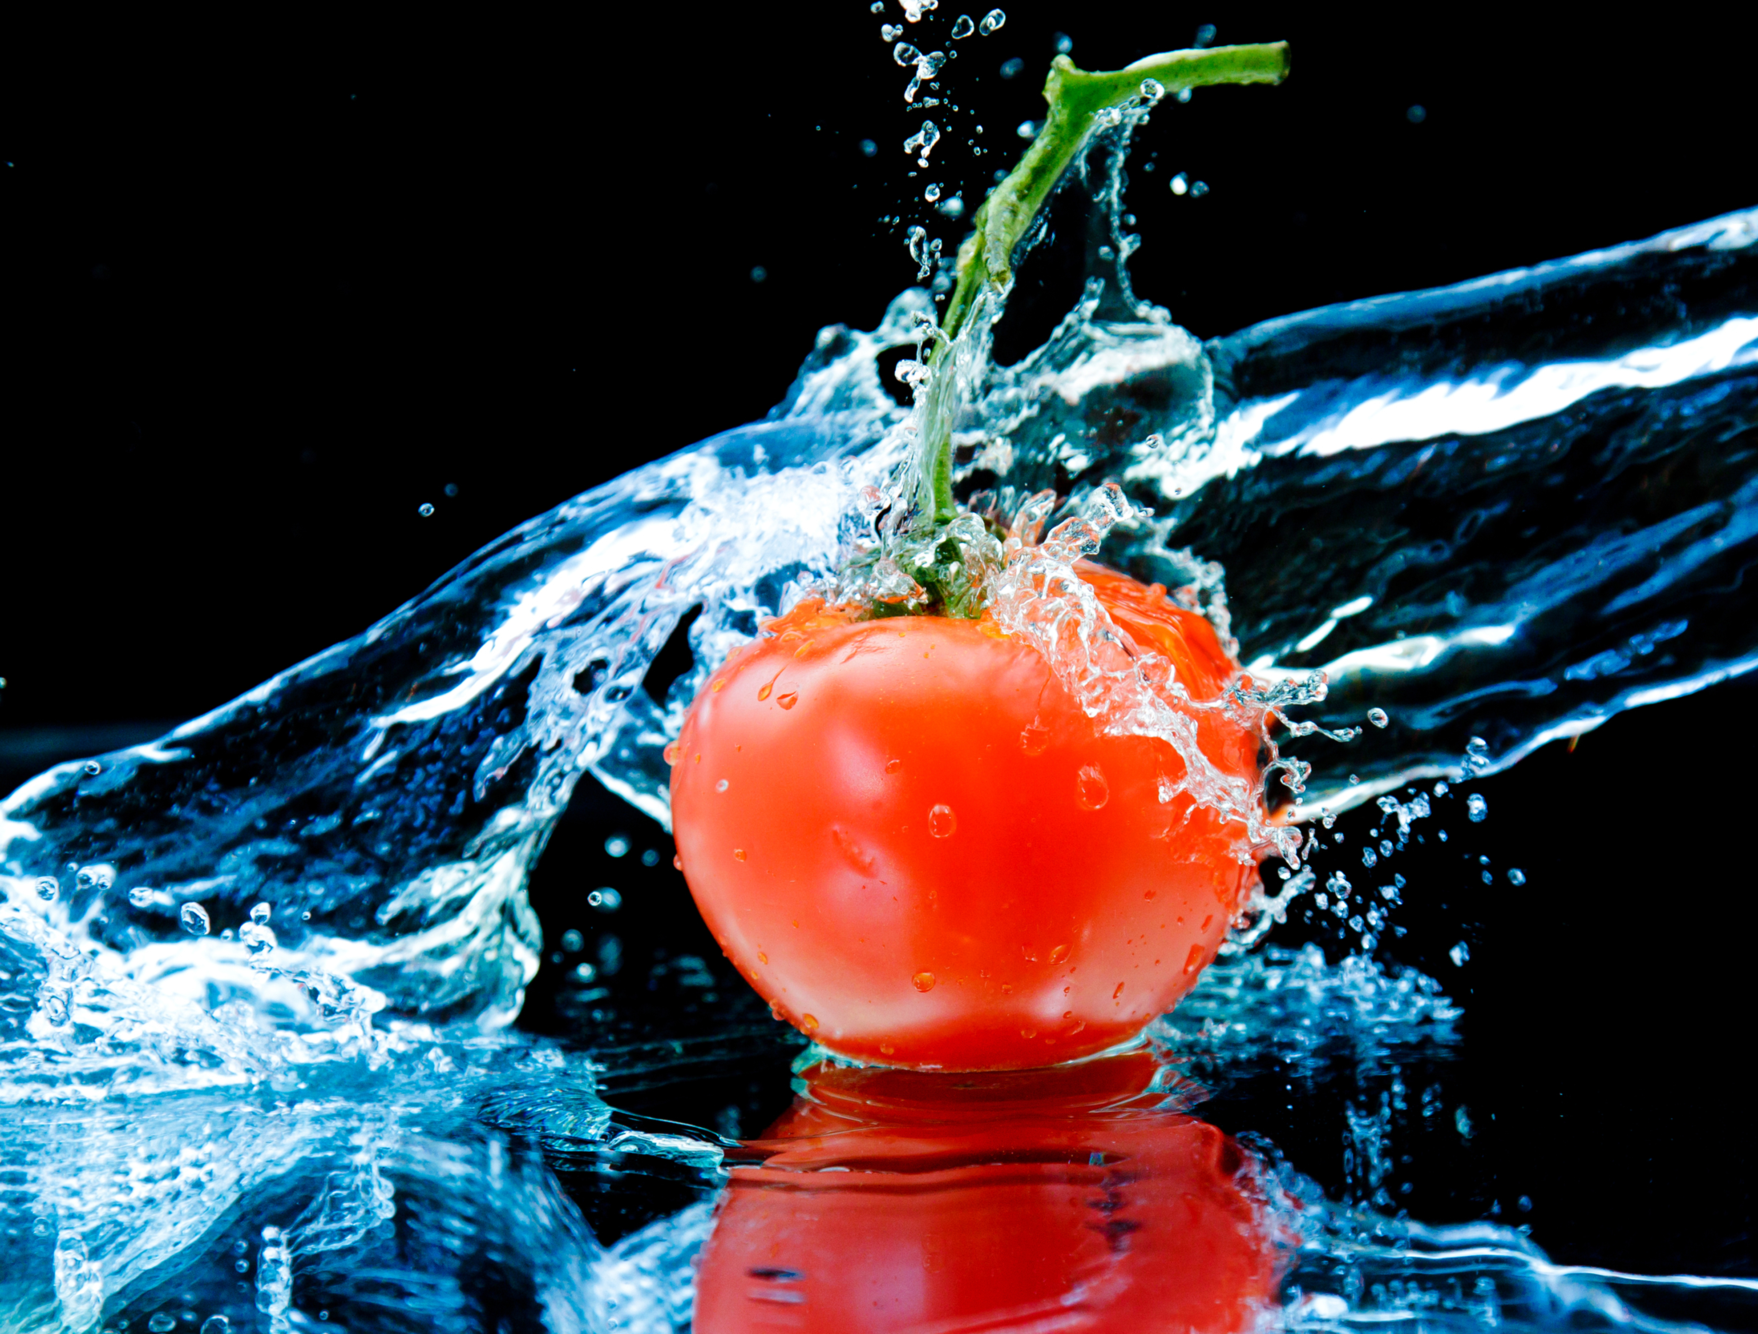

This is a perfect thread painting project for beginners. I have posterized the tomato in Photoshop. This means that colors are clumped together in like tones. This makes it easier for you to match threads to the photograph printed on fabric. You will not match every color. If you stitch lightly over some colors, the color printed on the fabric will show through between the threads. The goal is to create a well blended Thread Painting that is realistic in the finished product.

This is the posterized Tomato.

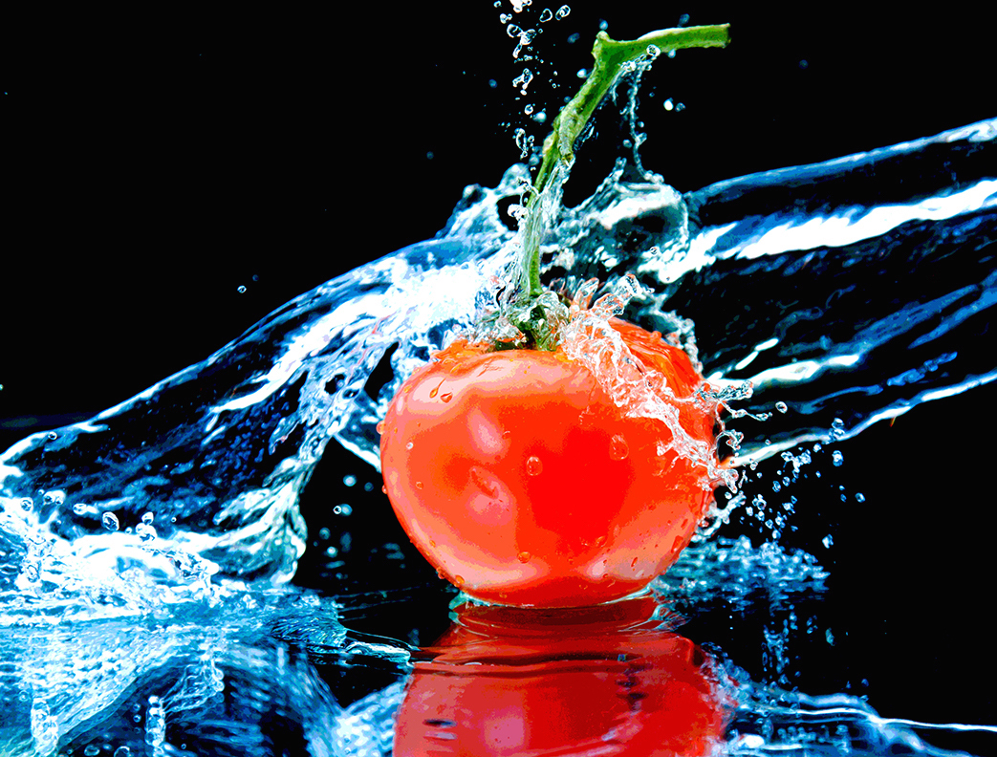

Because there is so much energy in the water, I choose to begin with replicating the waters reflection. Across the skin of the tomato the water appears white. I chose to just stitch the highlights. The softer light remins unstitched to give depth to the image.

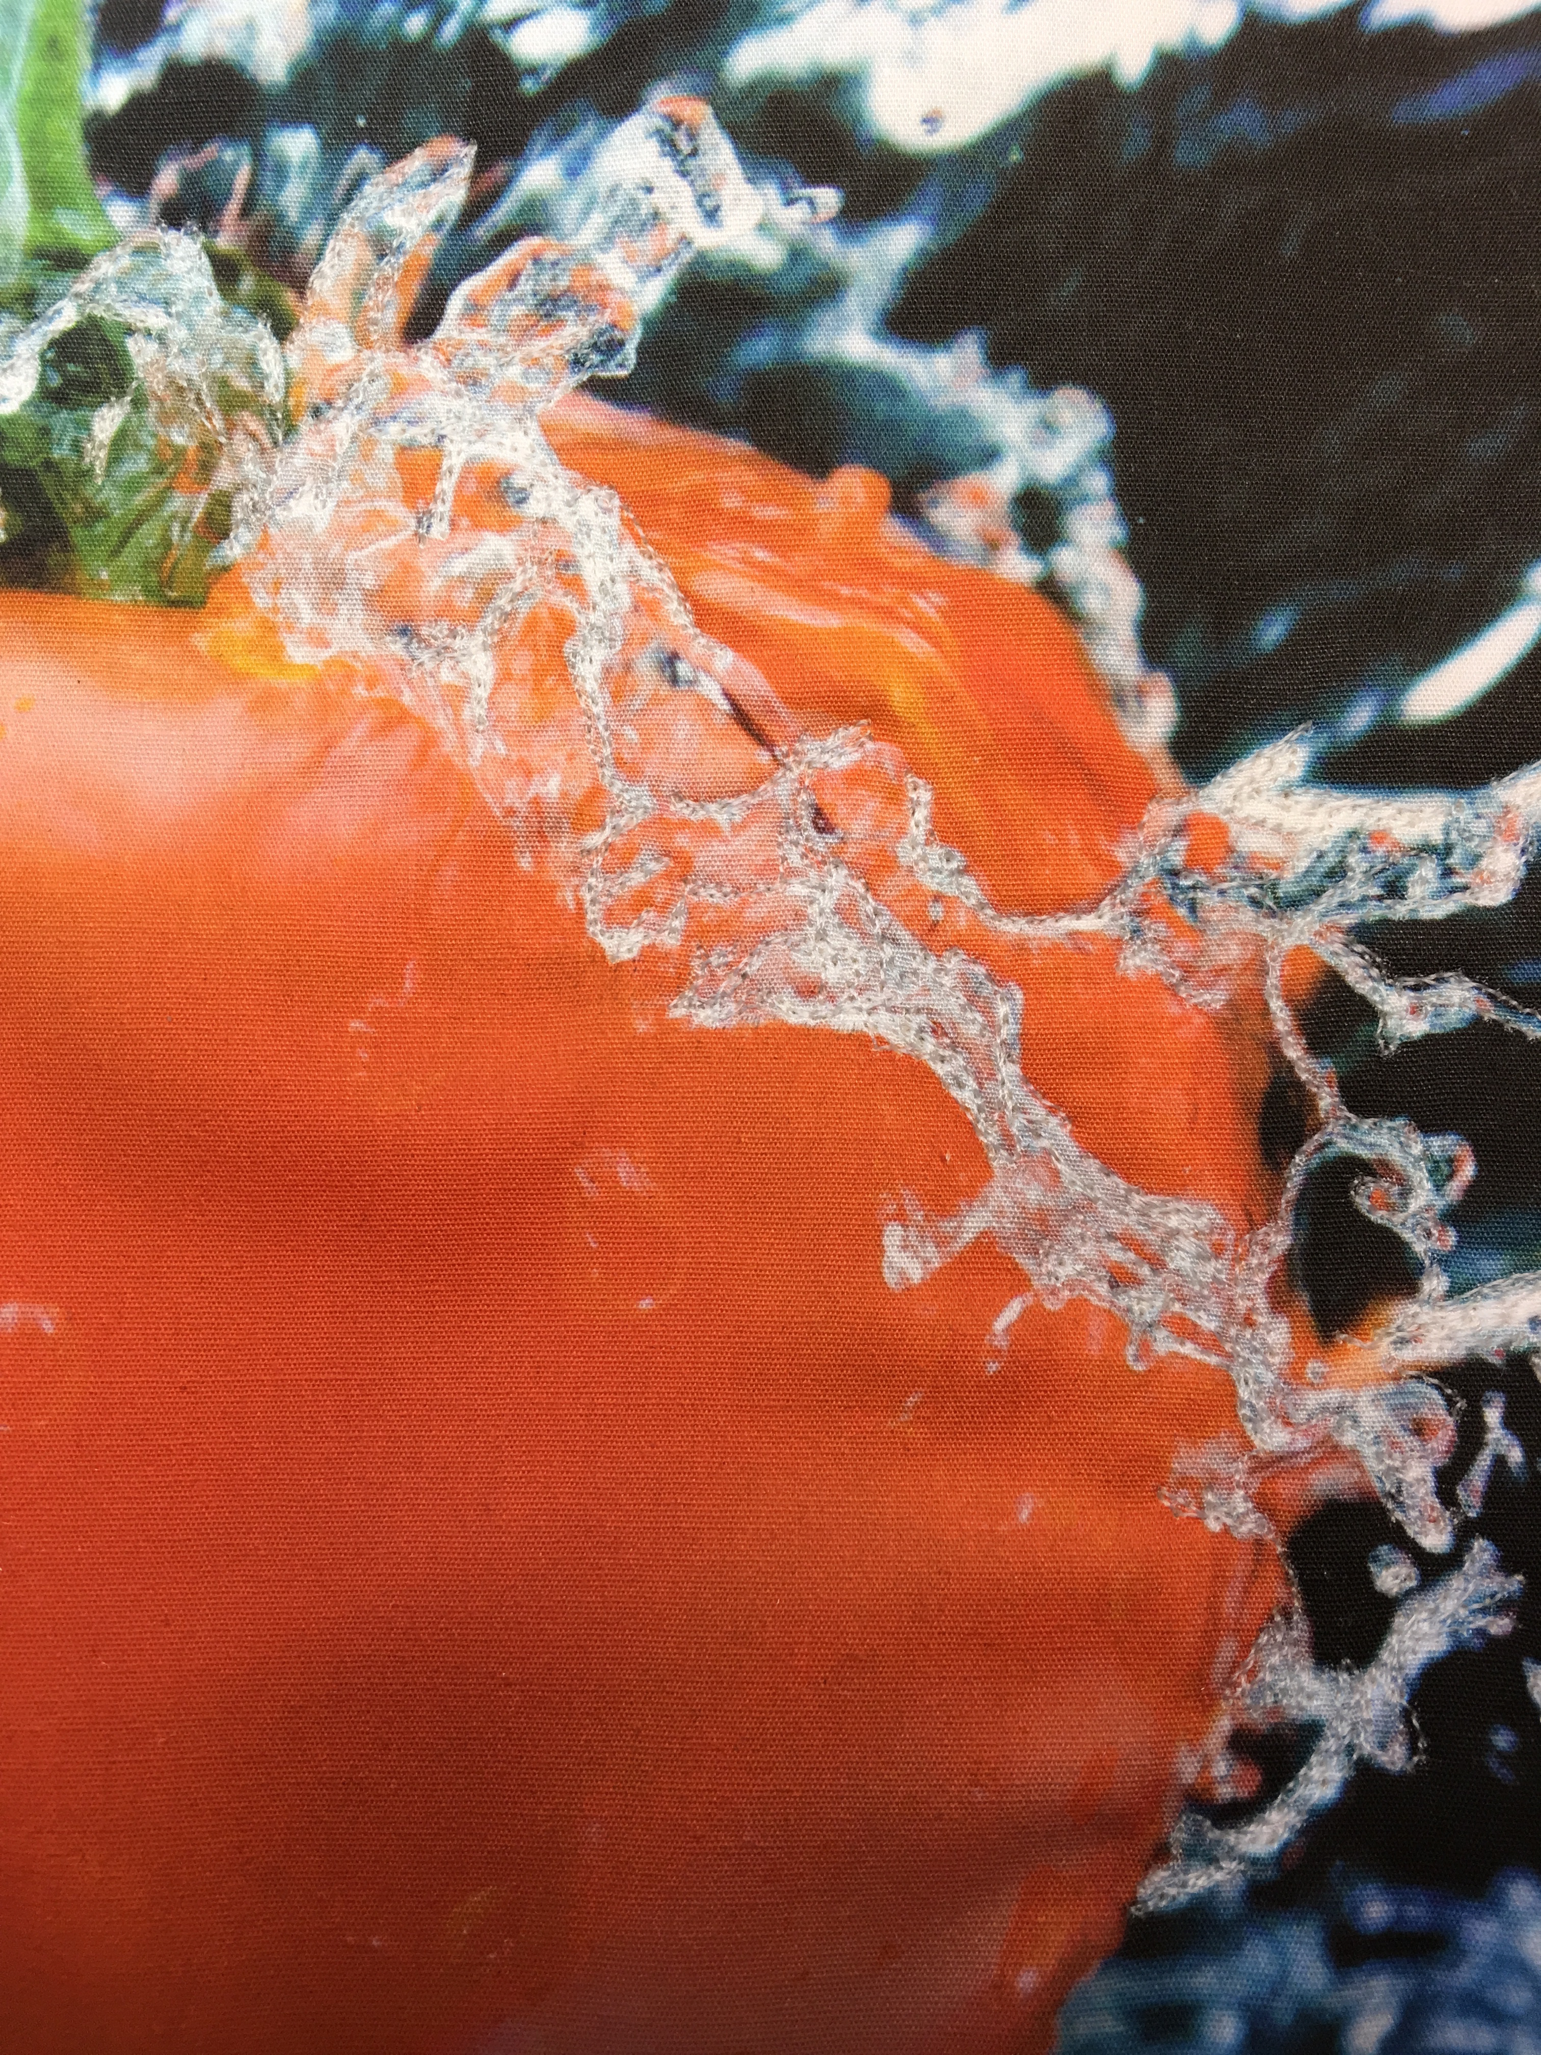

As I begin working the water above and to the side of the tomato, It is important to stretch the fabric so that the material is not loose in the middle of the quilt. Just pull the fabric taught. Then place a few stitches to stabilize the art.

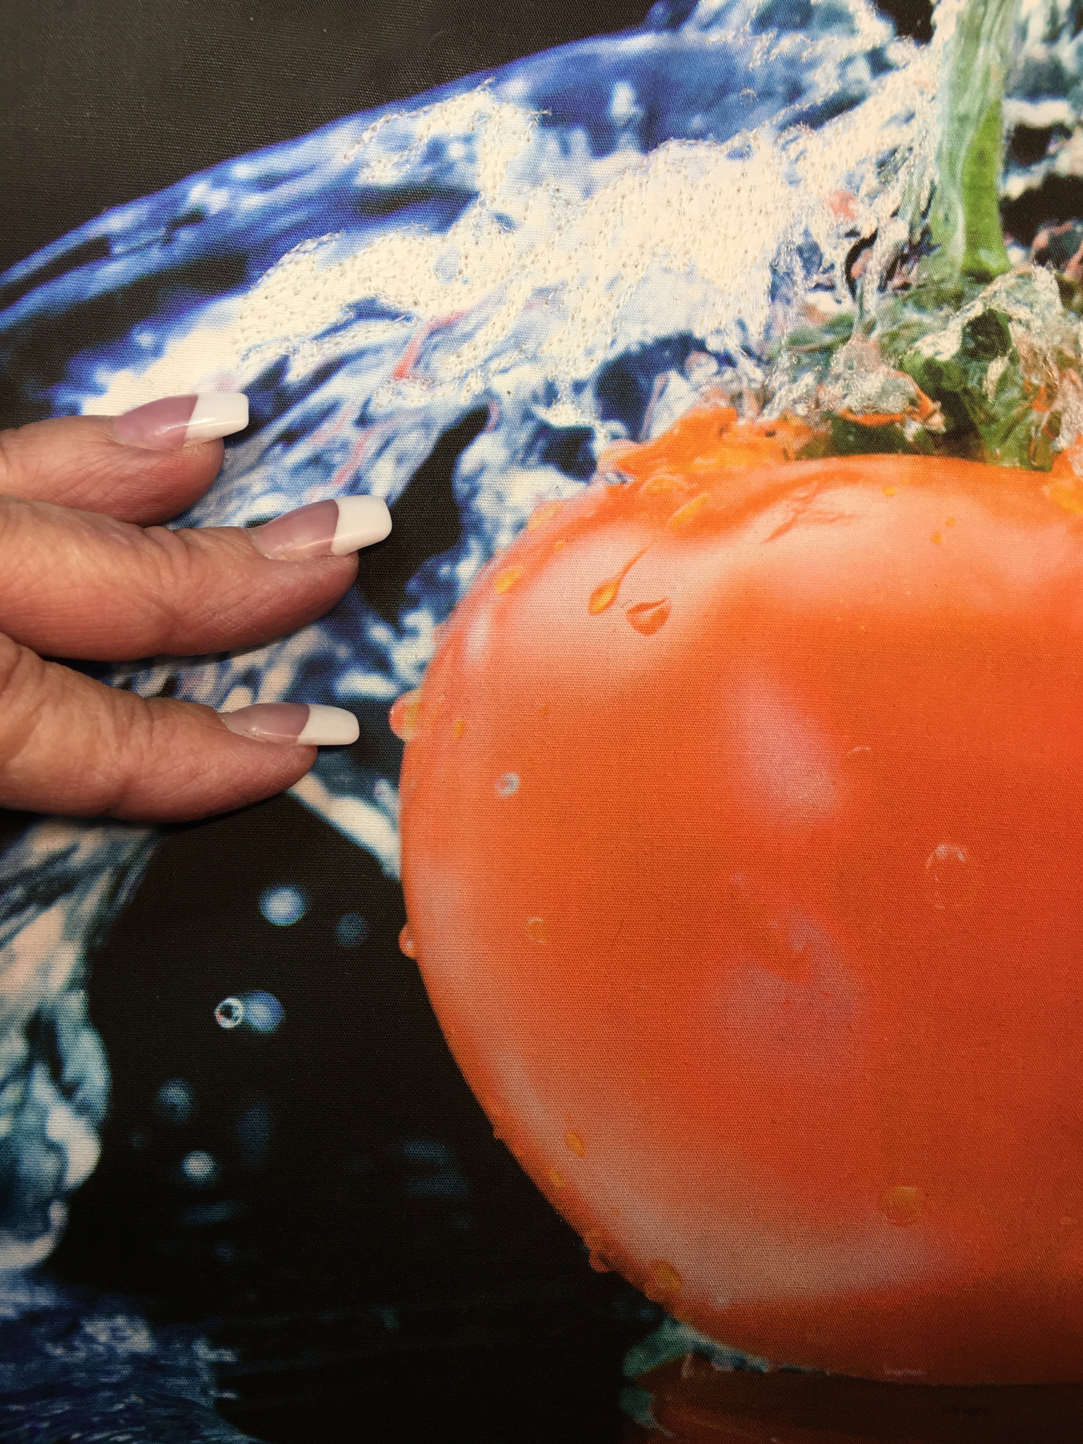

As o begin to add threads to the drops of water it is easier to move the needle and leave extra thread between drops vs. cutting threads every time you move to a new spot. I use this technique constantly when I am sewing.

Note: Remember to clip the threads on the back when you clip threads on the front!

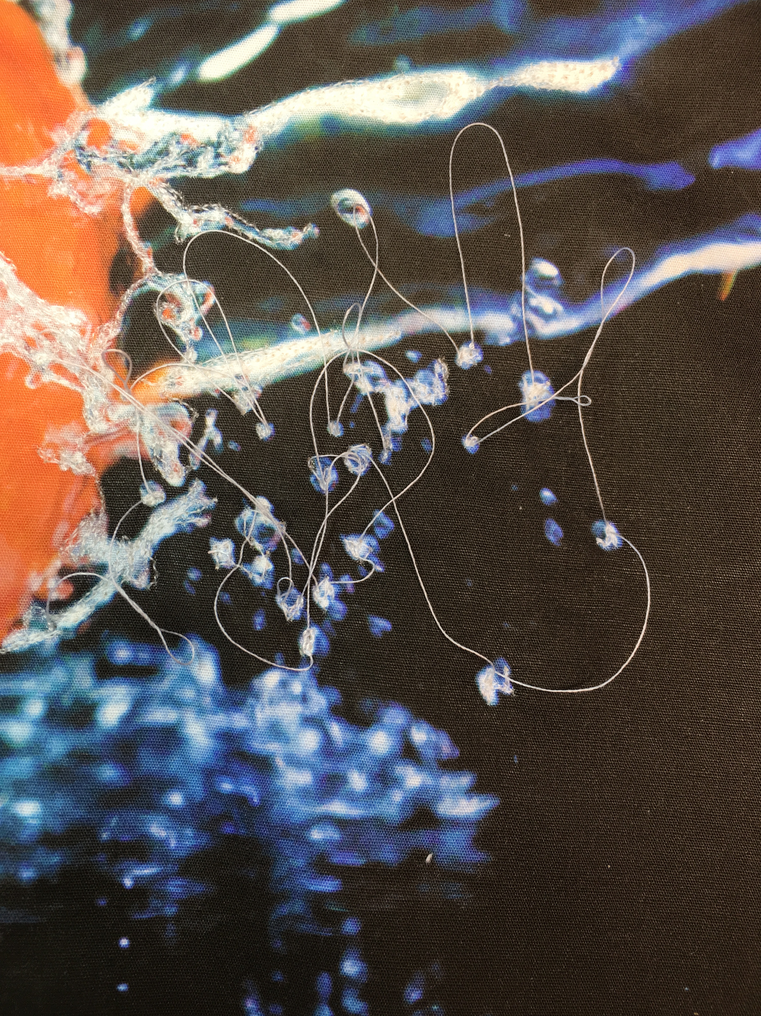

It is amazing how many thread colors there are in a small area! The minute gradations between colors are the key to blending. I always start with the darkest color first. As I add lighter colors it is important to allow a few stitches to cover a portion of the darer threads. This will allow the viewers eye to merge the colors together creating a blended area of the art.

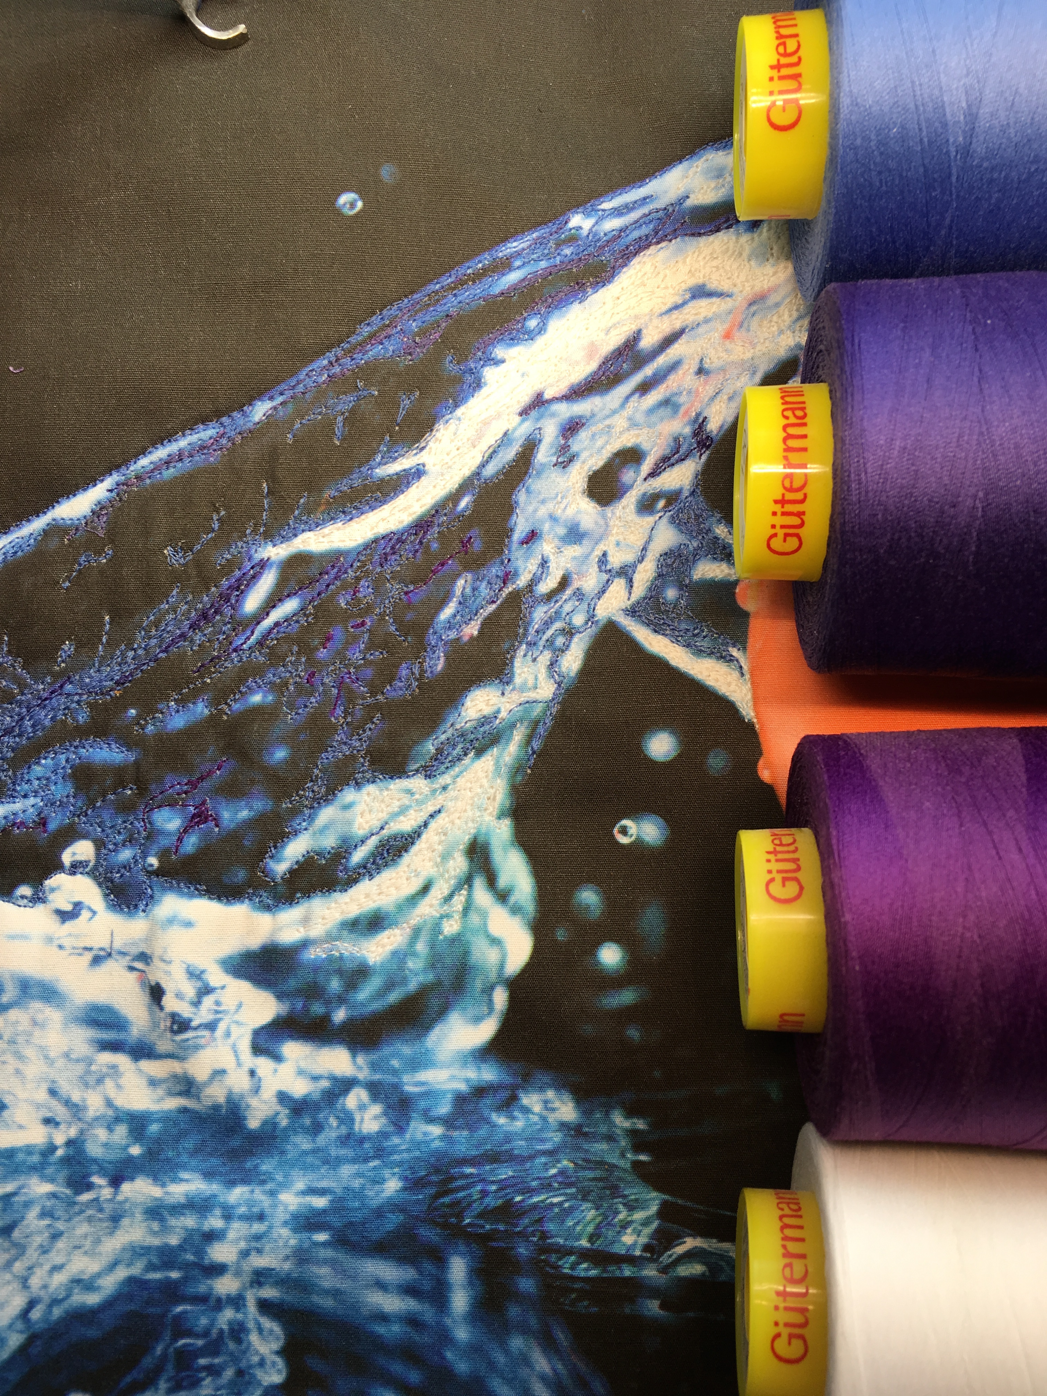

Pay particular attention to the aquamarine threads in this photograph. You can see that I have blended this color over the darker blue. This creates a third color to the viewer’s eye that is a shade between the two thread colors. Thread is a static material. It is not like two paint colors that can be combined together to create a third color. Think of your threads as your “paint box”.

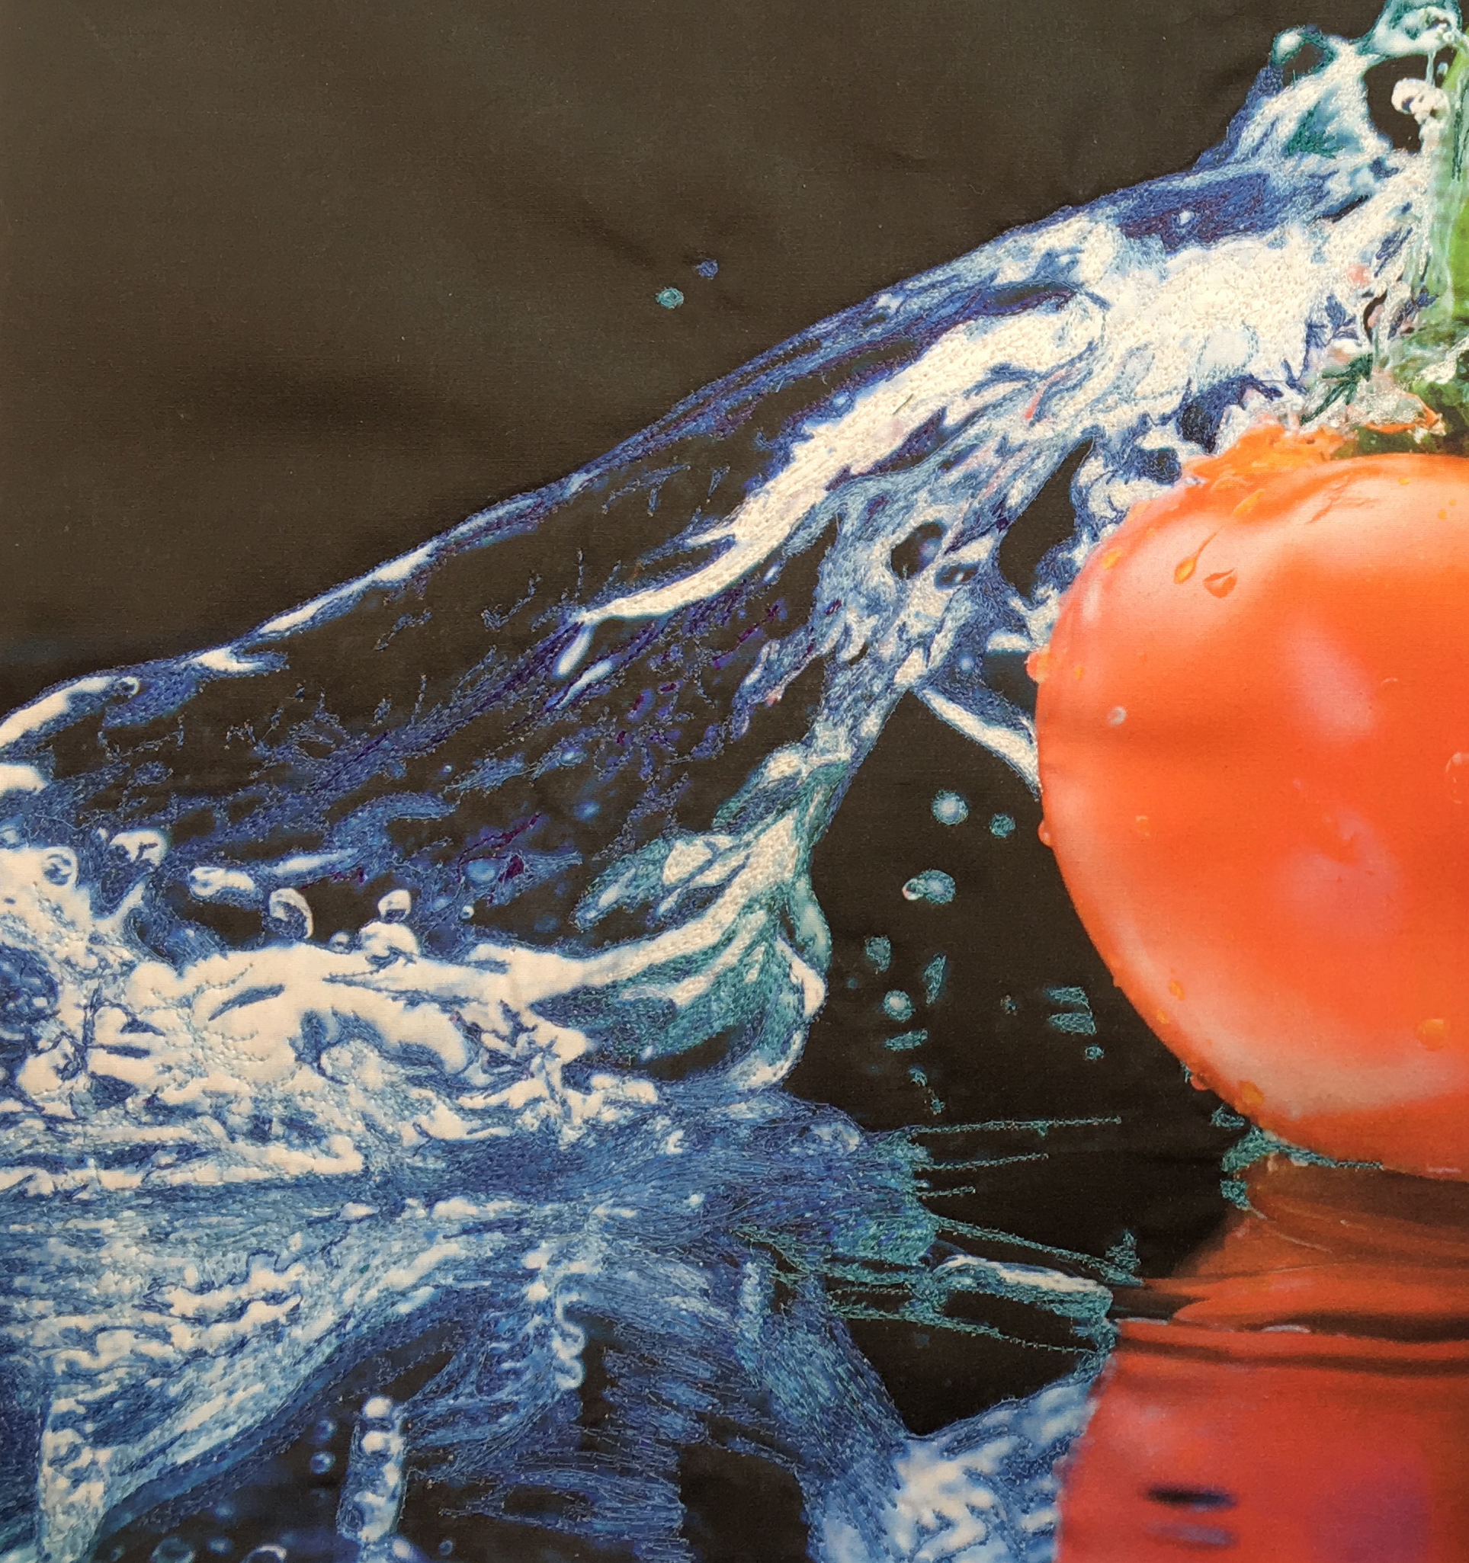

When I am teaching, I like to start my students on a project that has been posterized in Photoshop. This process “clumps” colors. Posterization of an image entails the conversion of a continuous gradation of tone to several regions of fewer tones, with abrupt changes from one tone to another. This was originally done with photographic processes to create posters. Now it is easier to select thread colors in a given area.

I began the stitching on this quilt using the original photograph. I now am using an applique of the posterized image for further stitching. It is easy to see the difference in these images. As you continue using this technique, you will train your eye to determine the correct colors to select without the use of posterization.

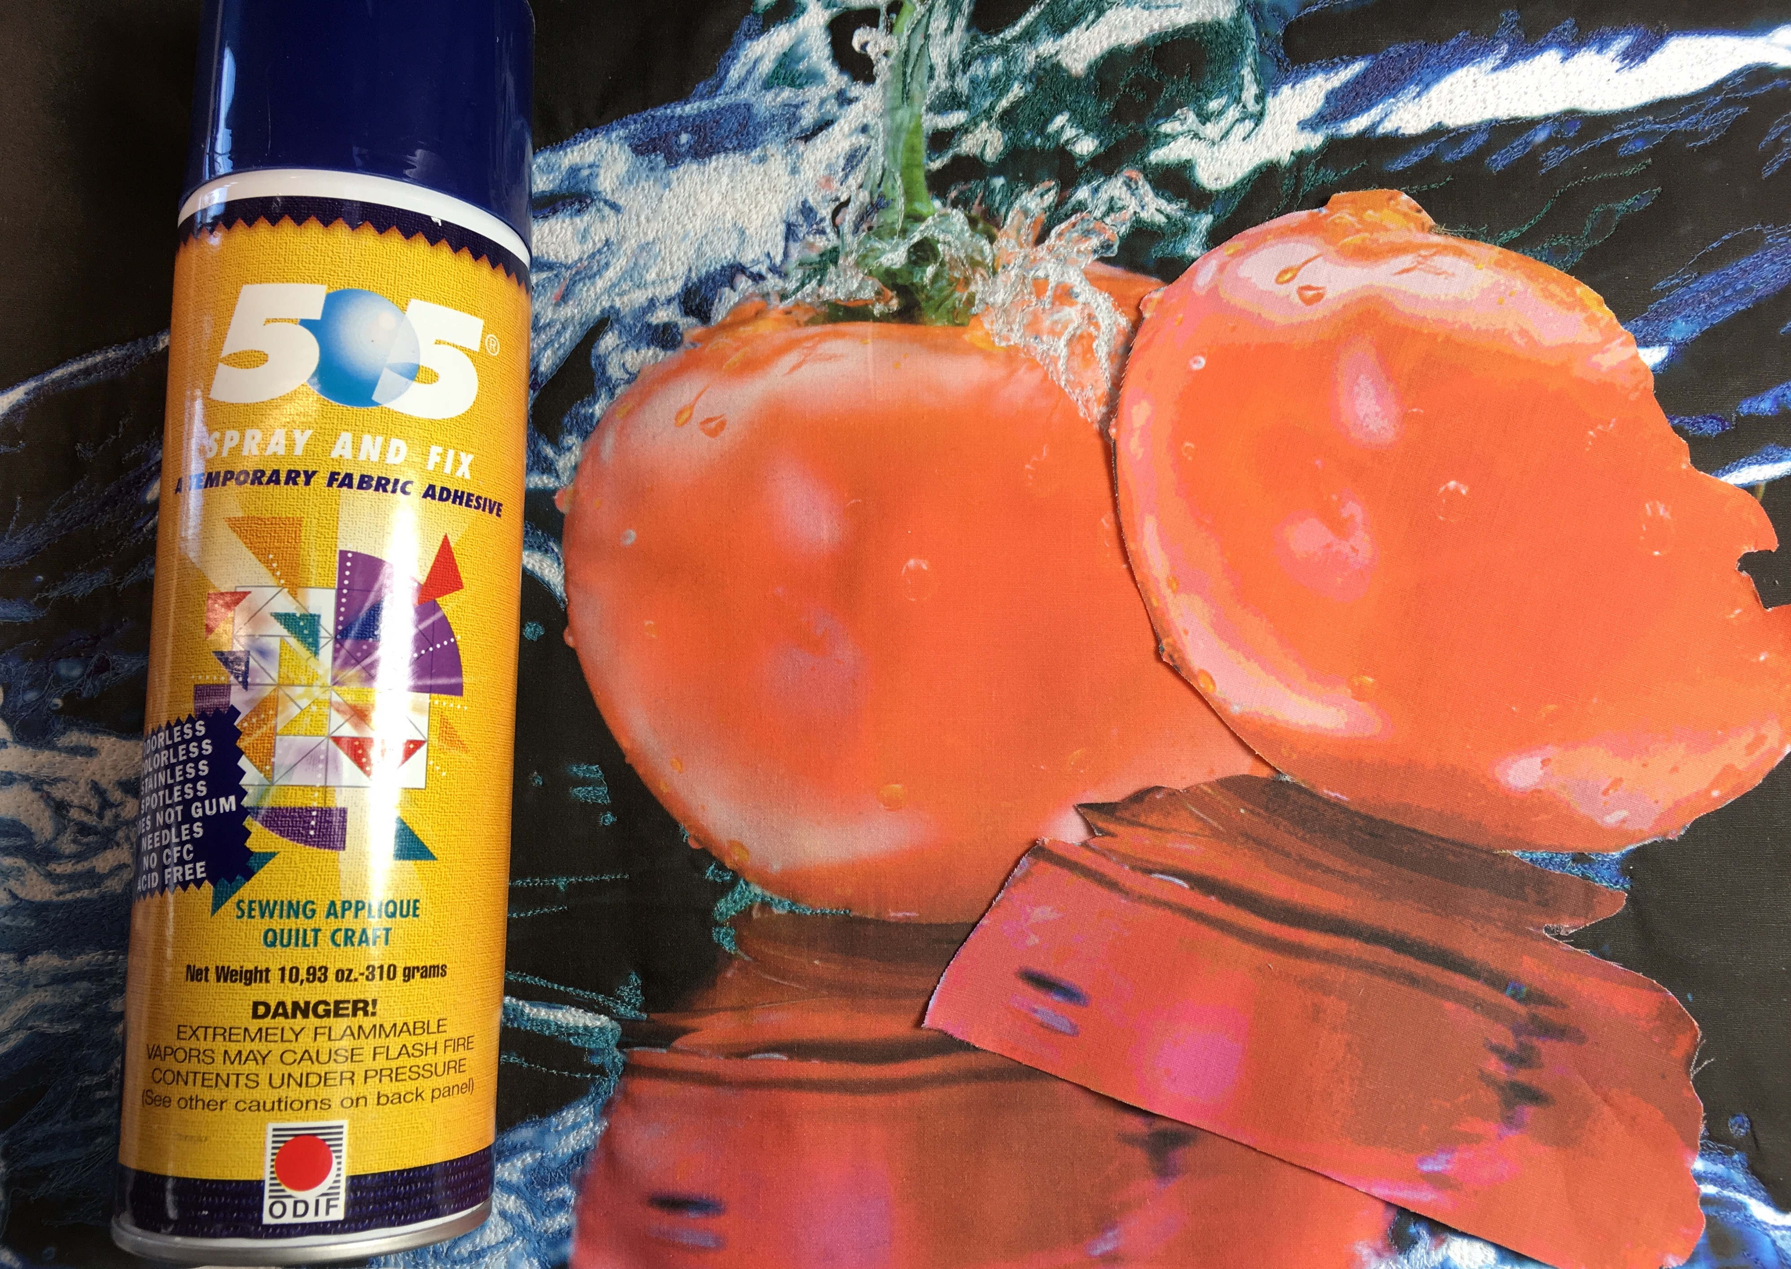

It is important to capture some obscure details first before laying down the darker colors. If you do not do this, you will lose the detail. You can look at the original photograph and add these at a later time, but this is a quick fix.

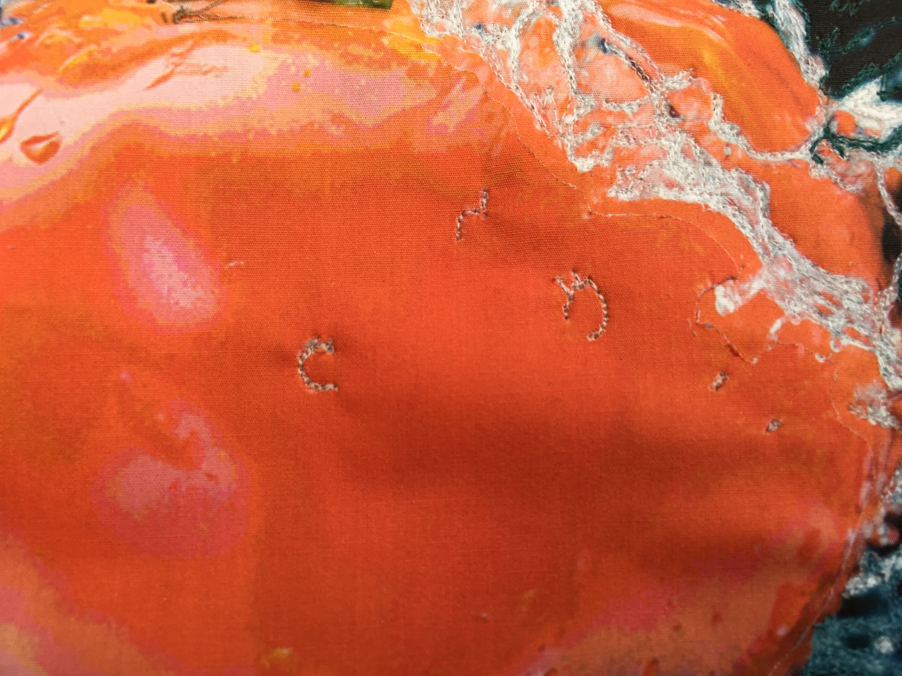

It is important to audition threads before choosing the one you want to work with. This is done by laying the thread on top of your art. By doing so, you can decide which one is the best color for your project. In this case, The color on the right best matches the tomato skin, but I am going to use the one on the left to give the finished product a punch of color. It is important to realize that no one knows what your original photograph looked like. This is where your artist interpretation comes into play!

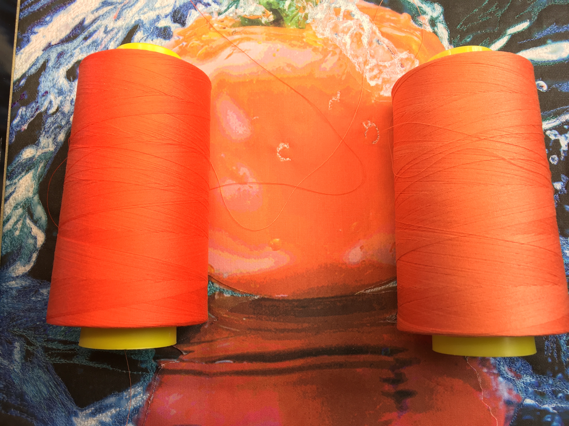

Now is the time to begin stitching the tomato. The next few photographs show a step by step approach to this process.

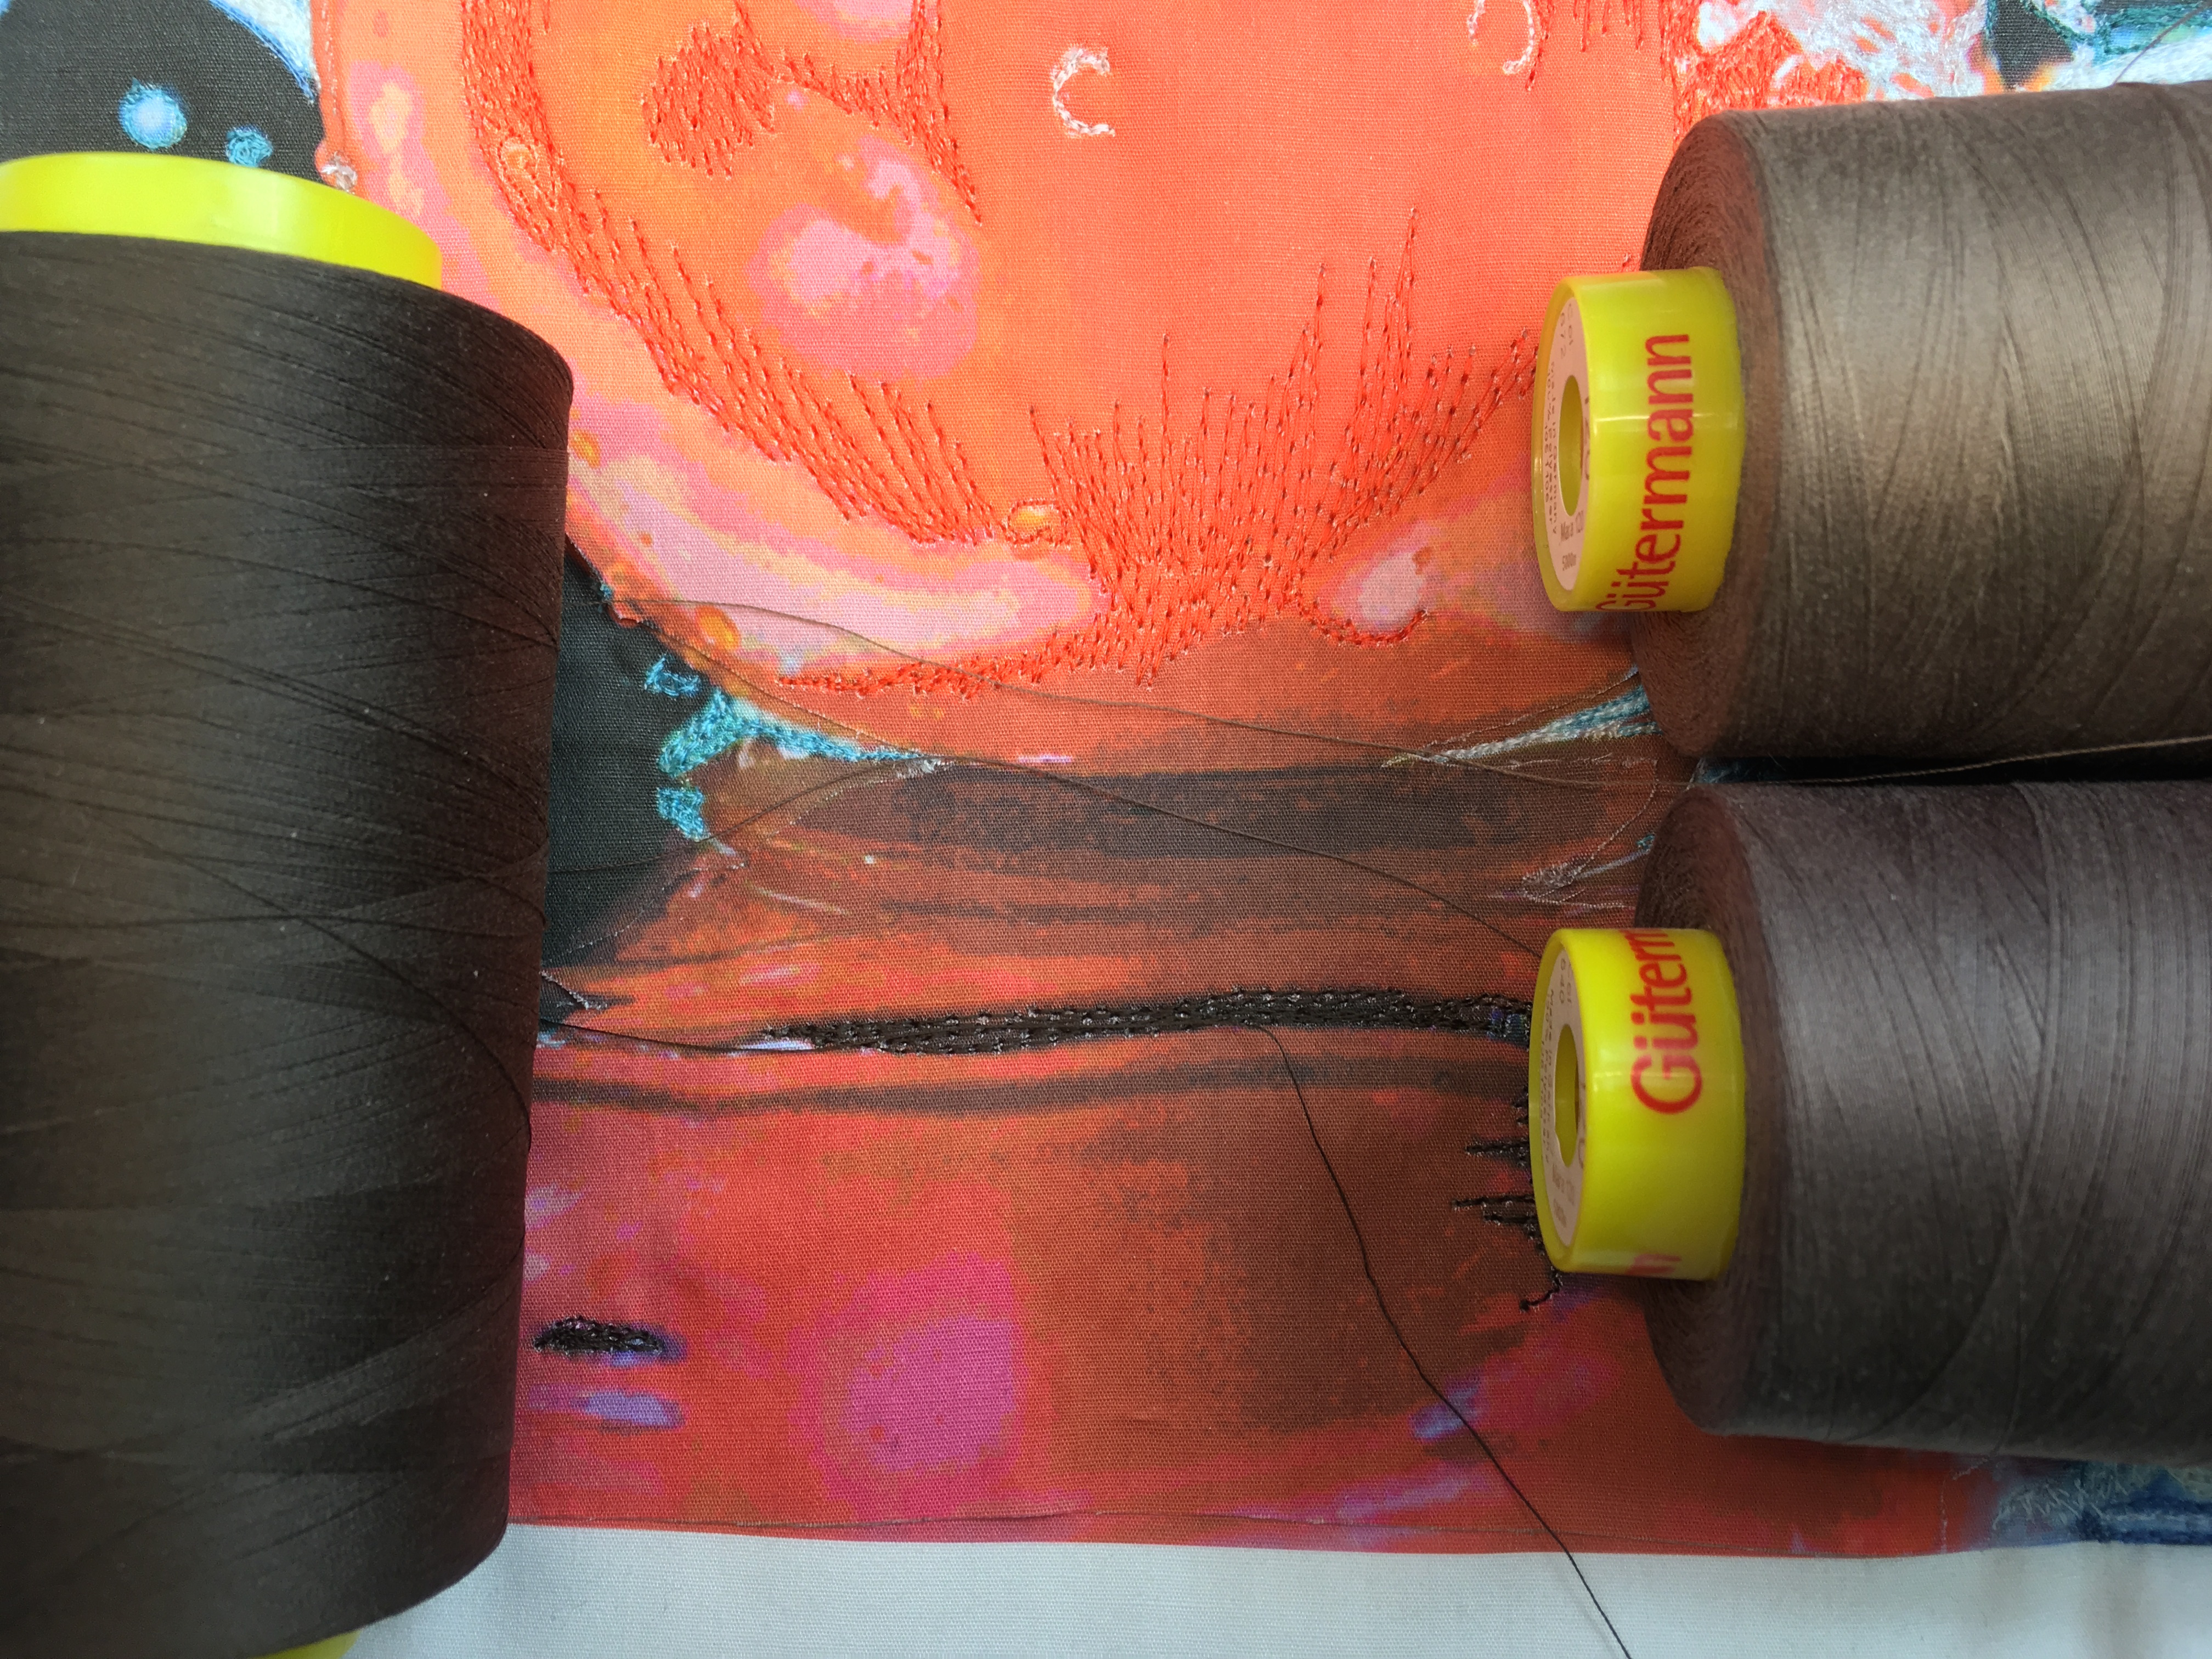

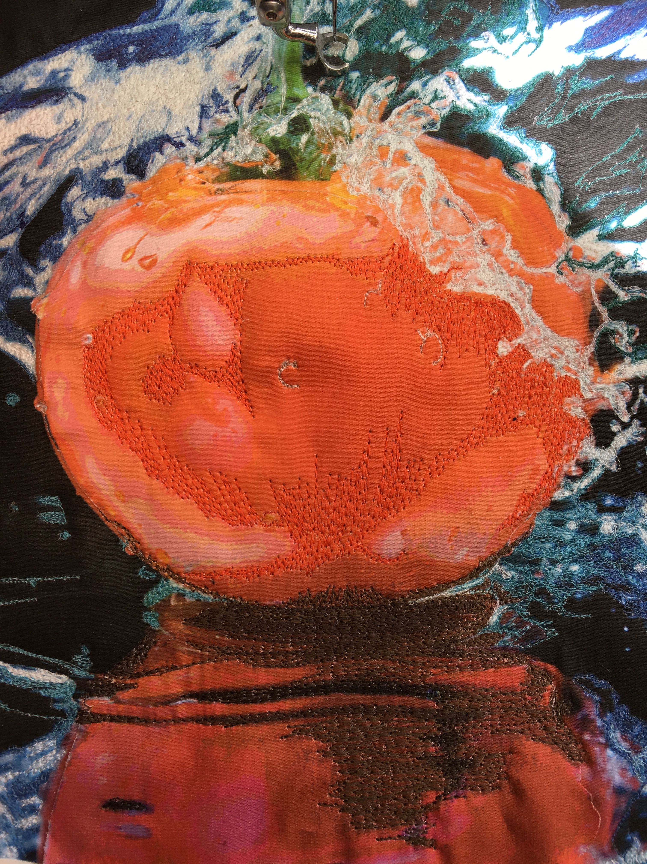

The tomato and tomato reflection need some additional blending.

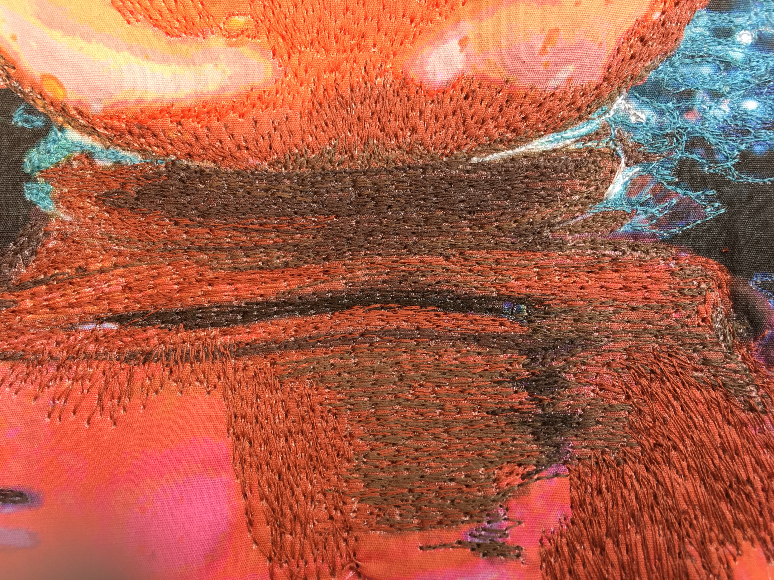

I now have chosen a third color that is not present in the photograph to blend the two colors that have already been stitched.

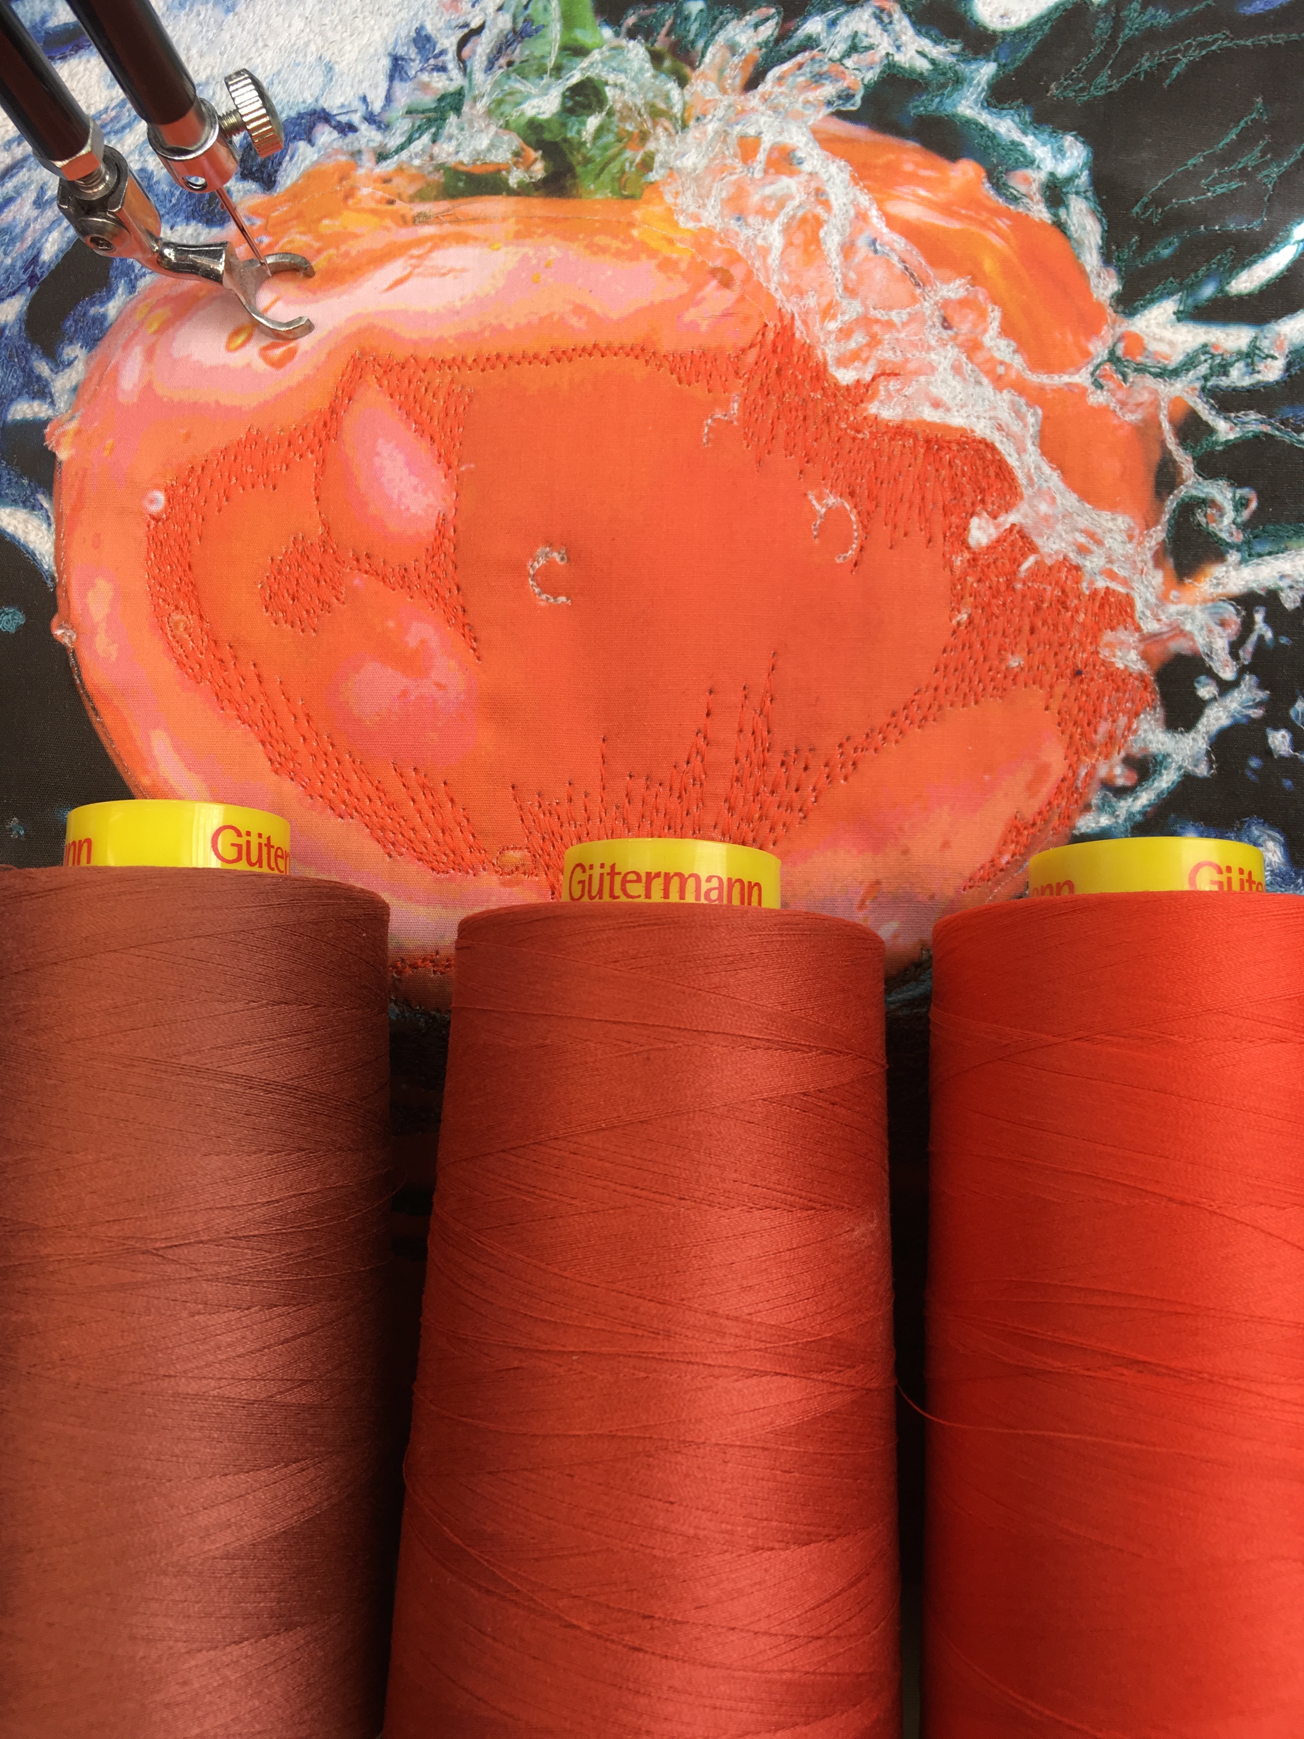

The colors are now blended and I have been sewing for one hour.

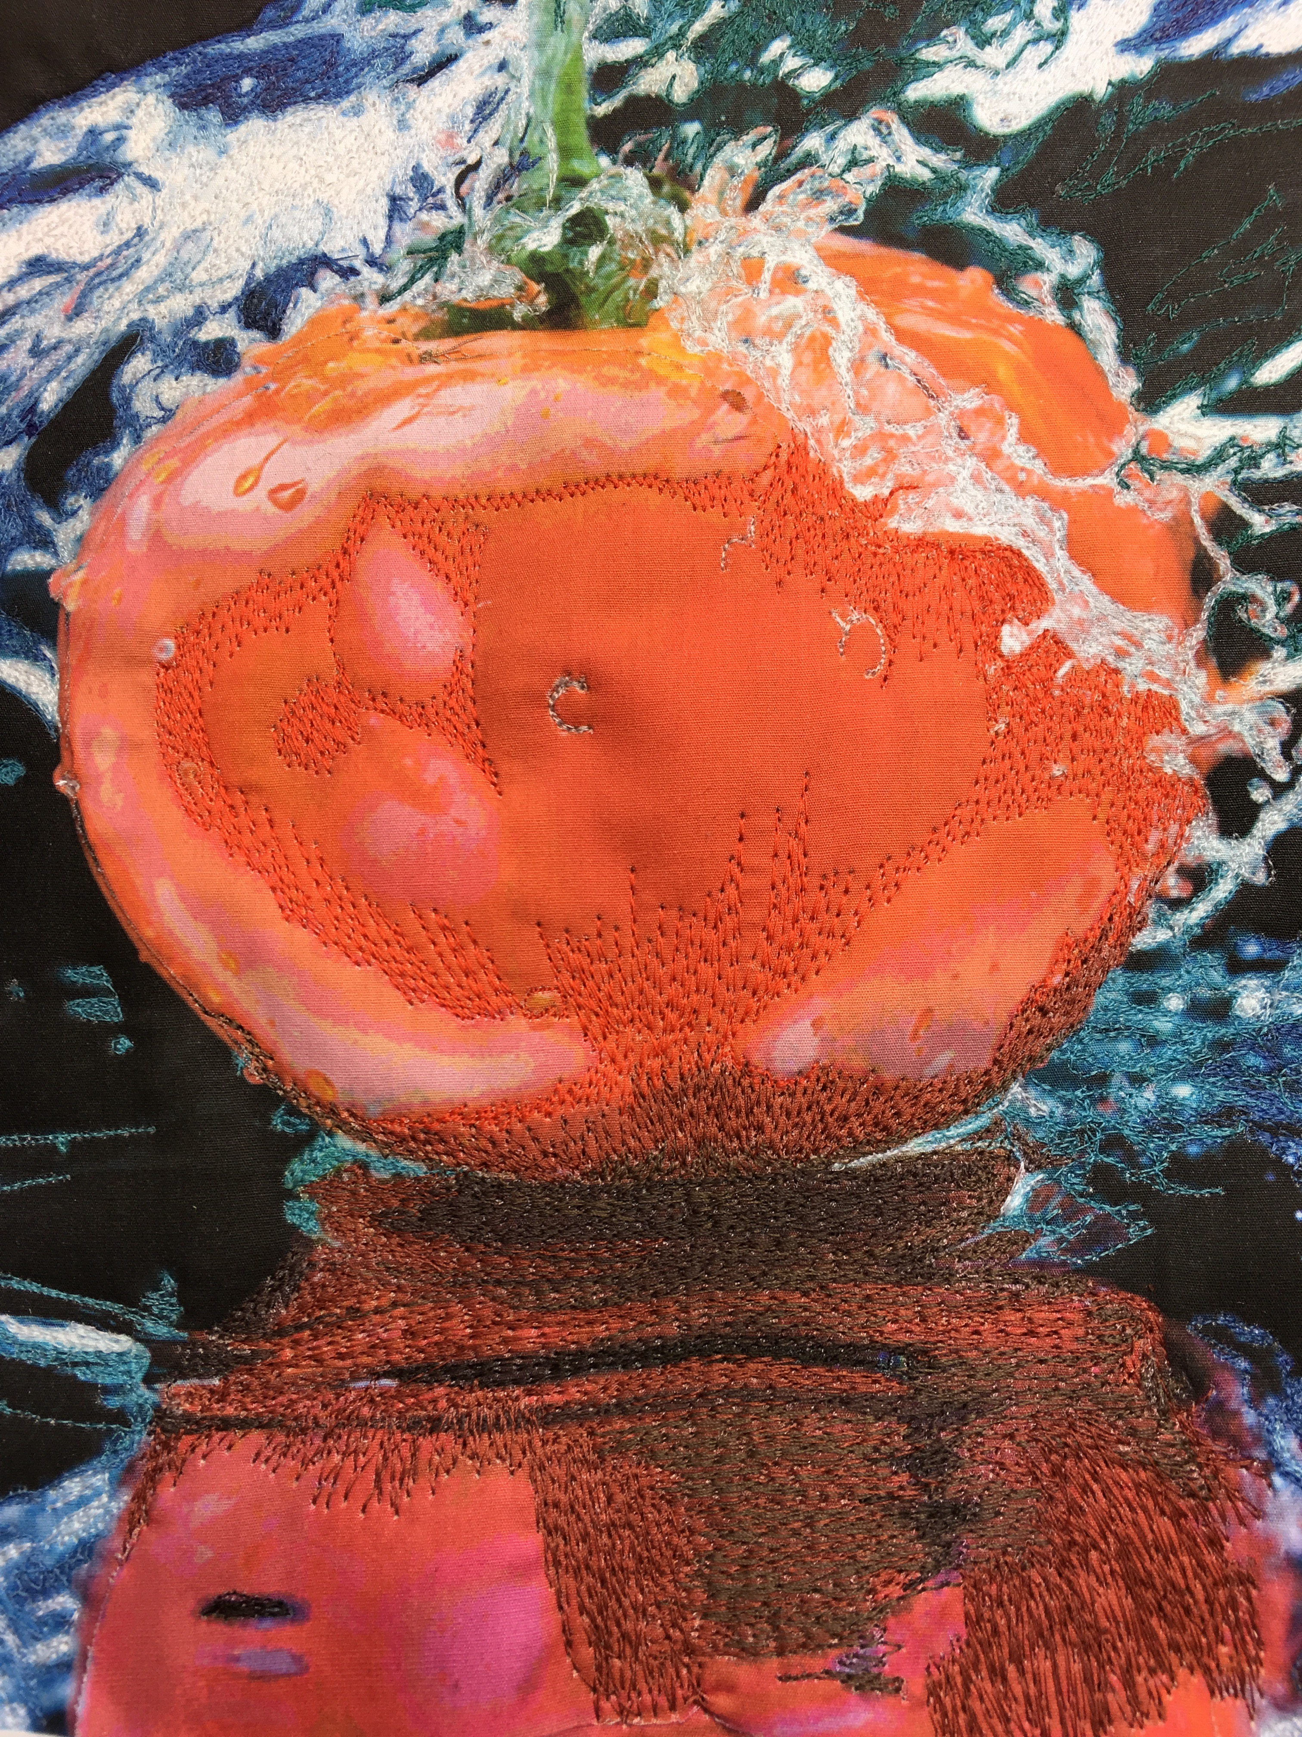

It is important to realize that it is not necessary to use all of the colors on the posterized image. If I stitch lightly over the pink with the main skin color, you will be able to see the gradation without actually adding the pink and making clearcut color changes. Remember – BLEND!

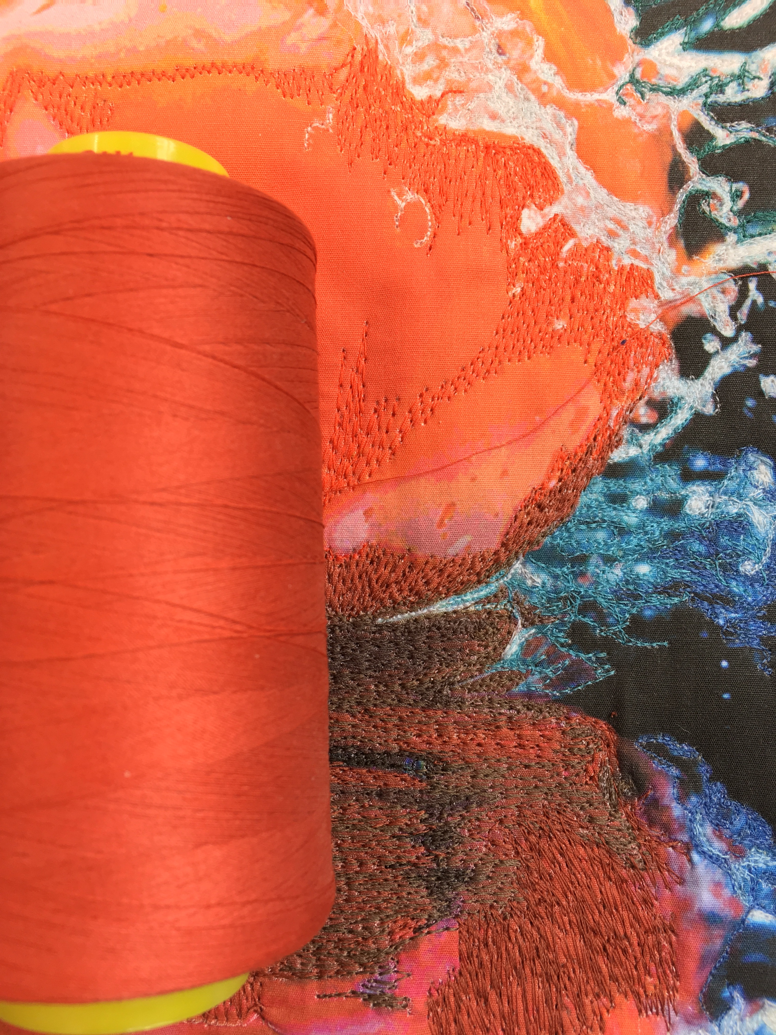

I now have added color over most of the tomato. It is now time to work on the highlights.

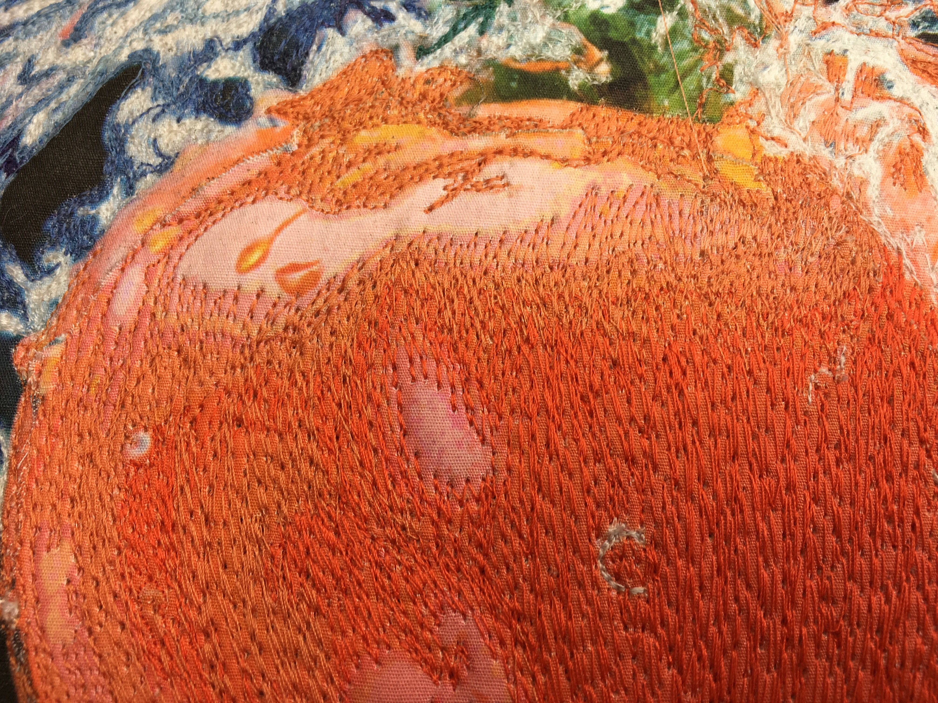

I am adding some of the peach tone into the lightest area in my “sketchy scratchy” technique. I stitch this color lightly onto the fabric. When I add the lightest color, some of the darker threads will show through giving this area a blended color.

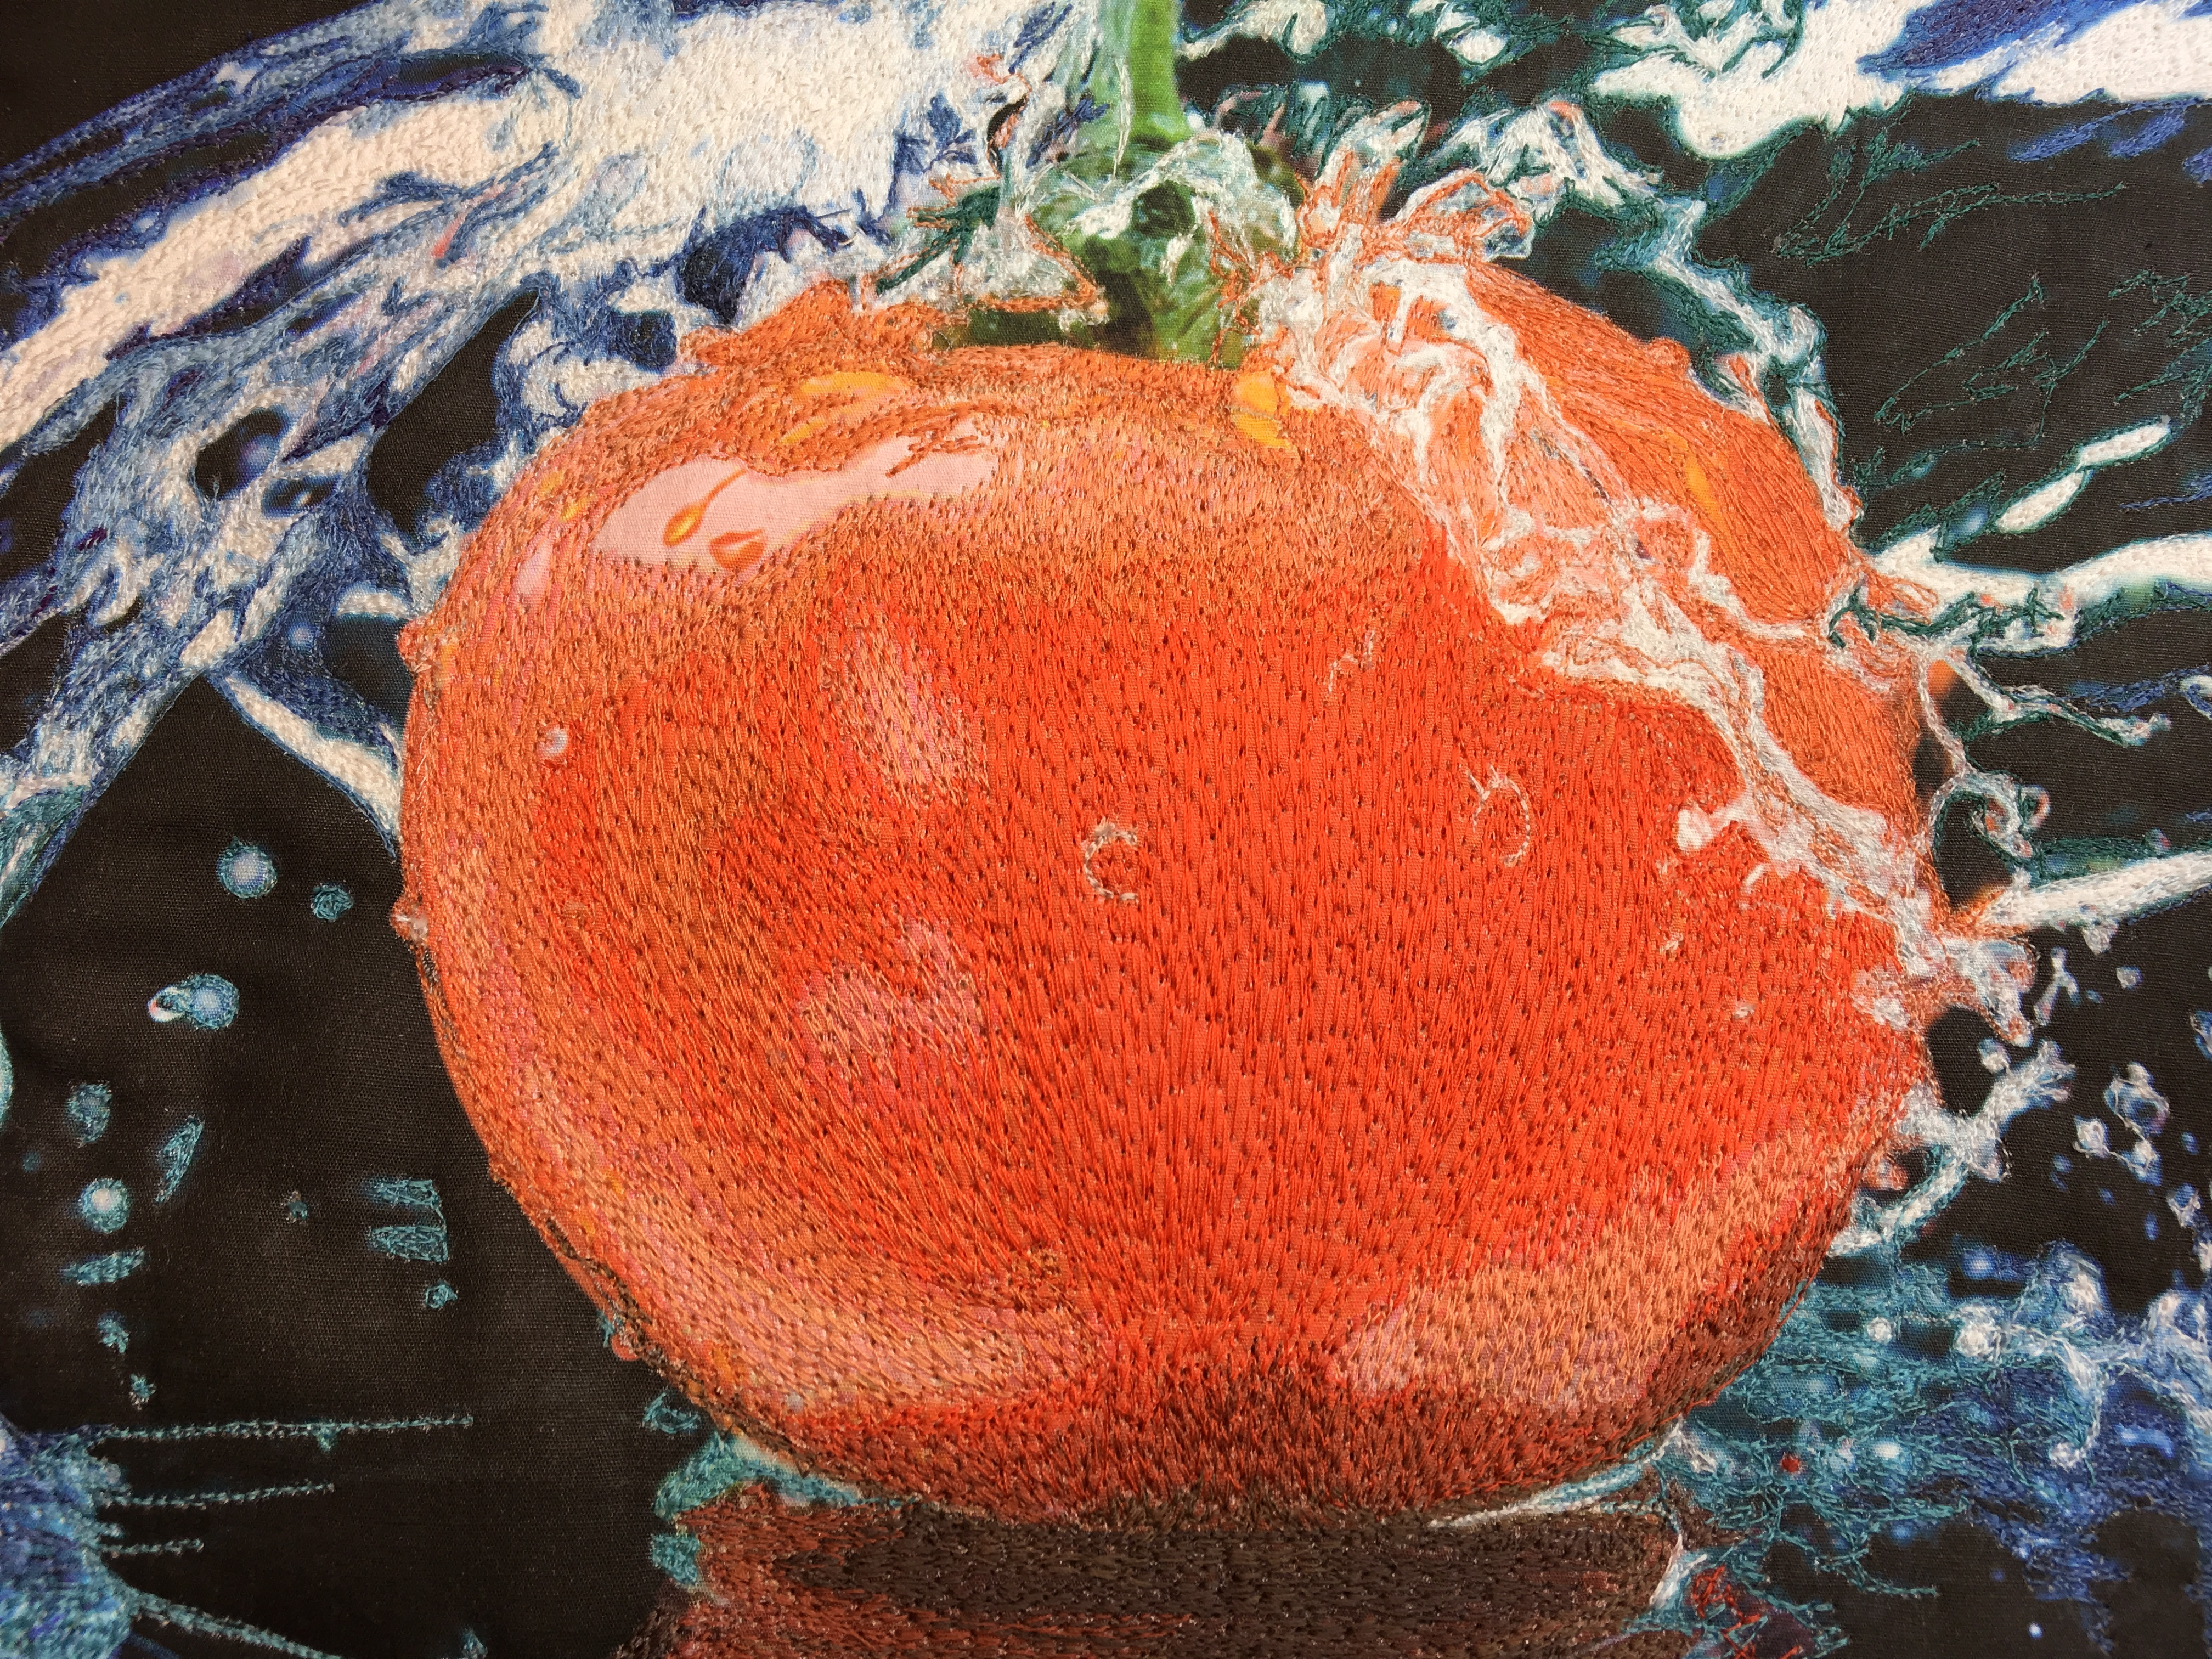

Note: I am not intensely stitching the tomato. I am allowing some of the base fabric to show through.

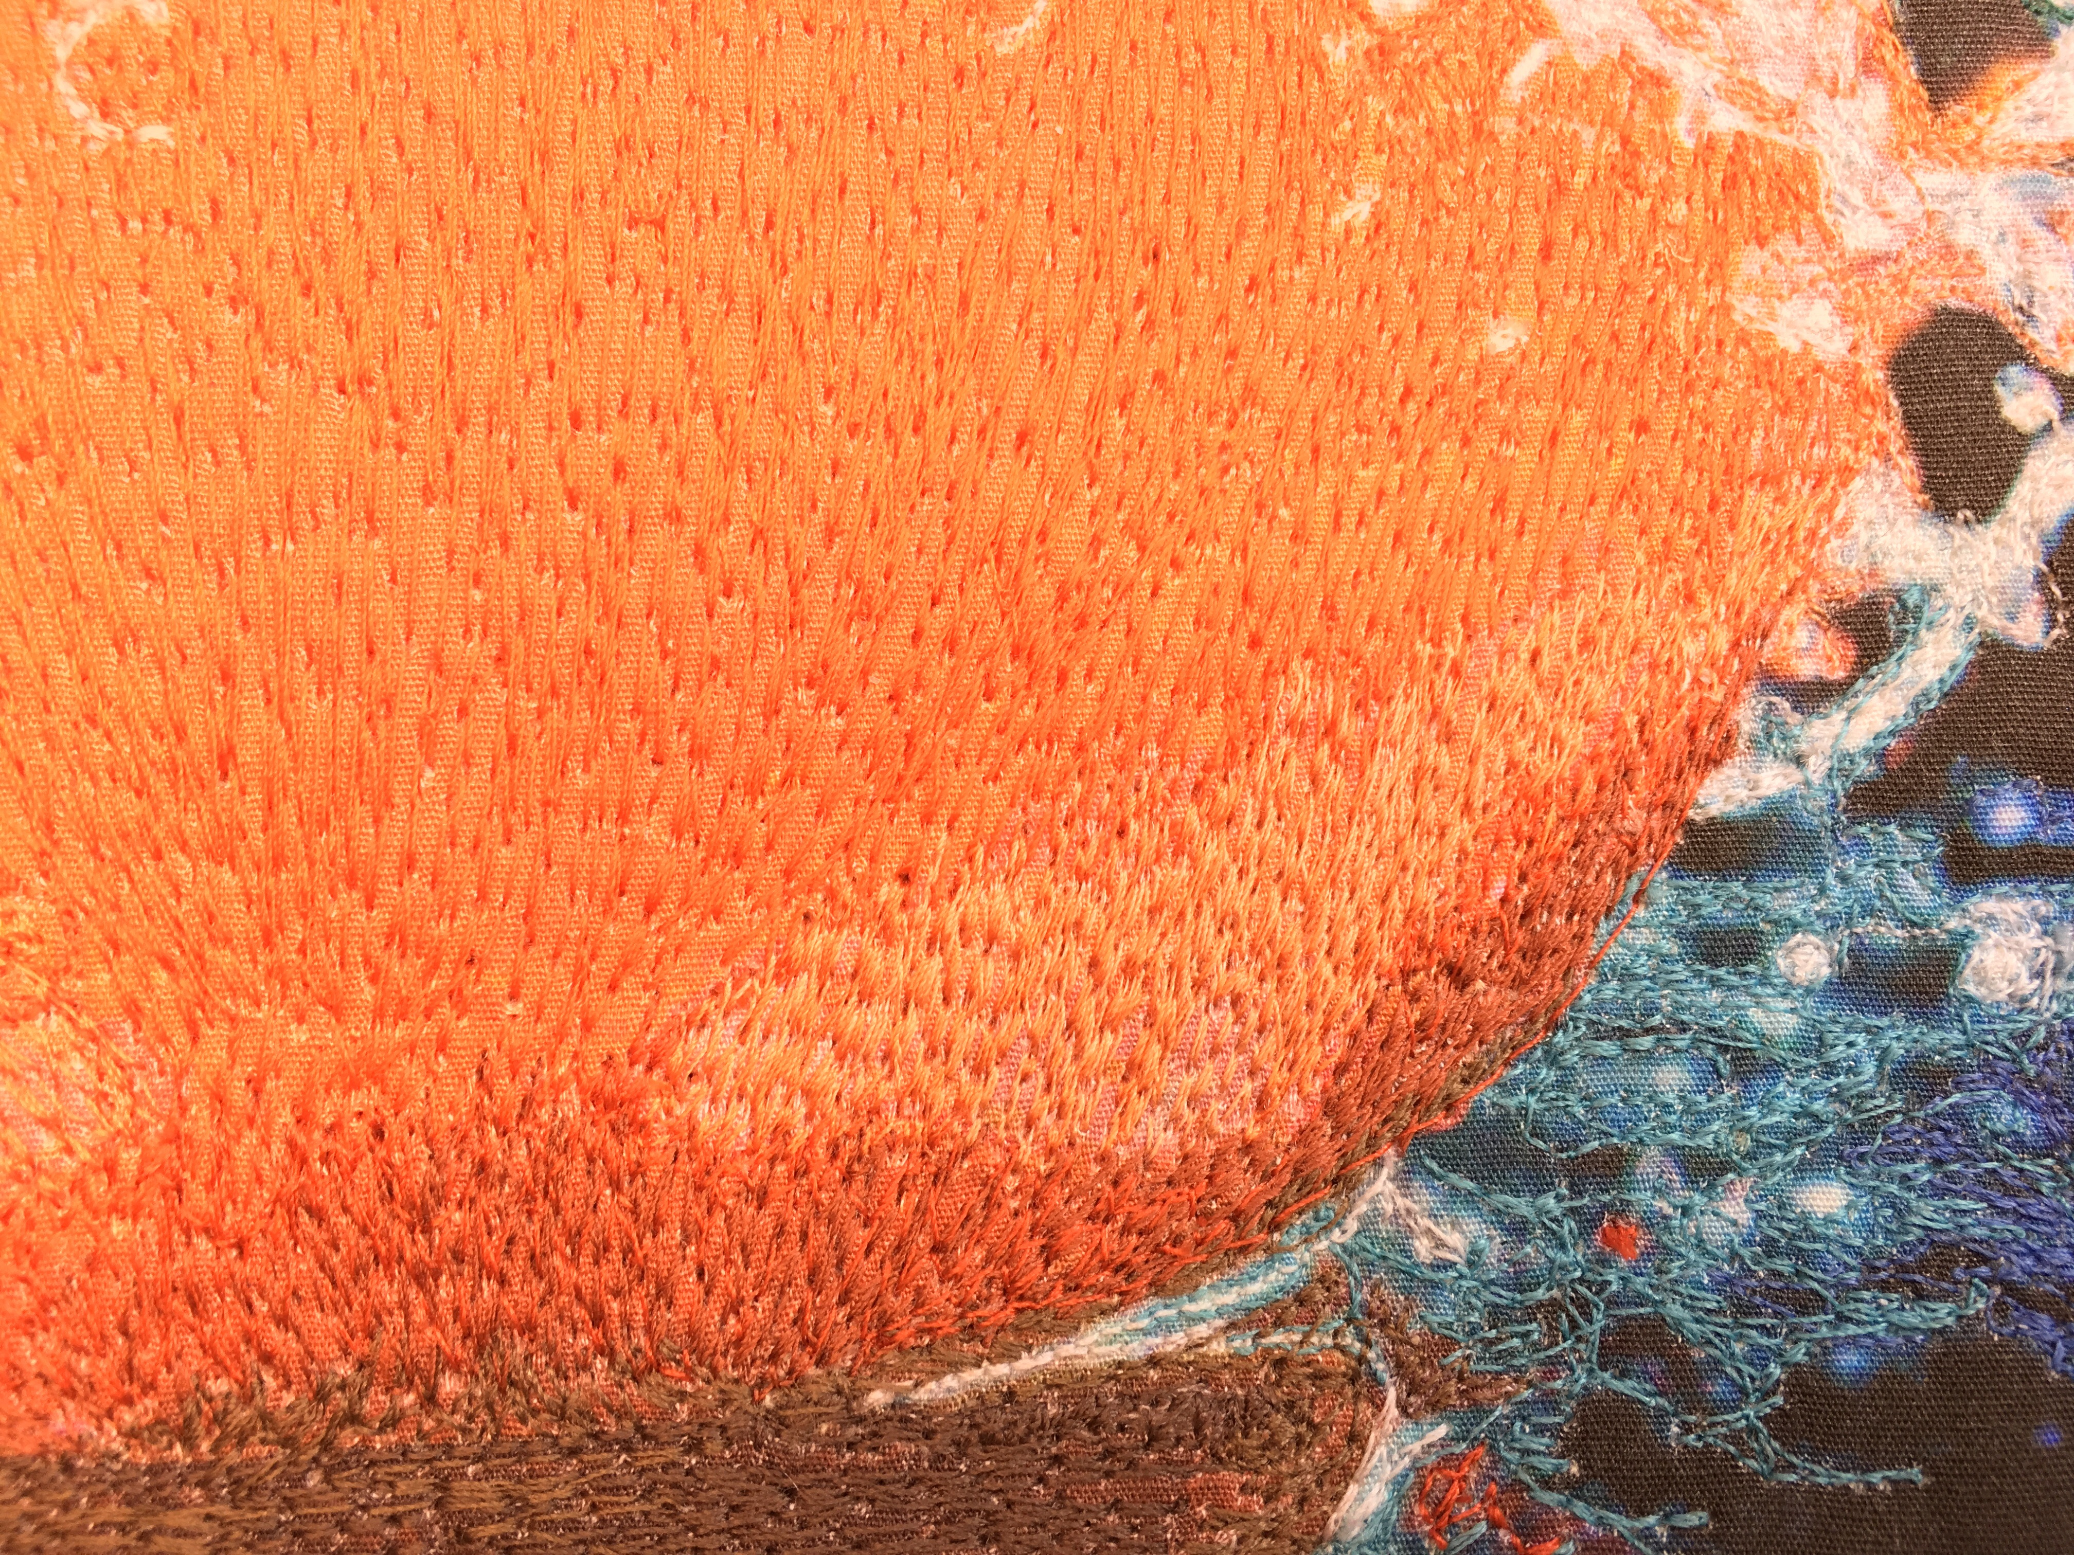

Now that I am almost finished, I can compare my work to the original photograph. By doing so I can decide where to add colors to create the realistic finished product.

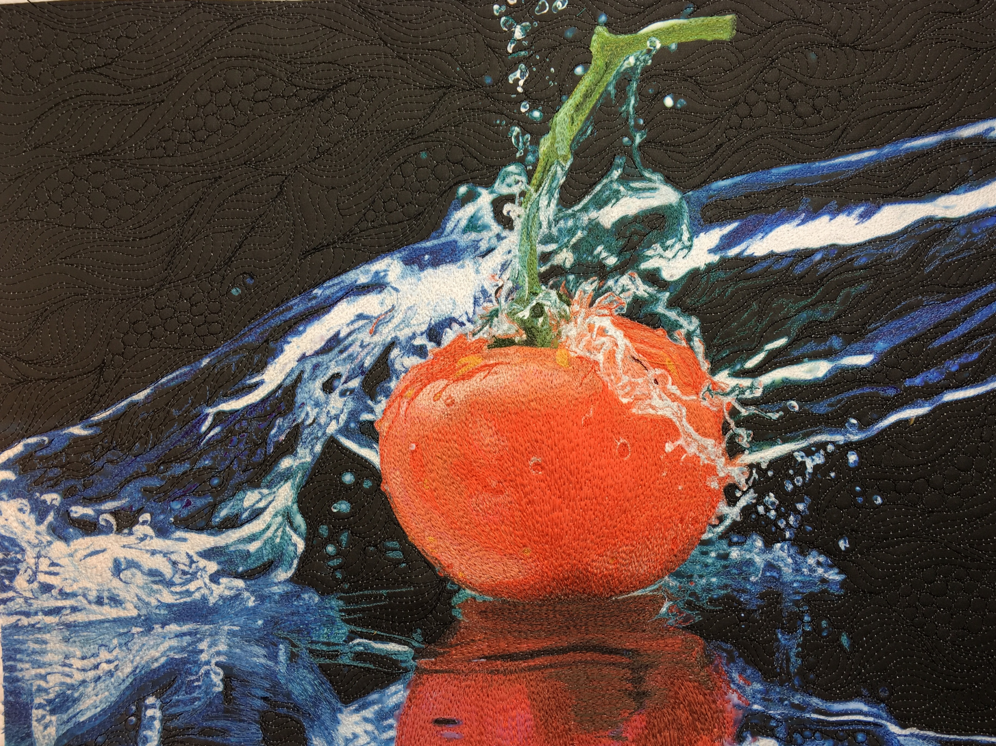

I add some dark threads to the left of the tomato to give more of a sense of light reflection. I also add some more drops of water on the skin of the tomato. There is a slight dimple on the skin in the center that I have exaggerated. I also have added highlights to the bottom of the fruit.

This is the original photograph without posterization.

This is the finished art!

