Cuban Ballerina by Jennifer Day

This is a step-by-step journey through the creation of the Fiber Art - Cuban Ballerina. The quilt is a masterful combination of photography, thread painting and free motion quilting.

As I created the quilt, Cuban Ballerina, I also created a pictorial story of its creation. Each photograph documents the journey through the design process of this art. This is an amazing journey.

This art quilt begins with a photograph. I took this photograph in Havana, Cuba. Several dancers with the world renown Cuban National Ballet met to dance in an old building downtown in Old Havana. In the 1950’s, the building was once a grand structure, complete with marble floors, stairs, gilt ironwork and statuary. Elegant arches and arched windows grace the hall where the dancers gathered. All are in disrepair today. The marble is cracked. The ironwork is rusted. The statue that sits at the base of the grand stair is missing her head. The walls are covered in graffiti and there is laundry from the restaurant on the third floor, hanging in the grand hall. This is the state of Havana. Once a fabulous center of romance and nightlife, now this fabulous building is in disrepair.

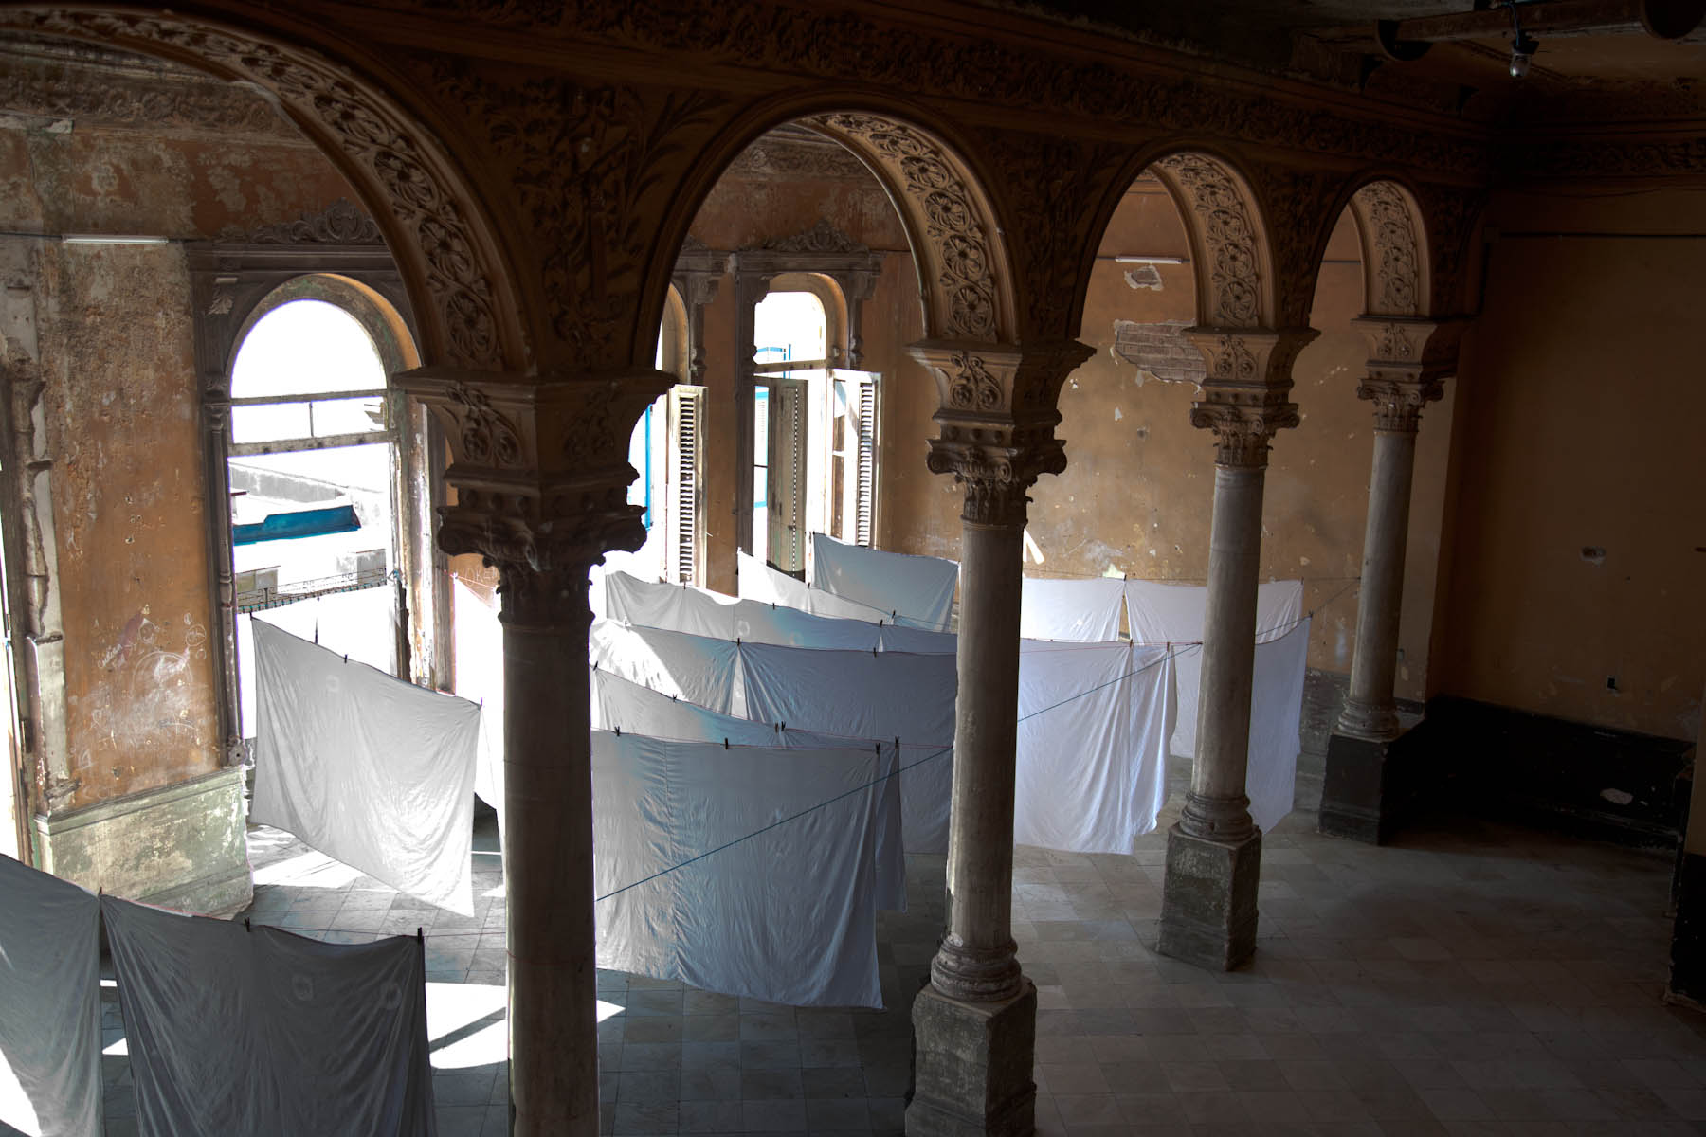

The dancers of the Cuban National Ballet begin their studies at the age of five years. After completing the training, a dancer earns approximately $30 a month, which compares to the salaries of doctors and skilled workers. They represent the heart of culture and refinement in Cuba.

I spent several fascinating hours with the young ballerinas. I moved with them, photographing them as they danced in this grand hall.

These are some of the photographs that I took:

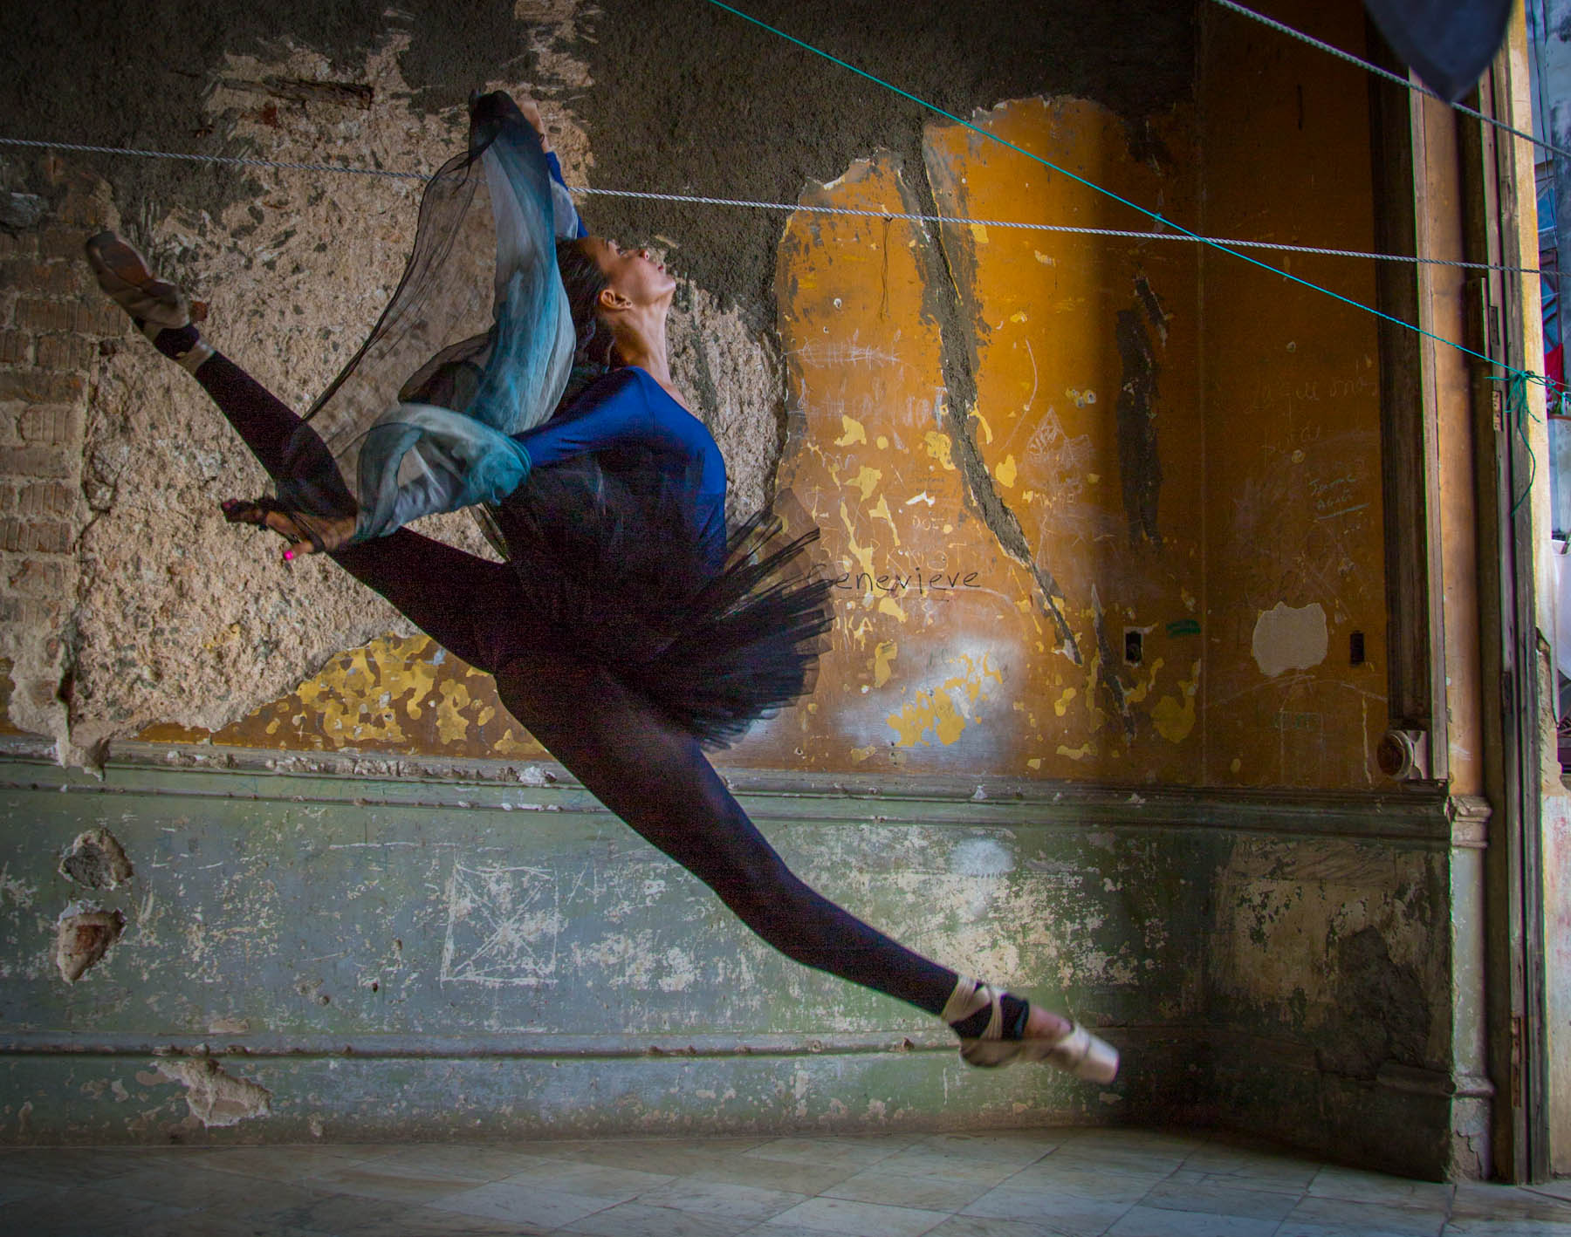

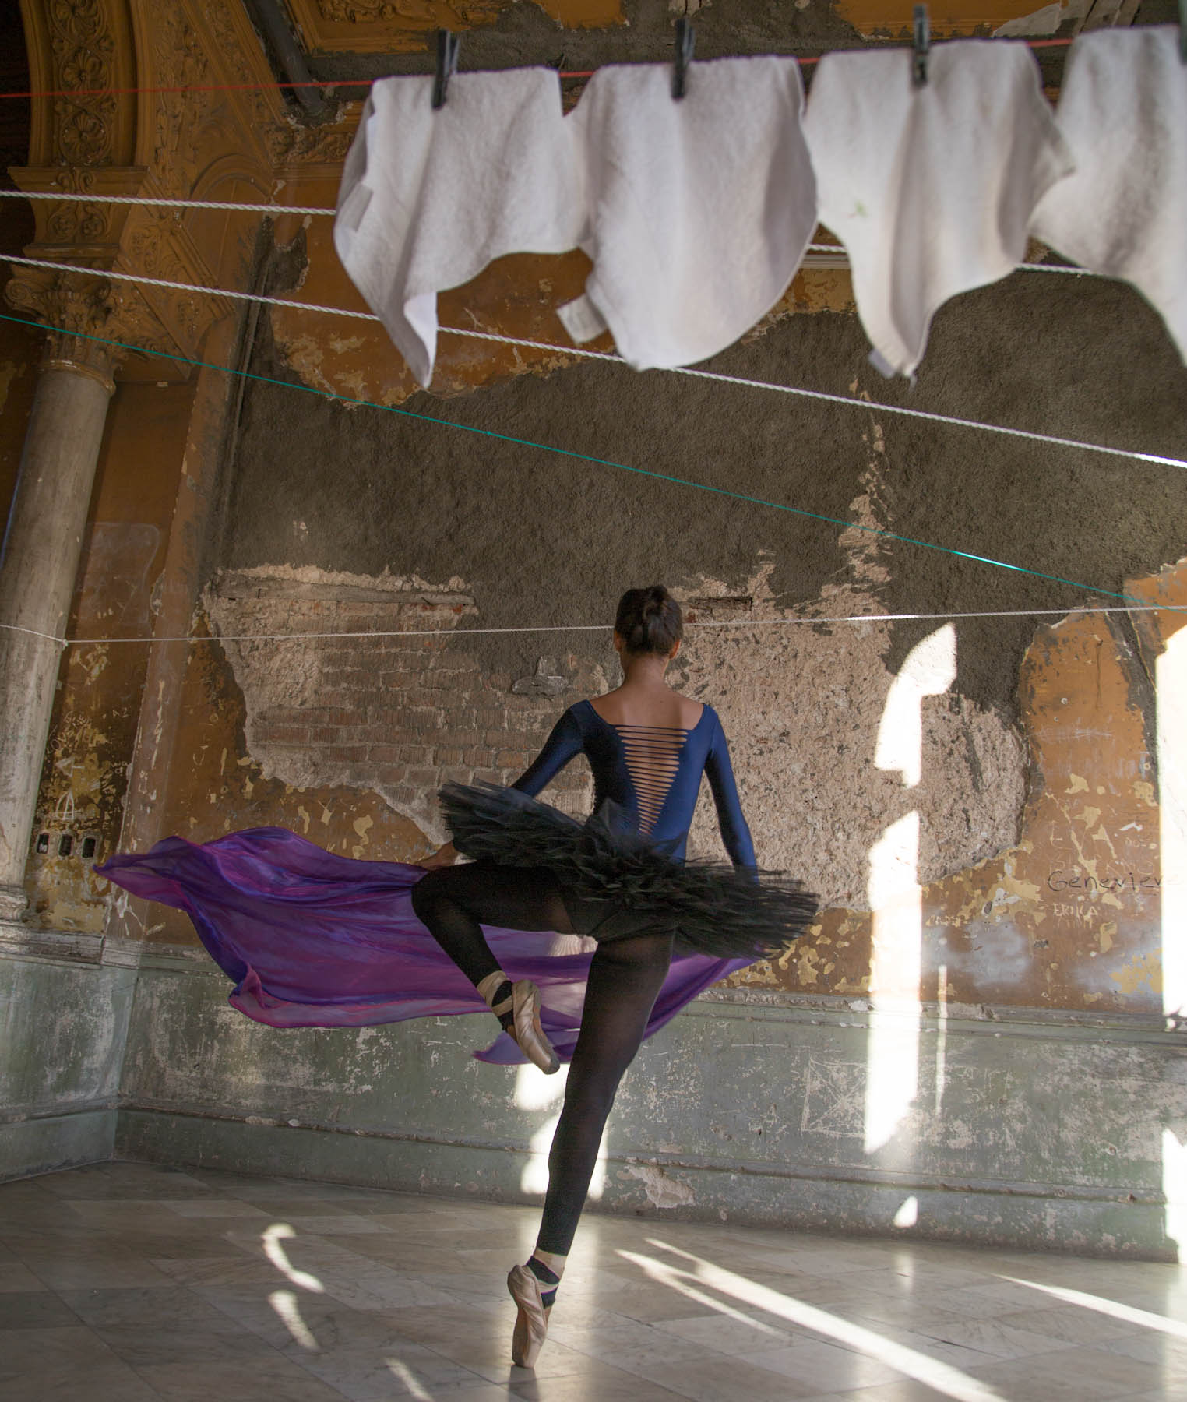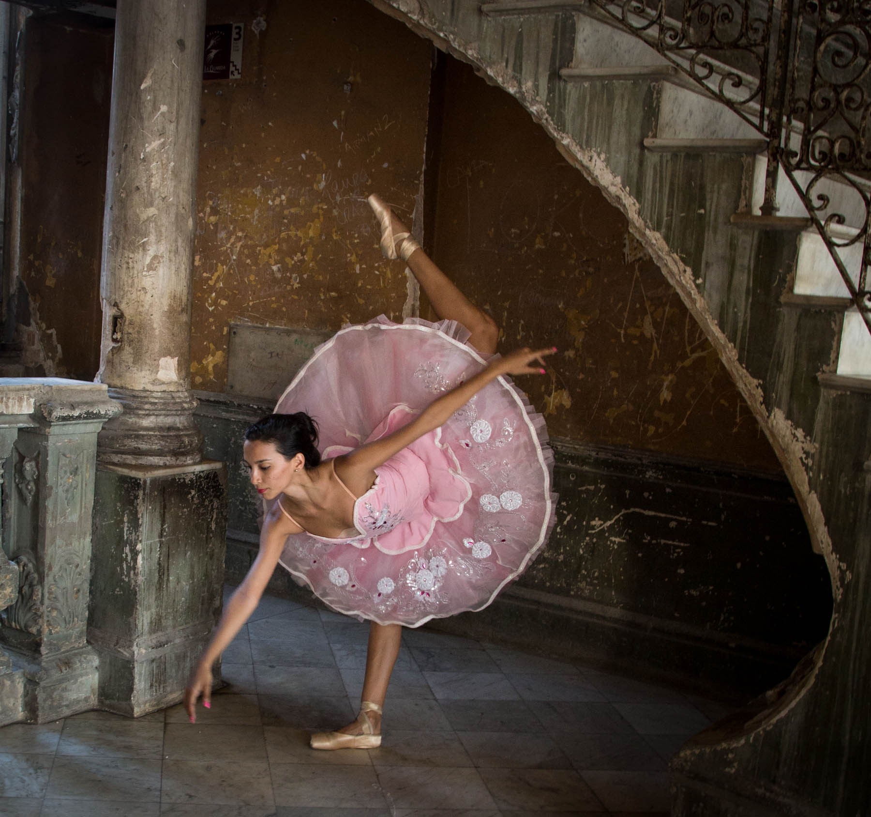

I chose this photograph to use for my art. I love her toe pointing on the stair. I took some creative license and added a translucent image of her putting on her point shoes to the photograph. I wanted to show her preparations for dance as well as her performance.

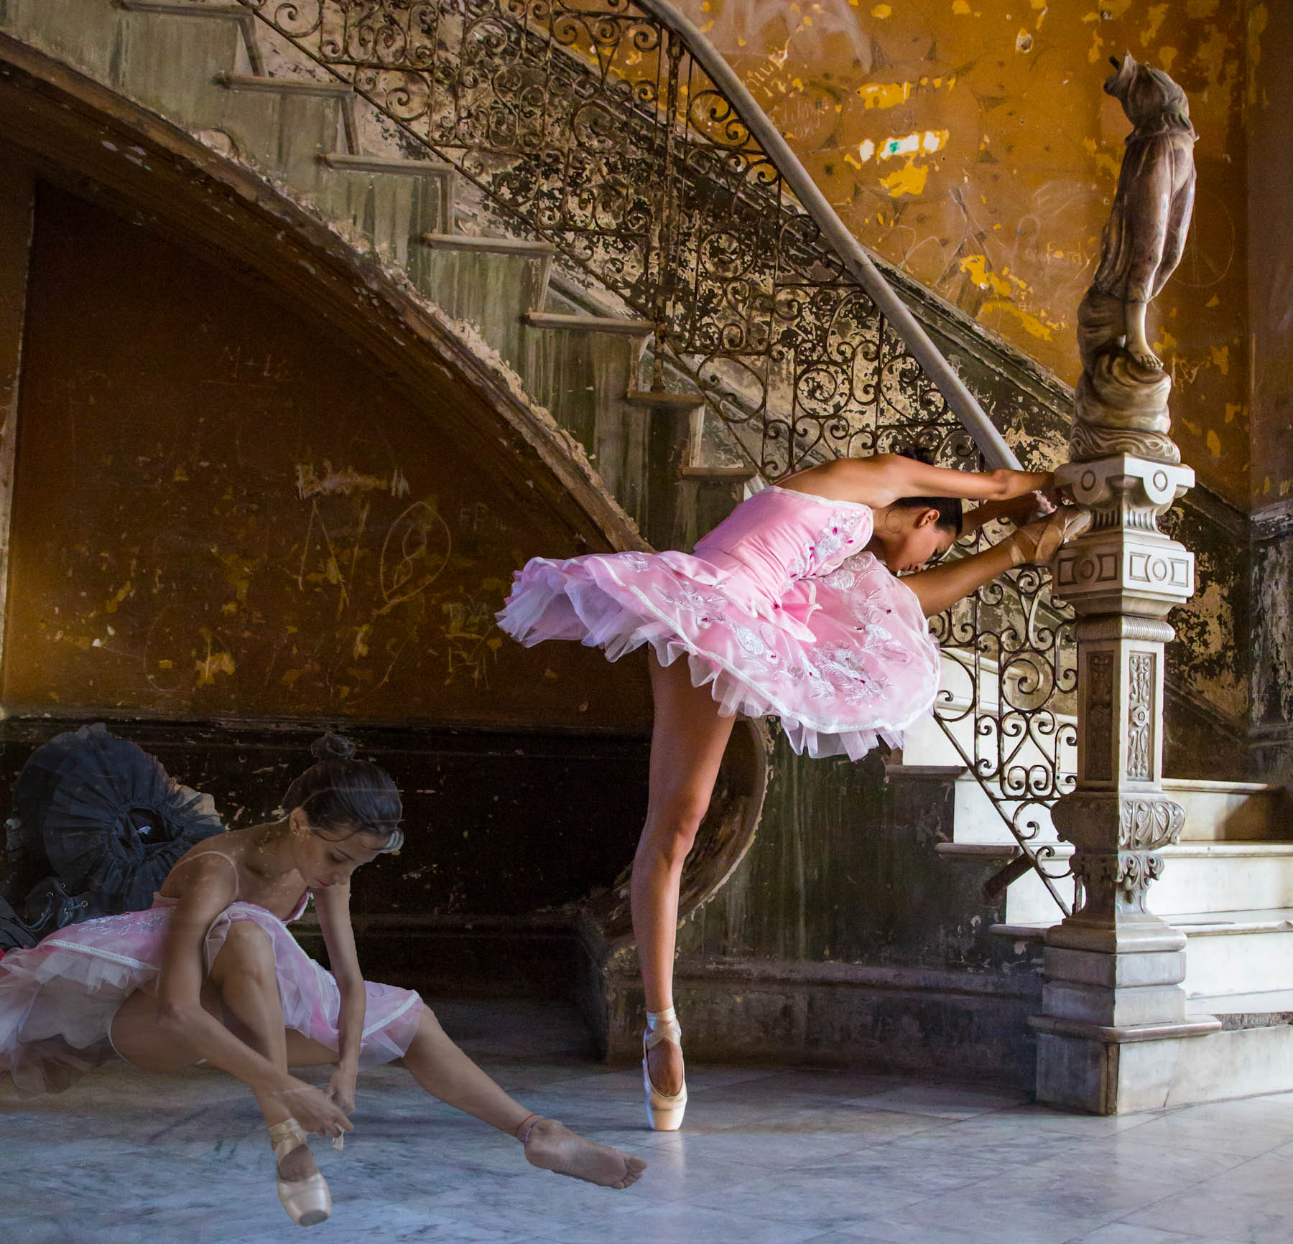

The following is a step-by-step photographic journey that shows how this evolved into a piece of art.

The first thing that is required on any project using the Thread stories technique is to audition threads. This means selecting threads that match the coloration of the photograph. I do this by laying the threads over the areas to be stitched. Many threads are analyzed before the correct thread is chosen. I have already stitched two colors of thread on her leg and will add two more that catch the light reflection.

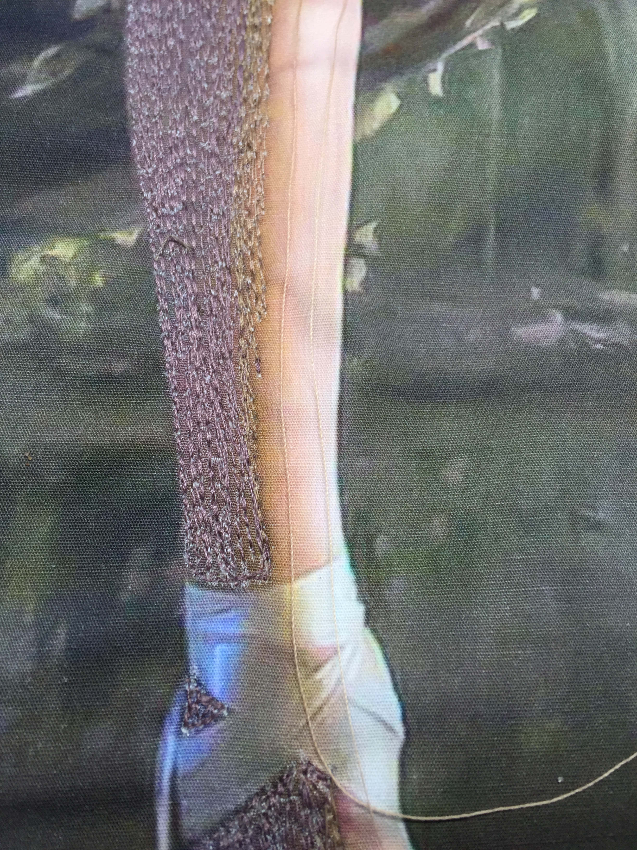

Her finished leg includes eight thread changes. From the shadow on her thigh to the lightest color on her shinbone, the colors gradually become lighter and are blended almost seamlessly.

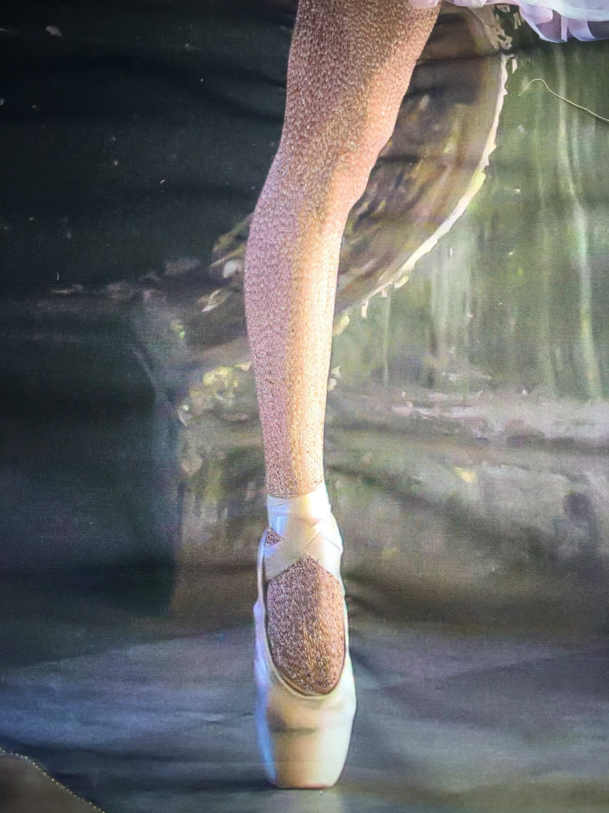

I always choose a section of the project to start on, and then work my way out from that point. I wanted to finish the ballerina first and chose to begin on her leg. The next area to be stitched is her dress.

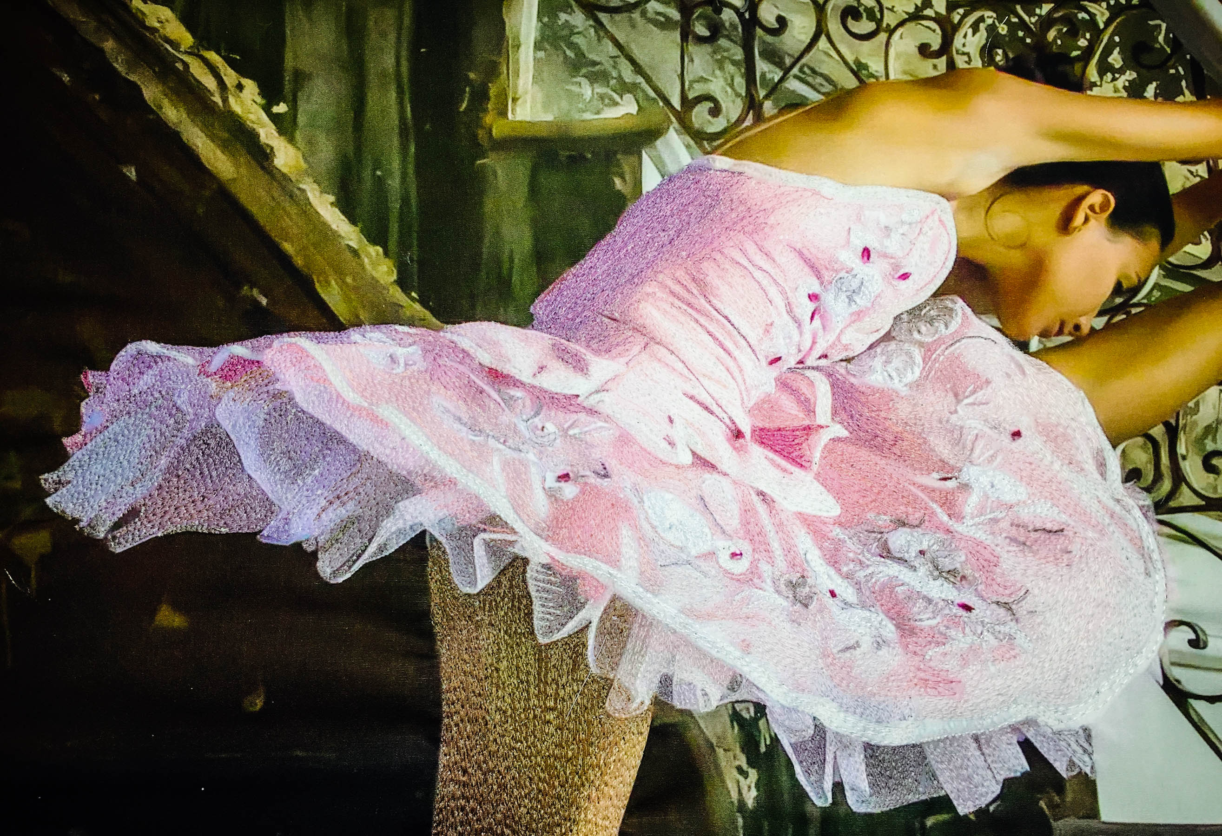

Her dress is a fantasy of pink satin, jewels and tulle. I stitched the dress in 16 different colors of thread. This took hours, changing threads constantly as I moved from her leg towards her bodice.

I chose to stitch fairly lightly, letting the color of the photograph come to the fore in several sections. In the photograph below, you can see the pink area to the right of the central flower has only a few stitches of a darker pink thread. This gives movement to the area, but allows the lighter pink to be seen. This also “tricks” the eye into seeing a third color when the viewer stands back. I could have covered this portion of the quilt entirely in thread, but by stitching in this manner, there is a three dimensionality that adds to the finished product.

I also left a lighter pink area above the flower without stitching. I could have added another thread color here, but this allows the fabric of her dress to become almost translucent.

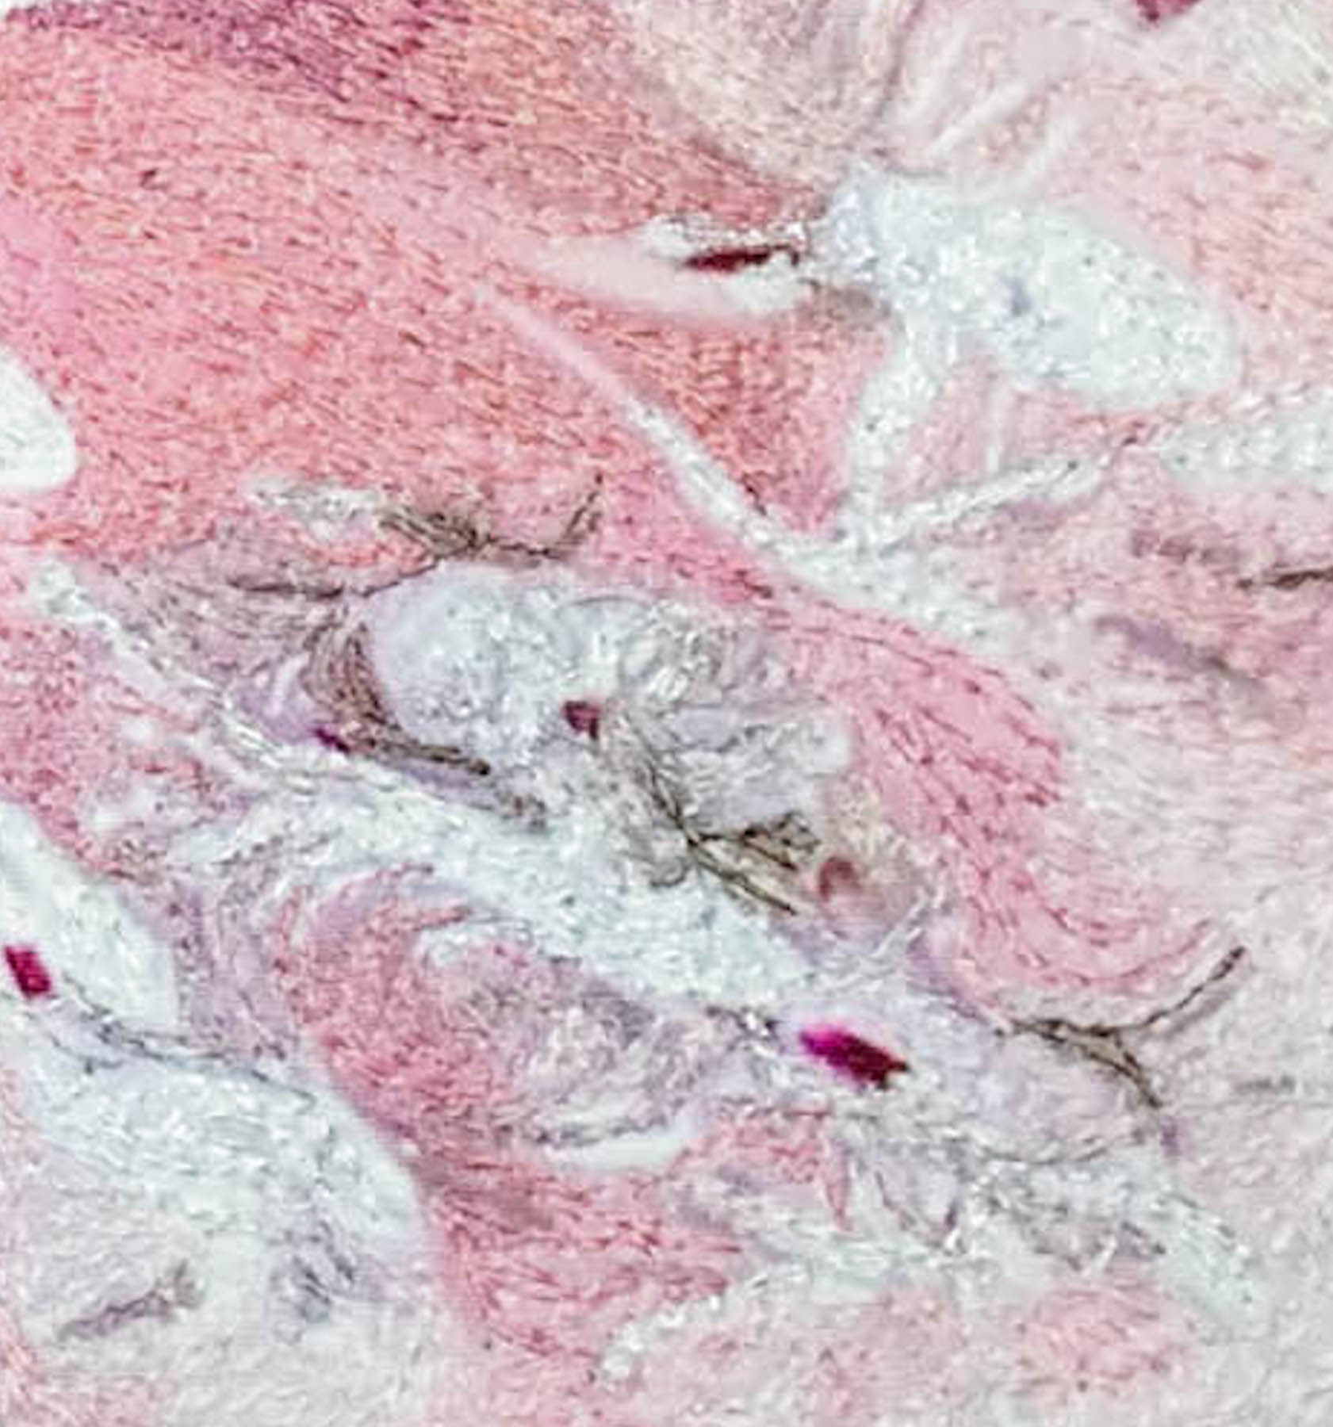

As you begin the sewing process, it is important to analyze clothing to determine if you want the fabric of the clothing to be an important part of the story – covered completely in thread- or if it is a supporting theme. In this case, the dress is almost as important as her movement as she dances, so I left wisps of the cloth without thread.

The tulle under her skirt is naturally, semi transparent. I used 17 different colors of thread in this small space. Yes, this drove me a bit crazy as I changed threads at least once every few minutes, blending the tones of color in her skirt. The direction of the stitching creates a flow to the fabric that simulates movement as she dances. The white horizontal lines near the right of the photograph emulate the texture of the tulle.

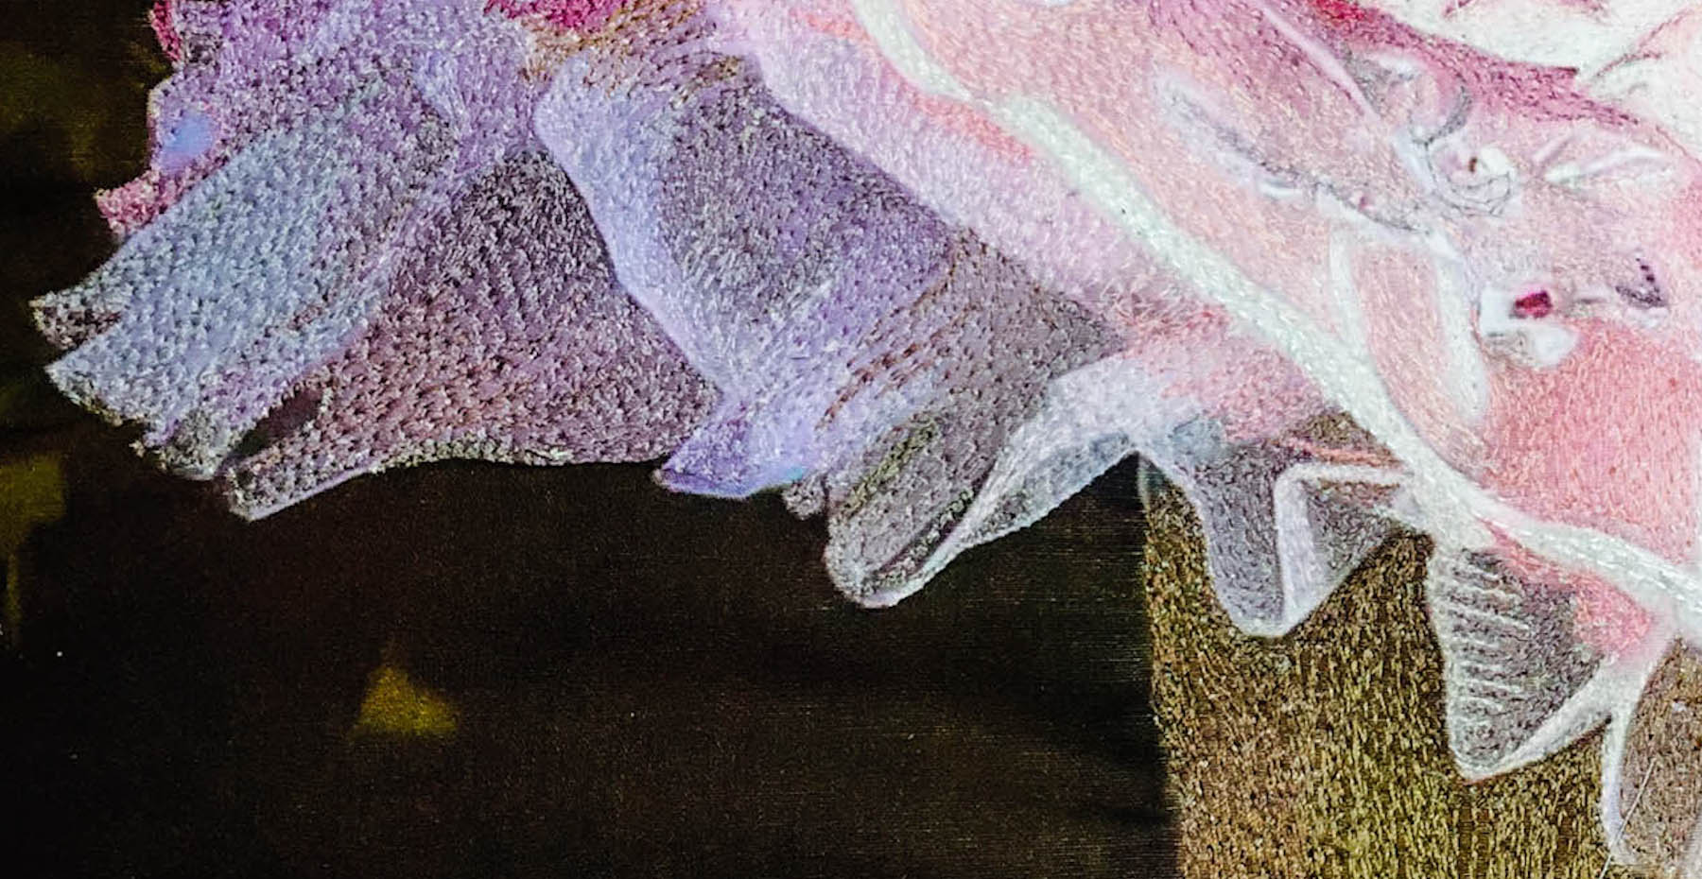

These are the colors that I used in the ballerinas dress. These 19 colors of thread have very minute gradations in the pinks and purples. If you were to try to create her dress using threads purchased from the quilt shop, you would quickly become frustrated. That is why I use the Gutermann Mara line of threads. These threads were created for the garment industry. You can purchase these on line from a notions company by the name of Wawak. I use the Gutermann Mara 100 – 40-weight thread or Gutermann Mara 70 – 30-weight thread. These threads are very inexpensive and are available in 1,000-meter cones. I have all 692 colors in my thread “paint box”.

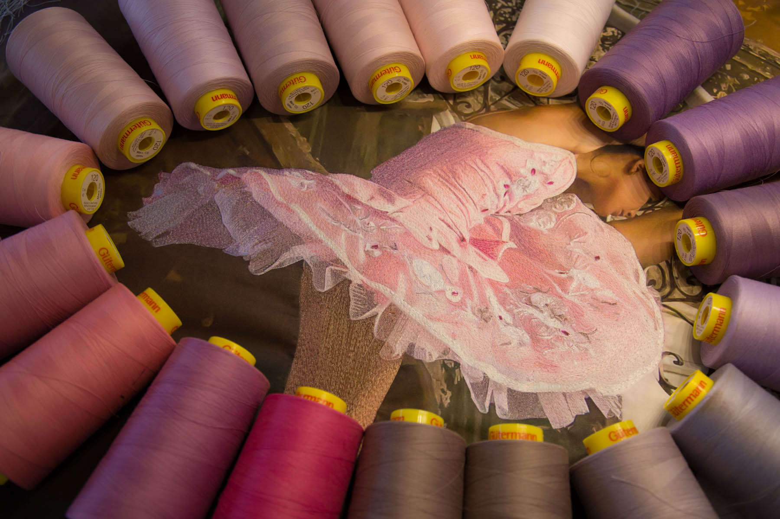

Now that the dress is complete, it is time to work on her arms and head. The technique of covering her arms and face with thread begins with stitching the dark threads first. I began with the shadows on her upper arm. I completed her upper arm first, and then moved to her face, hair, her second arm, then and her leg. I did this in this order so as not to create “pockets” of unstitched fabric that can become an area that has wrinkles when it is time to cover them in thread. Wrinkles can become a problem if they are not heavily stitched. They will attract the viewers eye unnecessarily and detract from the overall art.

I finished the dress, then chose to add more threads to her face, the arm behind her head and the point of her shoe. It is impossible to finish all of the areas as they are stitched in progression. It is important to stand back and view the quilt in its “finished” state to determine the areas that need additional attention. I smoothed the skin tones on her arm, adding a bit more color to give her skin vibrance. . Additional threads added to her jawline softening her skin and creating a glow to her face. I also added a shadow at the point of her slipper to give definition to this area.

Now that the ballerina is finished, I can begin to thread the staircase behind her. This was a daunting task since there are so many colors in the wall behind the stair rail. From greens to tans, gold’s to yellows with the stair rail bisecting the colors to create a ménage of textures. This section of the quilt took hours to complete.

My first step was to audition the threads to determine the best color of green to use. Green is the darkest color in the area behind the ironwork. I chose not to thread the ironwork in this quilt because there are so many colors on the iron and the color of the metal would appear messy if covered in thread. By not threading the iron, the ironwork has the texture of a whole cloth quilt, adding another dimension to the art.

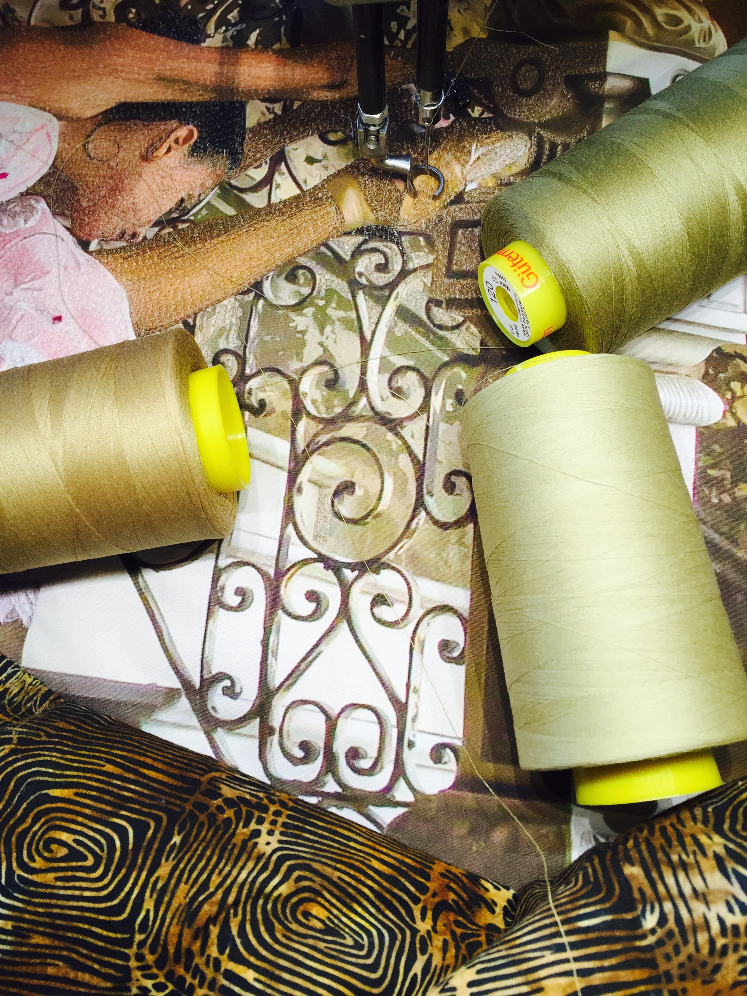

It is amazing how thread colors can trick the eye based on the color of the photograph behind the thread. I used two colors of green thread in this area of stitching. A dark green in used in the darkest area. The thread appears dark when stitched over a dark background and lighter if stitched over a background without color this is seen in the lower left area of the photograph. This will help you finish the project faster since you will not need to change threads so often.

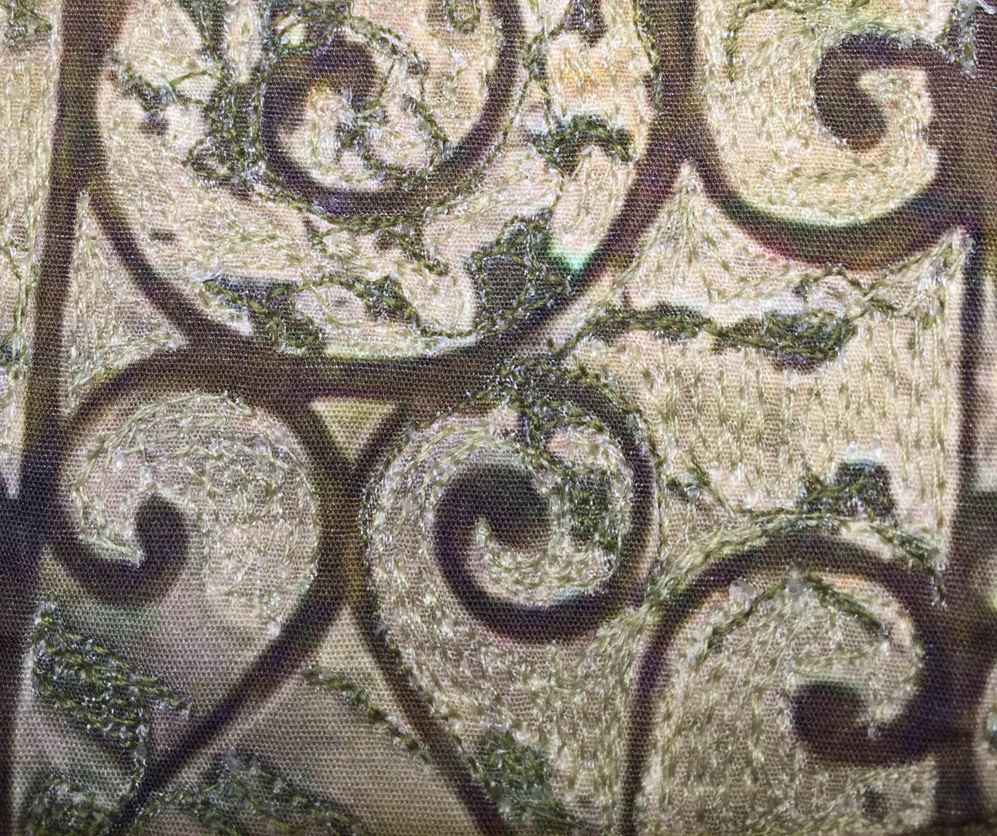

The ballerina is finished as well as the staircase behind her. This creates an almost eerie image. The next step will be to finish the stature and the stairs.

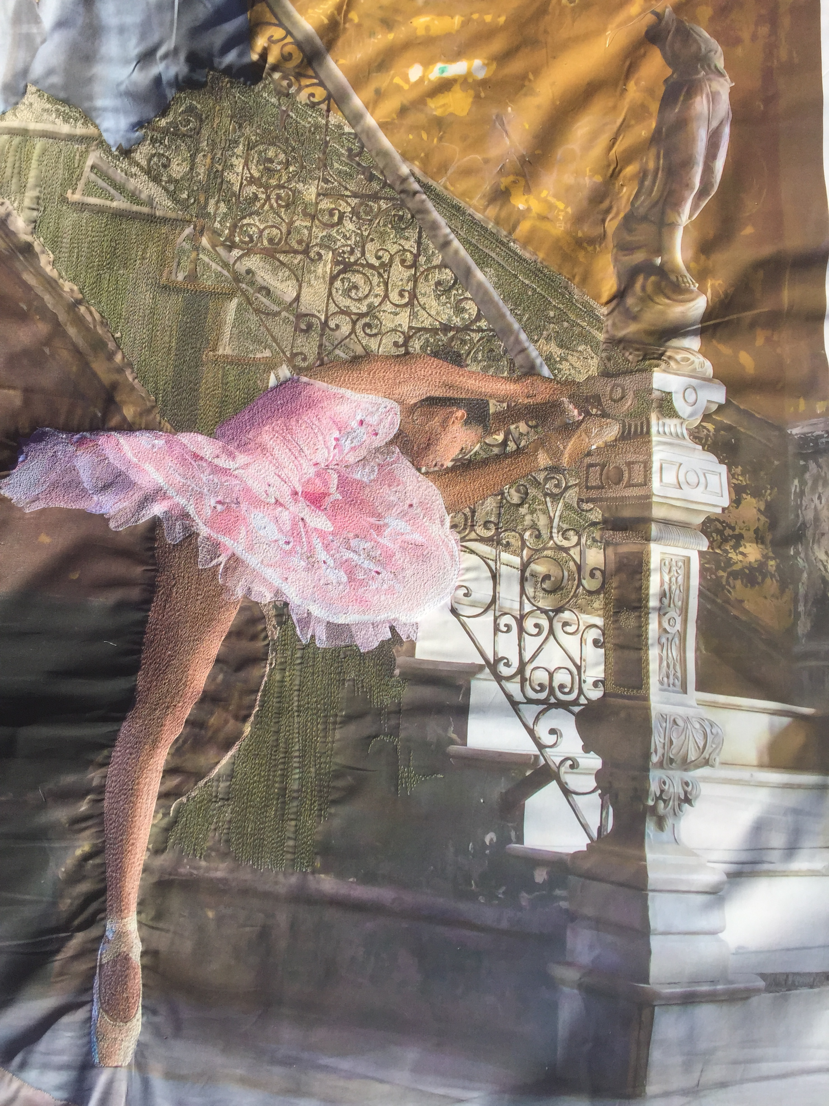

The statue has seventeen colors of thread covering it. Blending is certainly the key to creating this part of the quilt. One of the keys is to maintain the light on the subject. In this case I used seven colors as contrast to the darker colors to bring to life the light on her body.

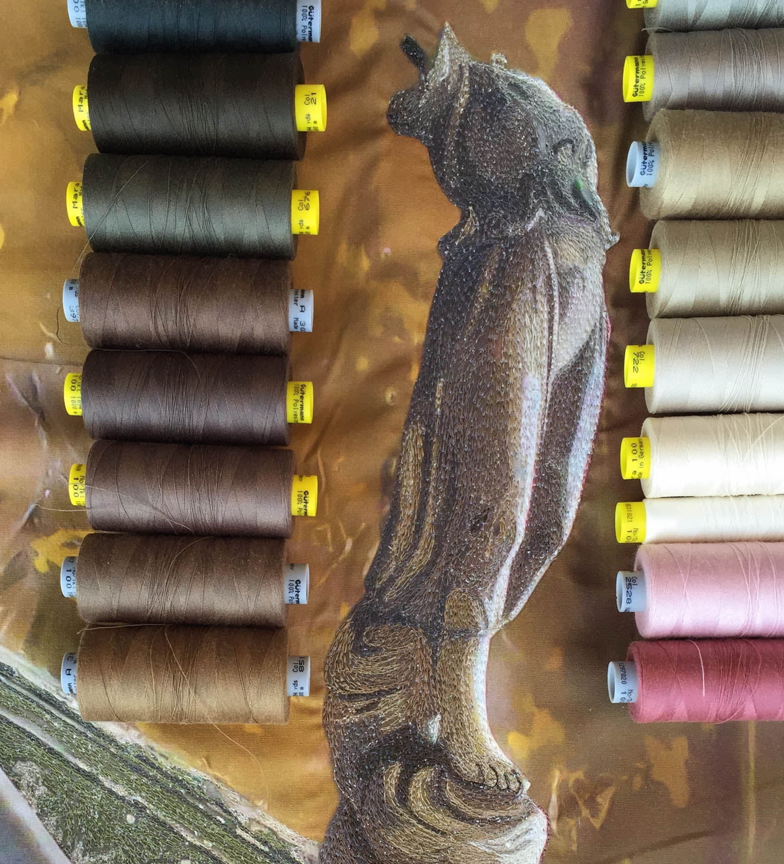

You can see the contrast between the light and the dark I the curves of her bosom and thighs. You need to look closely to see the subtle shading between colors. The seventeen color changes in a space of only five by seven inches is breathtaking in its final form. I left the small area of green below her bosom without thread to give a feeling of translucence and movement in her clothing.

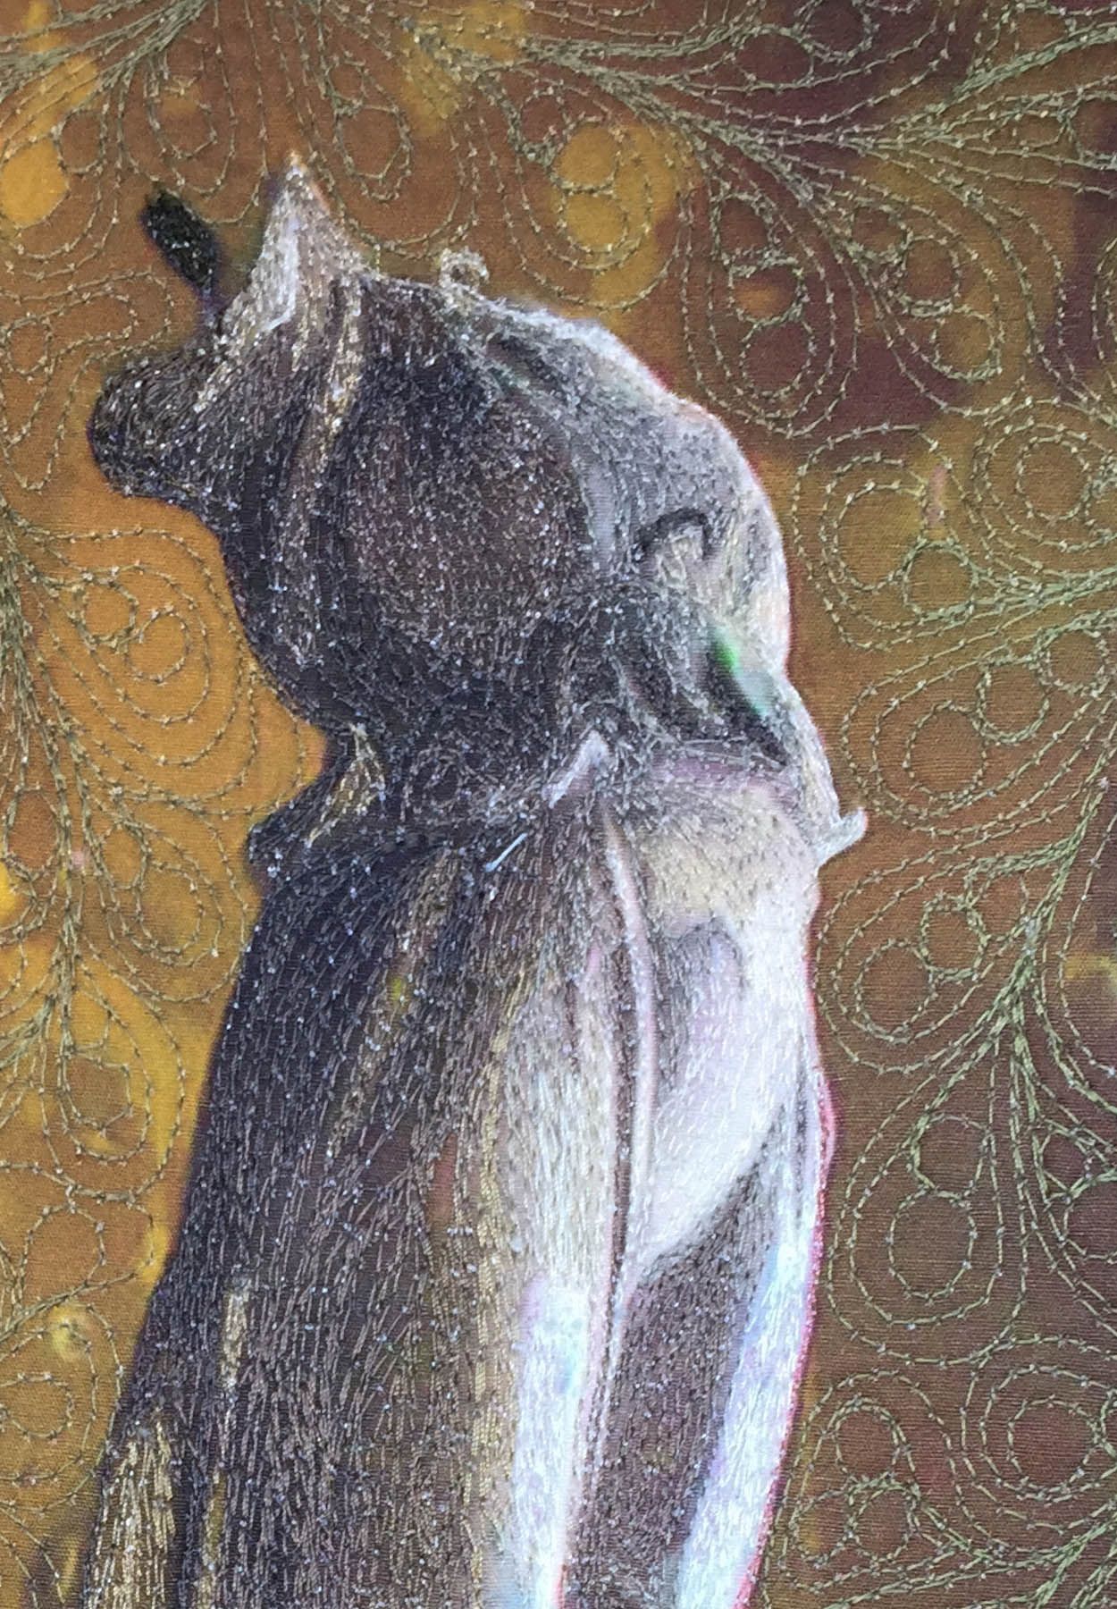

The blending of threads on the cloth napkins hanging on the line in the grand hall begins with stitching the shadows on the linen first. Always begin from darkest tone to the lightest. The threads will mimic the coloration of the photograph behind them. I chose to cover the napkins with thread. Creative license could have been taken by leaving an area unstitched. This would show a natural ripple in the cloth. Other areas of the quilt should also have a similar technique applied or this area would capture the viewer’s eye as a distraction.

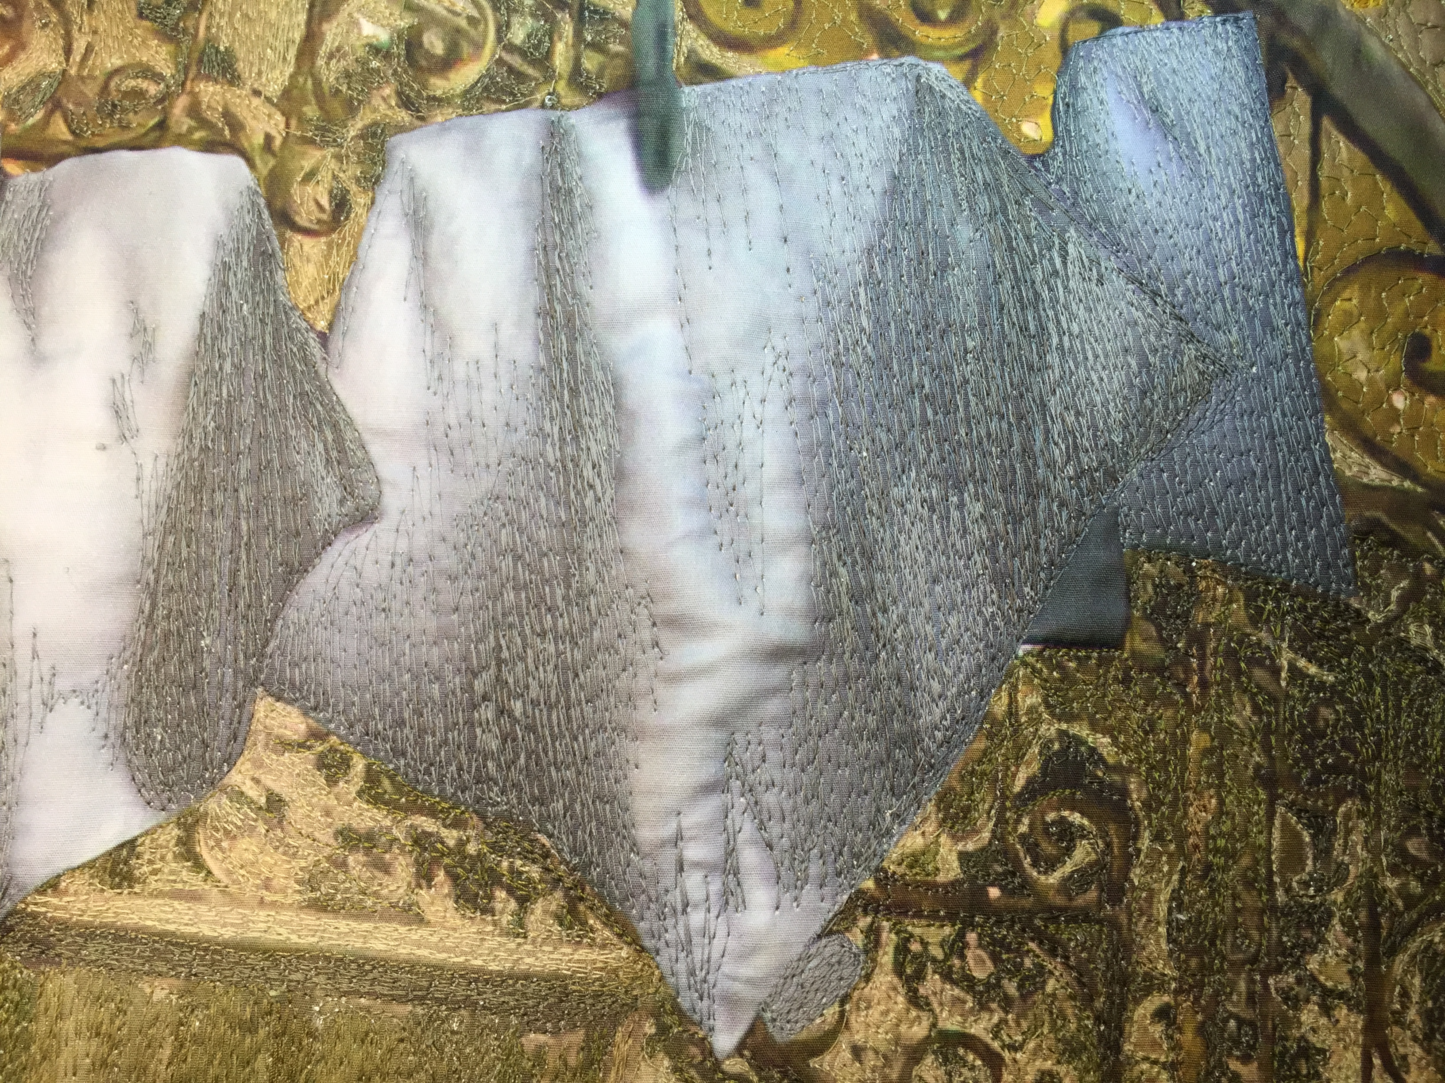

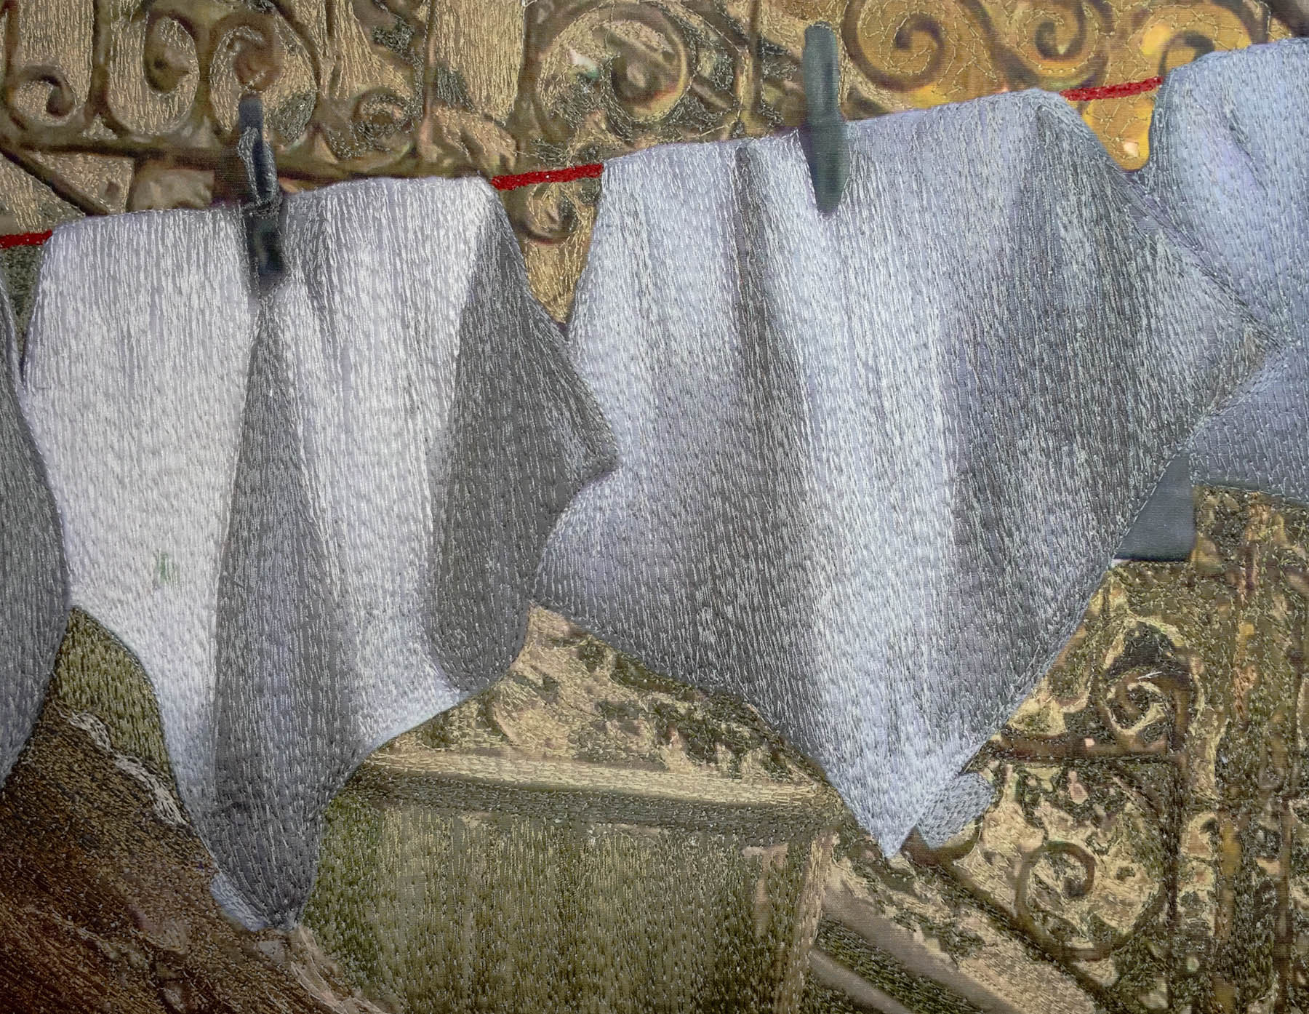

In its finished format, the napkins have wonderful shadows created by the light from the open window in the room. They almost seem to be swaying in the breeze.

Next I will begin to thread the ballerina sitting on the floor. This is the same young woman. I used a translucent image of her, placing the image into the original photograph via Photoshop I wanted to show her preparing to dance as well a dancing. Her image is portrayed in softer, darker tones, allowing the viewers attention to be drawn to her dancing with this image as a footnote.

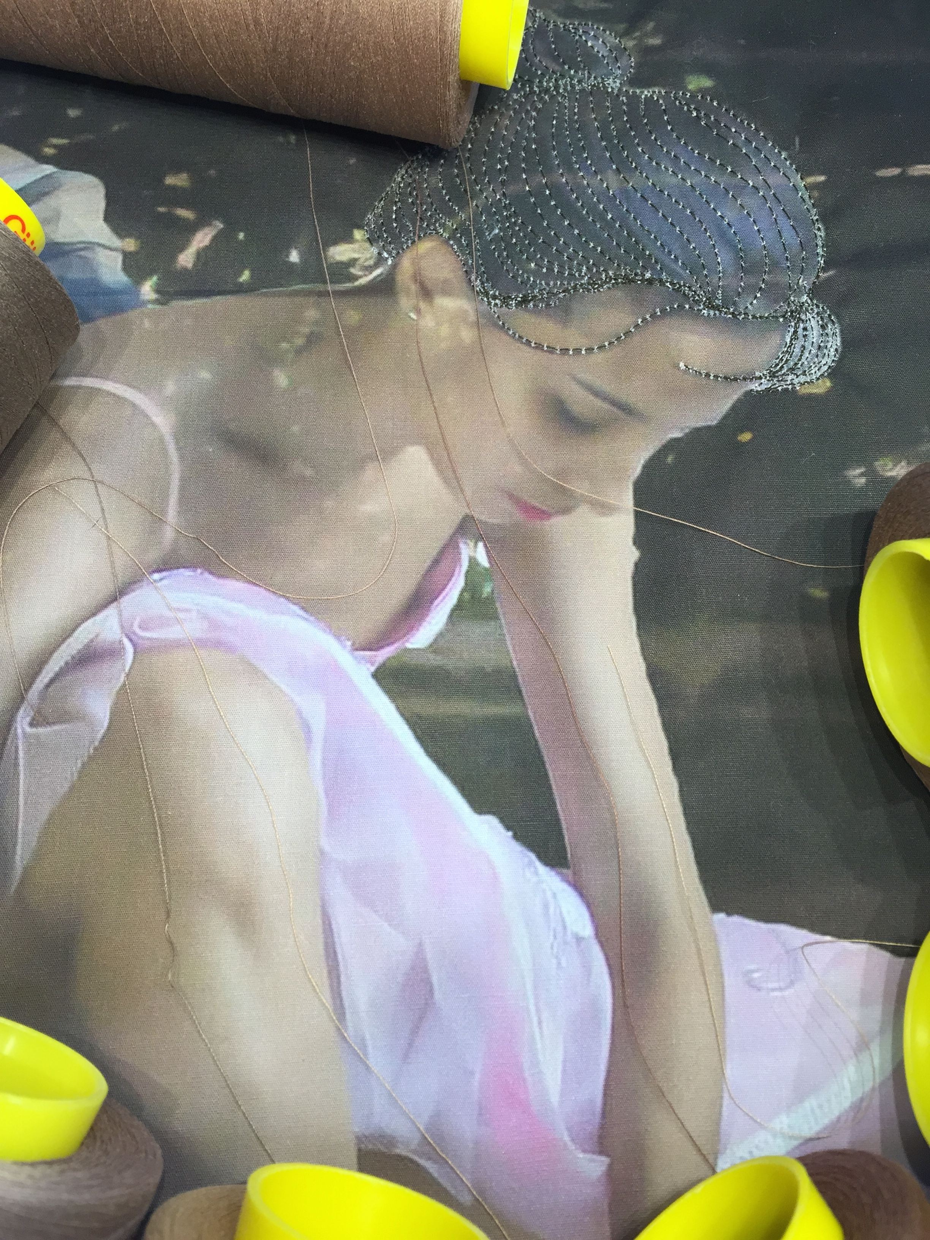

Again, the first step is to audition threads.

I chose seven threads to be used in the creation of her skin tones. There is a minute gradation of color between four of these. This gradation is important in the Thread Stories blending technique.

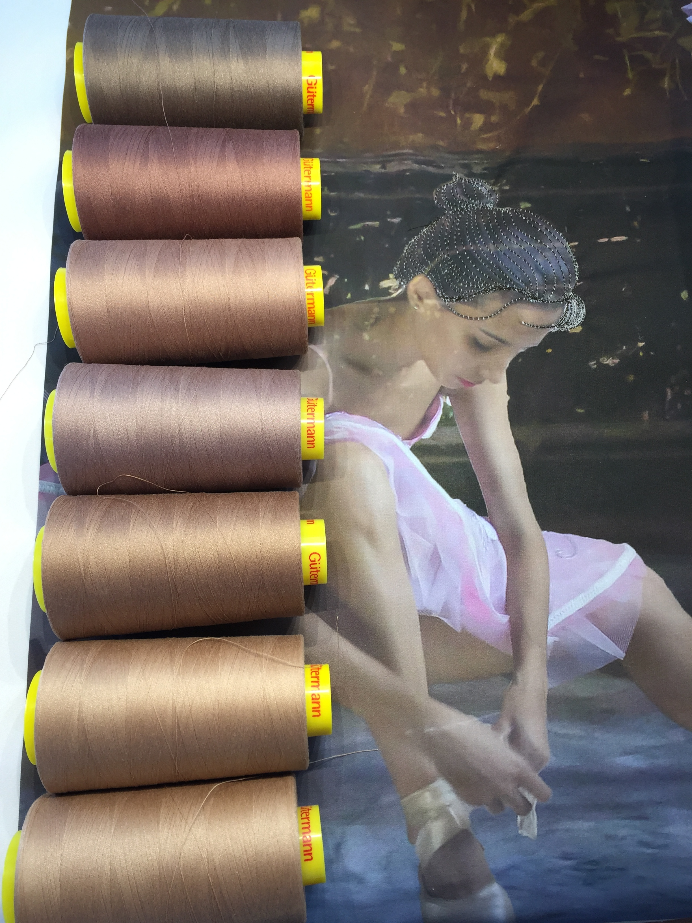

Many times, outlining your subject can be the best approach. I did this using each of the seven colors. This allows me to see where the colors start and stop in the process. This also gives you a stopping point along an edge that needs to maintain color differences. The line between her arm and thigh is critical to determining what colors to use in this area for separation of skin tones. This will also make your job easier when you reach for colors to use in a specific area. You will easily see the thread to use because it is already in place on the quilt.

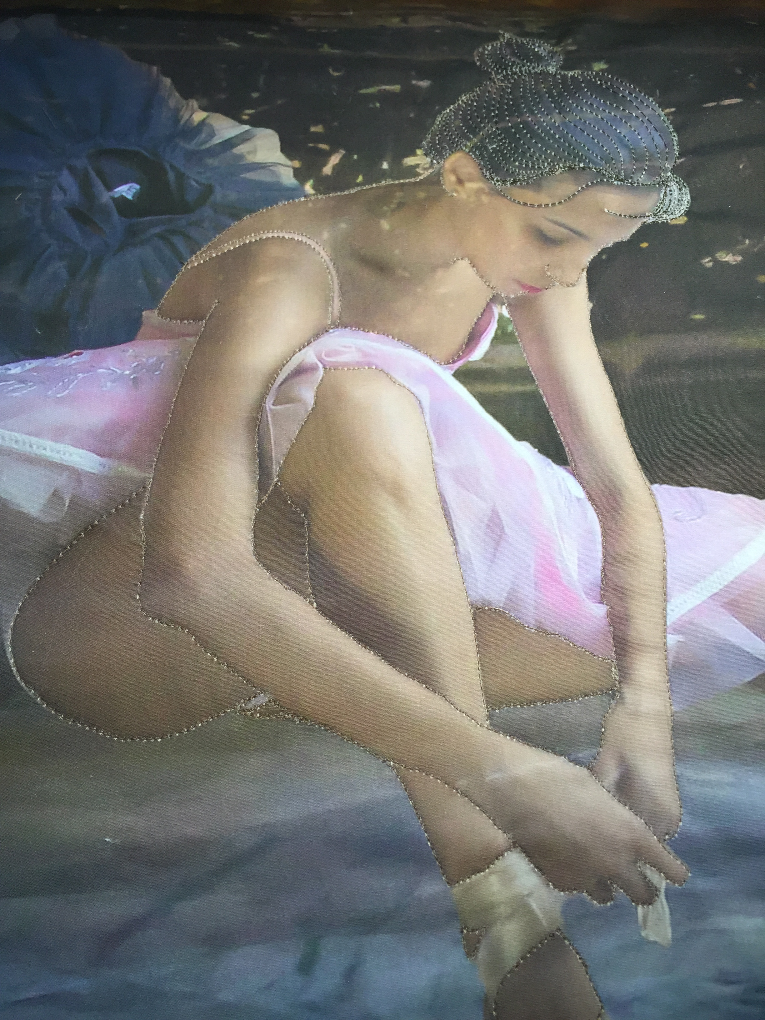

I have applied all of the threads to her skin in this image, but there is still some smoothing out to be done on her chest. I have stitched the lighter thread over the darker one, but it is splotchy. This happens often in this process. Sometimes you will need to add the darker thread over the edges of the lighter thread to smooth the transition.

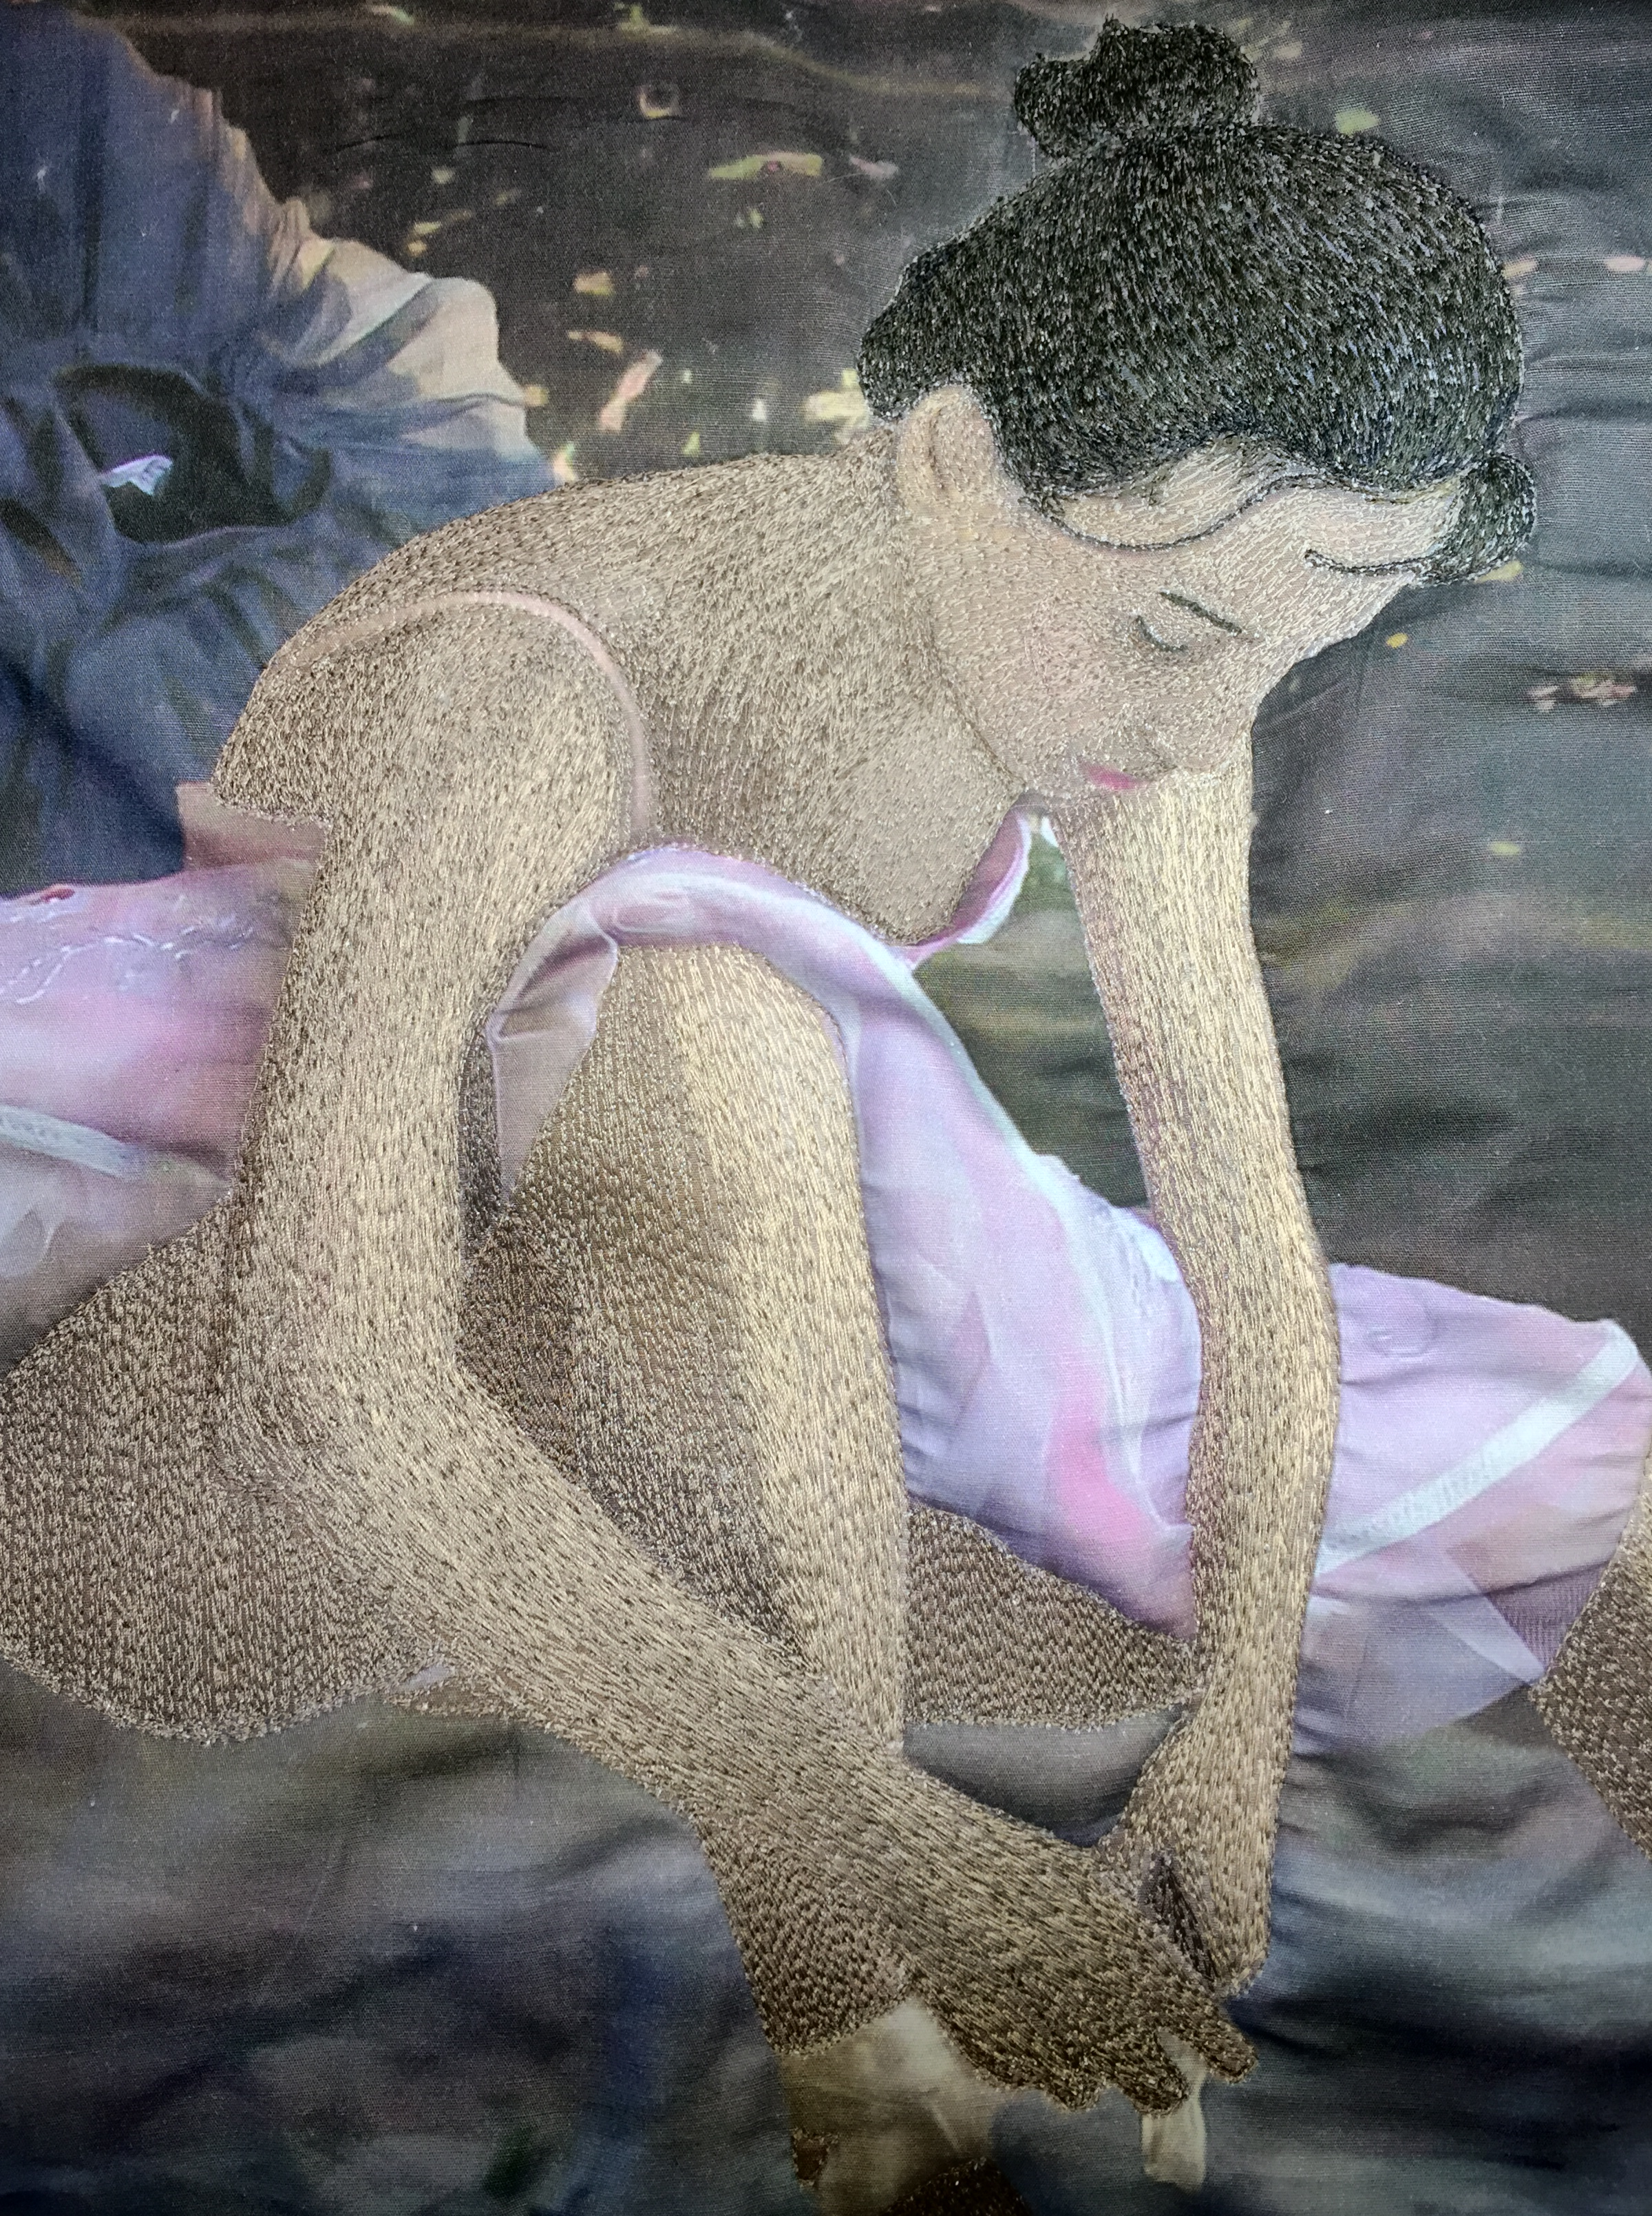

I have added that darker tone as well as some more of the lighter thread in this area to give a seamless appearance to the finished area.

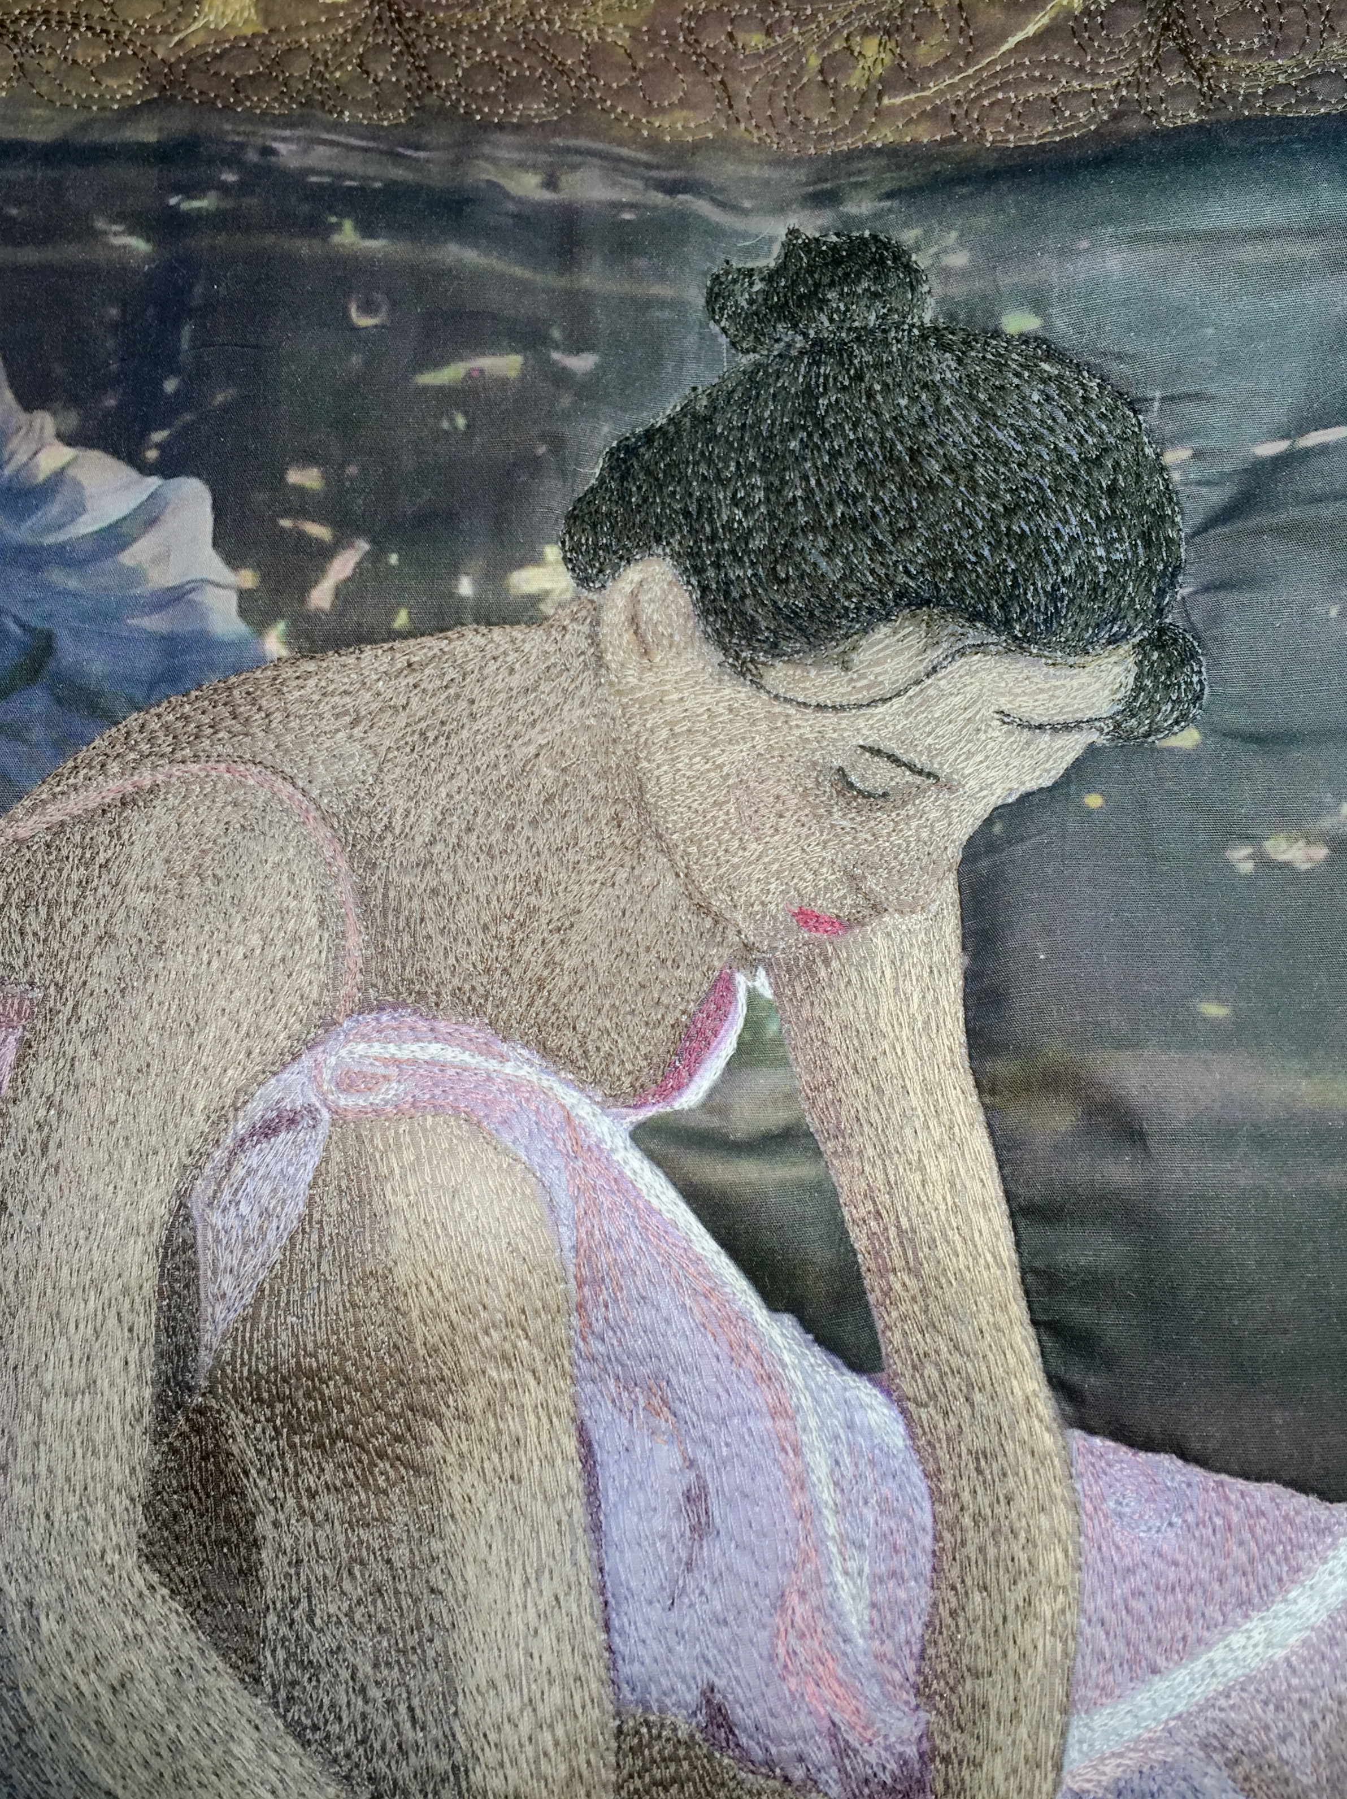

Now it is time to give some sparkle to her complexion. It is too late to add a blush to her cheek in thread. This should have been done before stitching her cheek. Now it is possible to add a bit of make-up to her face, giving her a glow. It is important to add only matte tone make-up. Any colors with sparkle will be a problem in flesh tones. I have used eye shadow on quilts to blend areas of color. If you block your art using water, you may have to reapply the make-up as a final touch to your art.

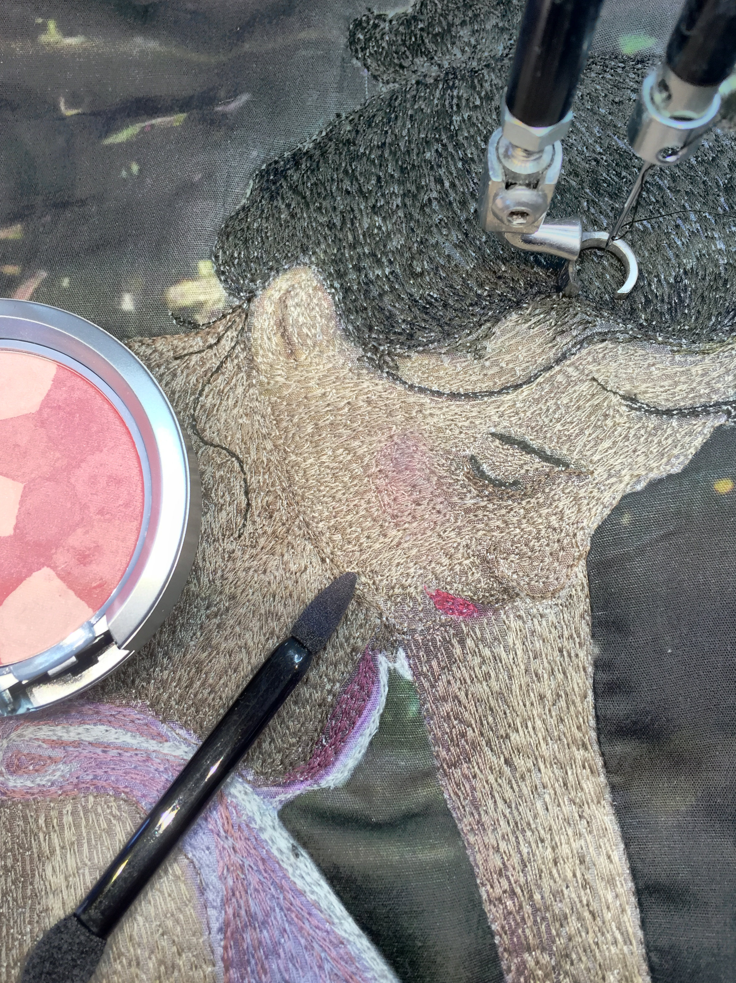

I also will use a sharpie or Identi.pen to cover those annoying white spots left in areas of very dark thread. You only want to brush this black ink over the area to be addressed. It can leave very dark blotches that are hard to correct if applied with a heavy hand.

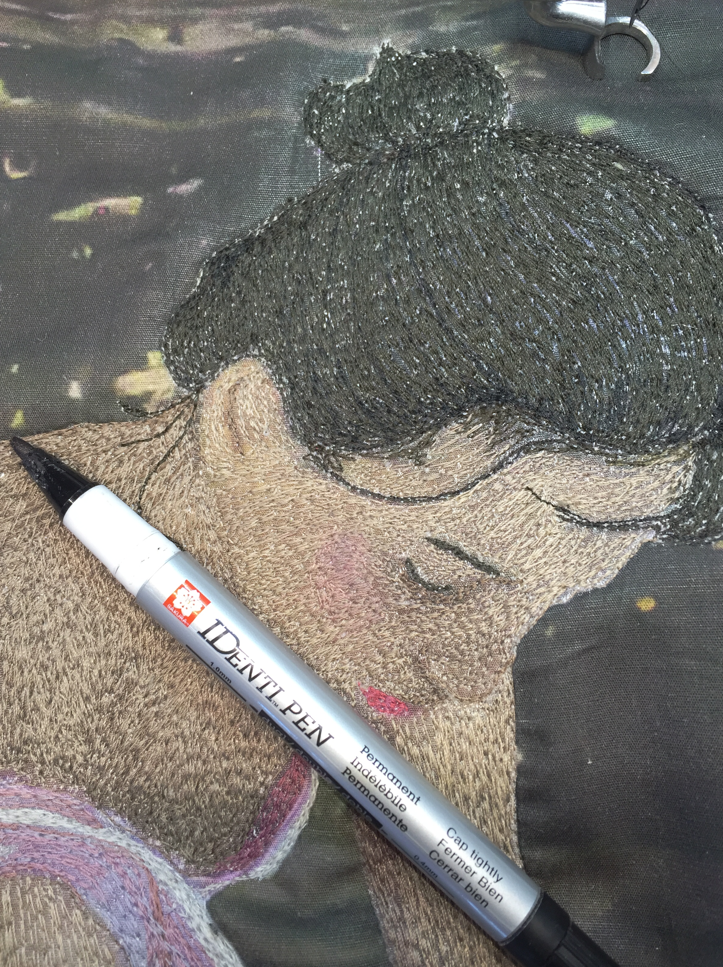

The last area that needs to be addressed is the marble floor. The floor is made of large square pieces of marble. I chose to accent the grout lines on the floor with a soft gray color.

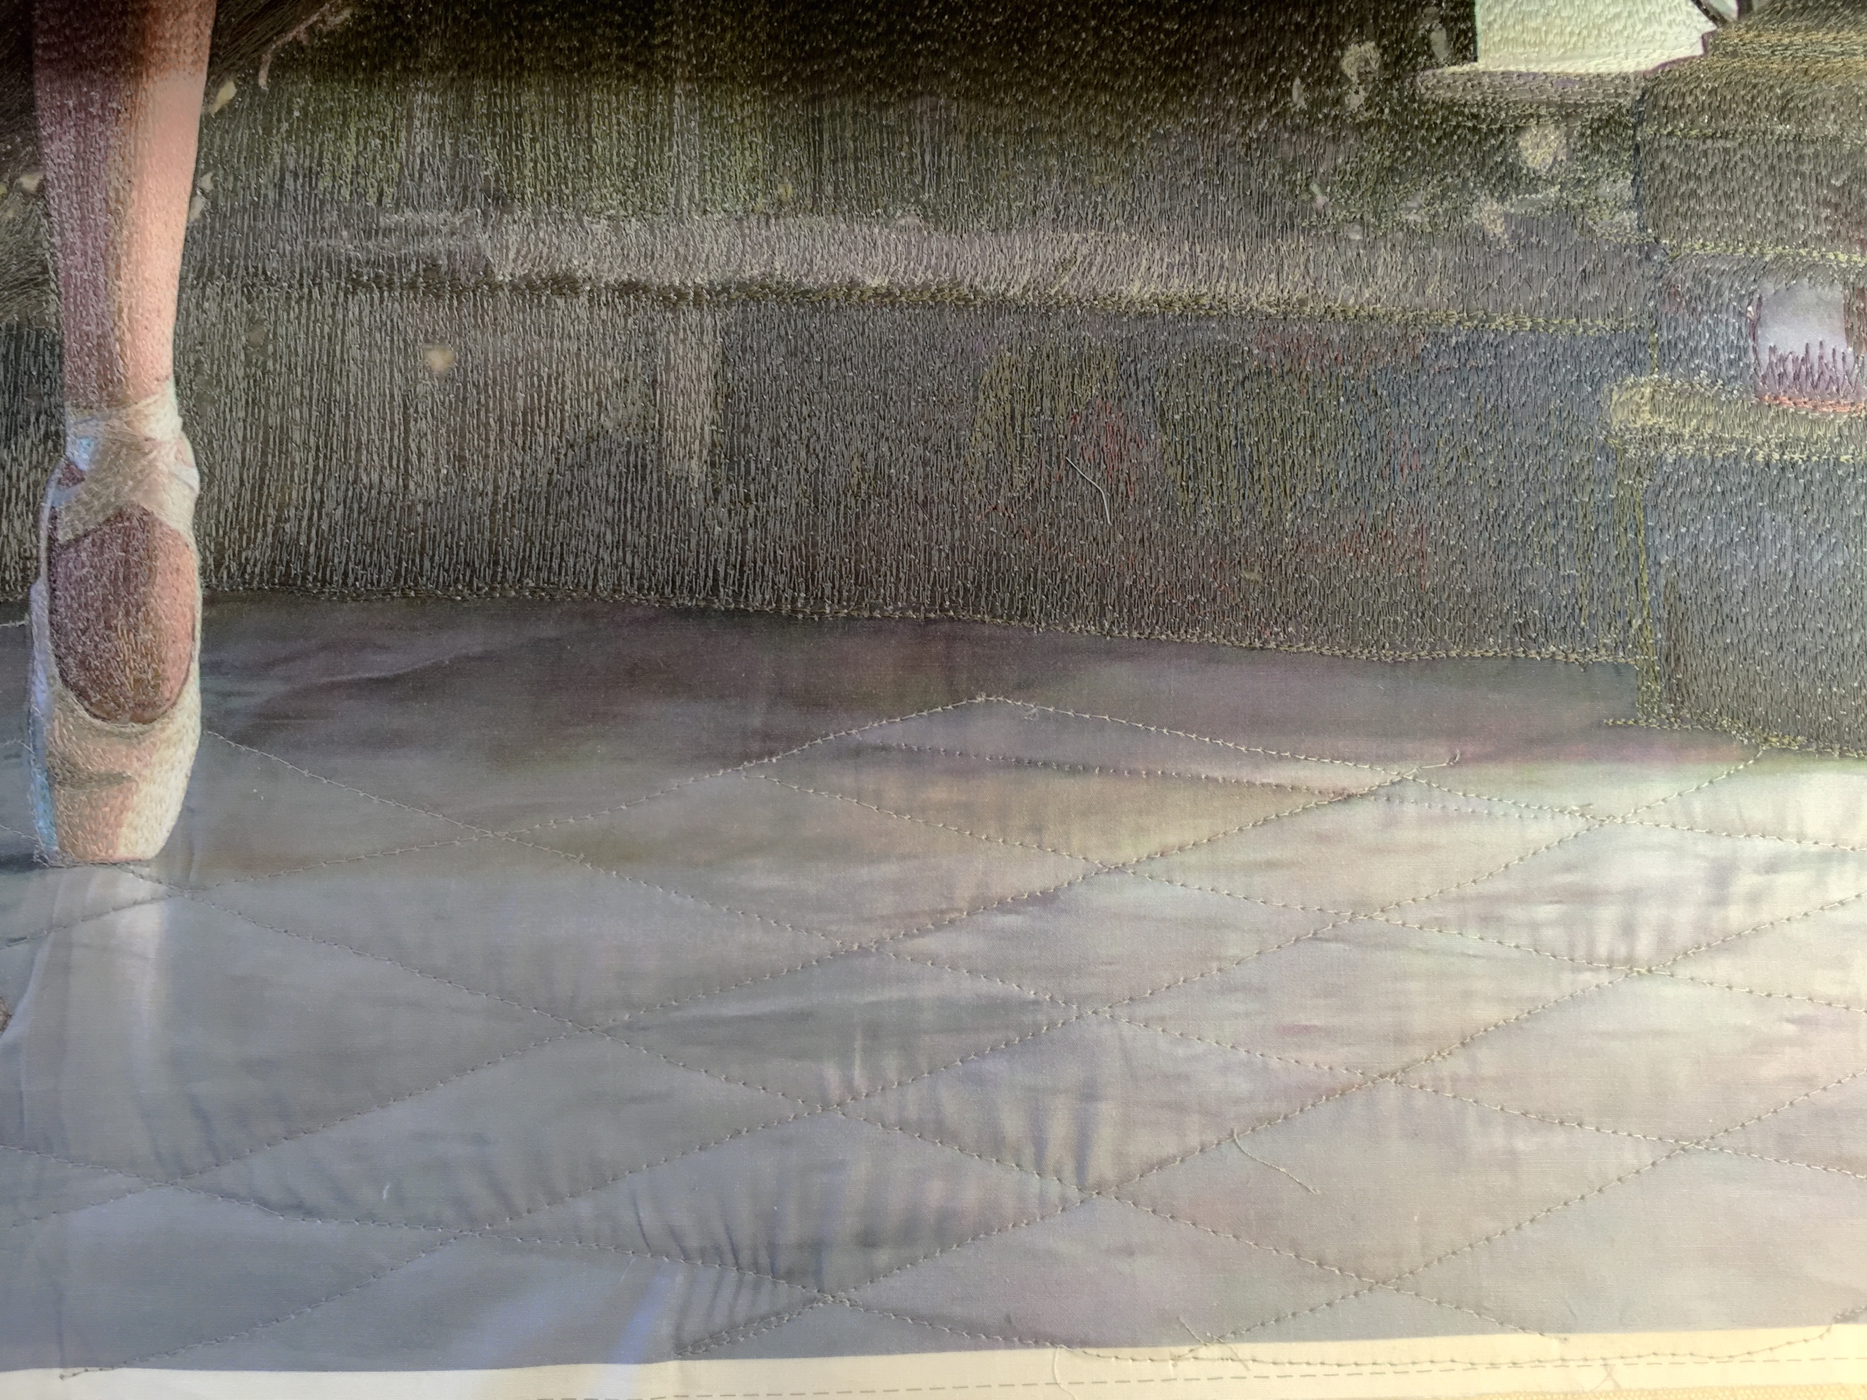

I then filled in the floor surface with very small stippling. The camera angle has accented the direction of the grout lines on the floor giving an almost fluid finish to the photograph. By adding the stippling, the floor becomes one with the ballerina, graceful in its movement.

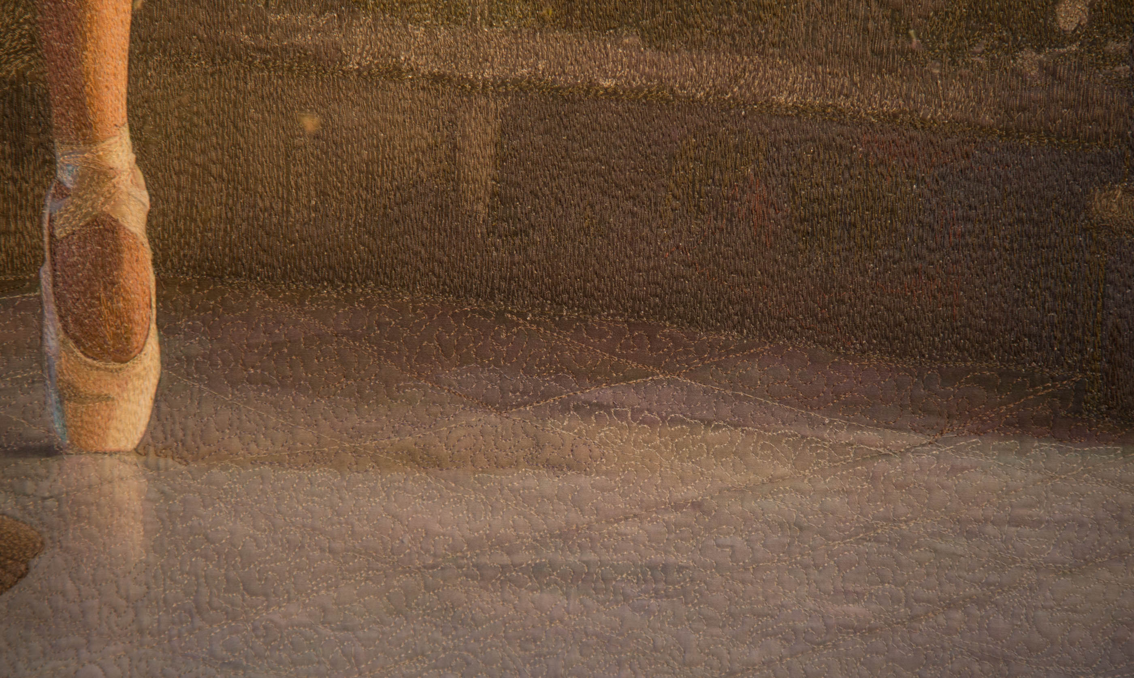

This process of analyzing the art from beginning to end is useful in telling the story of how it is made. From the first steps of auditioning threads to the last stitch on the quilt; the process is filled with nuance. Blending is the key to this technique. Starting with a dark color in the area to be sewn first is the main idea. Continuing to add lighter threads, softly feathered over the dark threads already in place, will help you create a seamless finished image in thread.

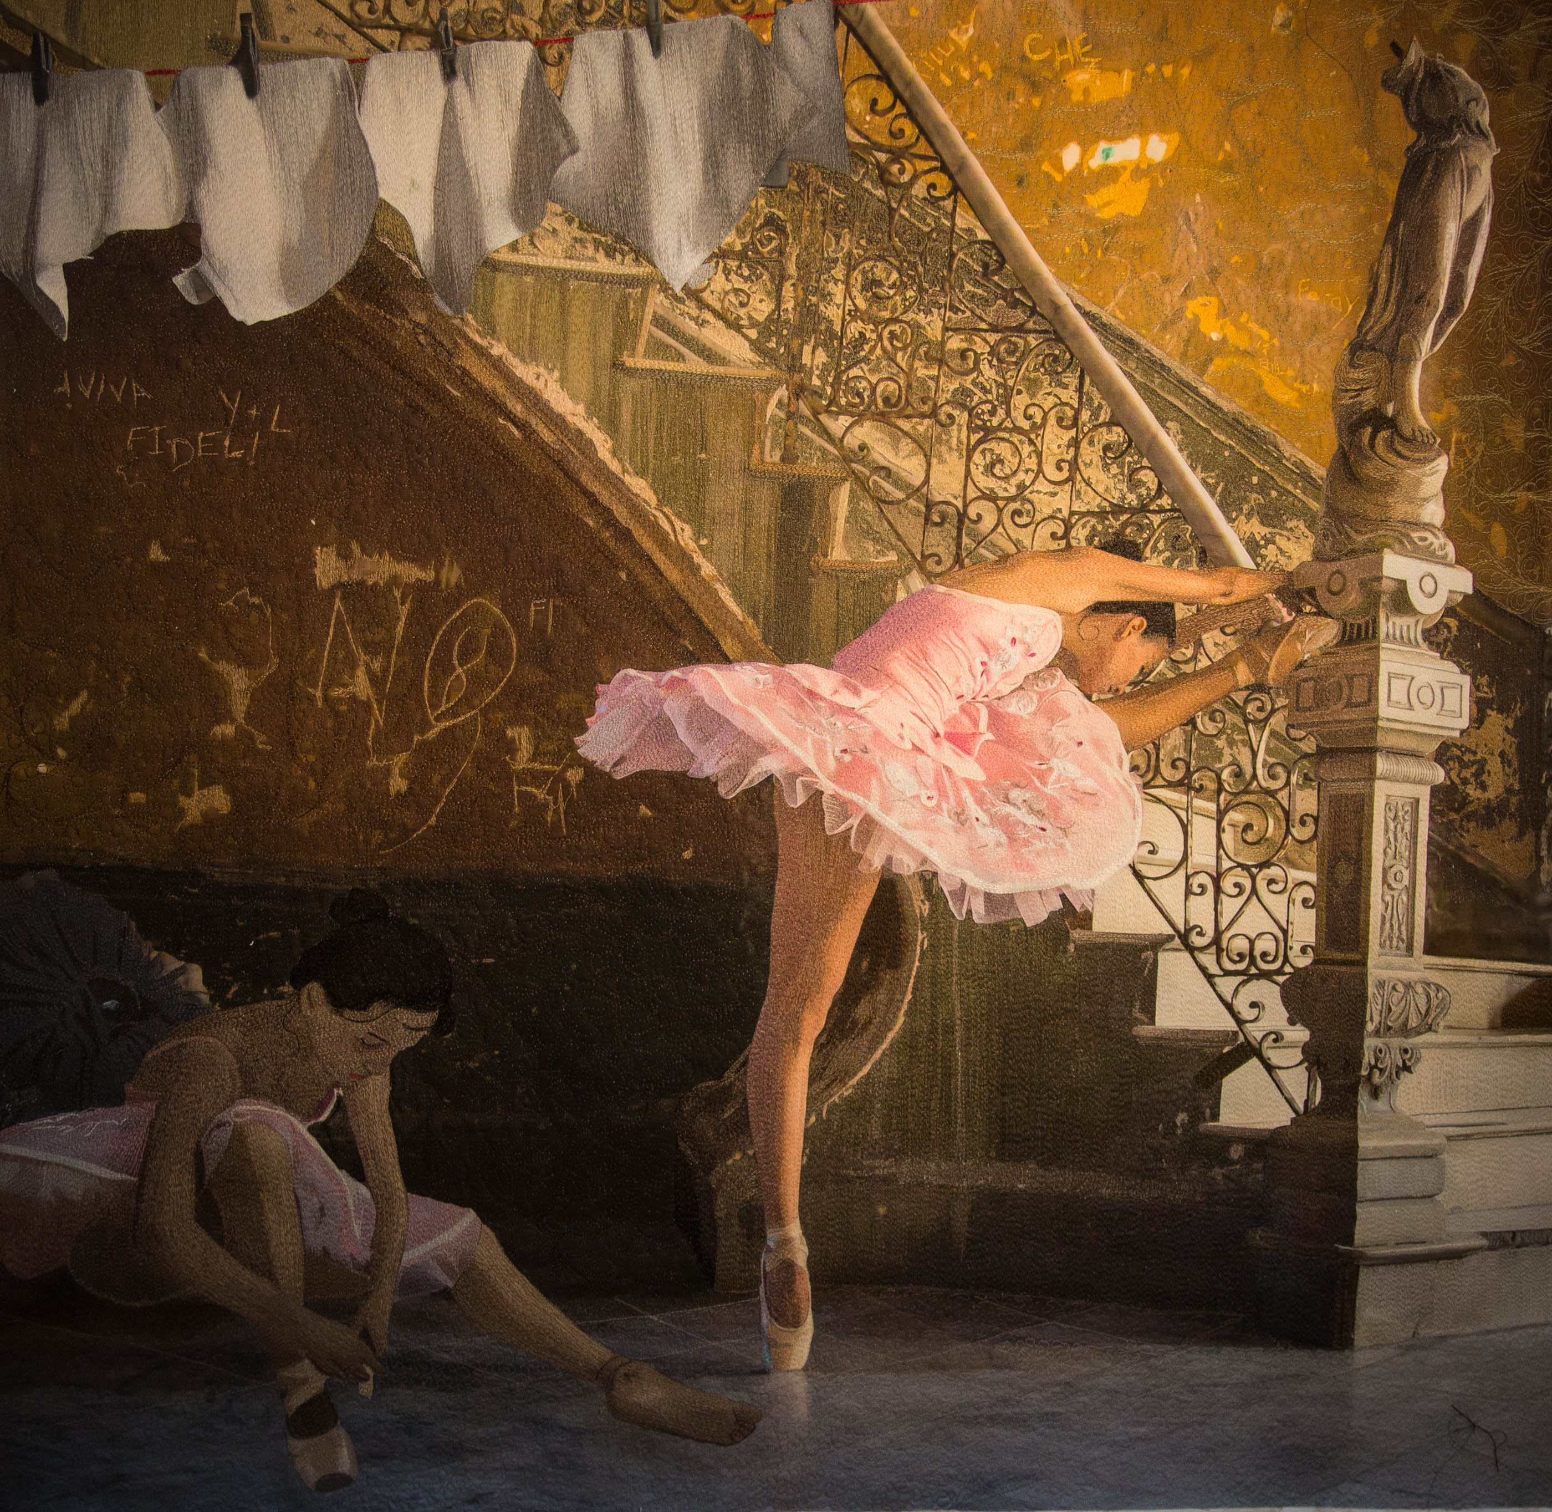

Thank you for following this in depth exploration of Thread Stories.

Jennifer is teaching private classes in her Thread Stories technique at her studio in Santa Fe, New Mexico. The classes are two or three days, and will provide all of the information on how to incorporate this technique into your future projects. Please contact her for more information:

Jennifer Day
505-660-8656
Jennifer@JDayDesign.com
www.JDayDesign.com

