Monochromatic Art

The world of Black and White in art is vast. From contemporary paint, to sculpture to Photography, Black and White is used as a way to capture an image in its purest form. This tutorial is a study in Monochromatic Fiber.

Two of my art pieces are a study in Black and White. Goddess of Speed – 1937 Packard,
and Flying Lady - 1930 Cadillac Fleetwood Roadster are hood ornaments on the front of vintage cars. Each of these pieces of art are a mixture of gray, black and white threads. Shadow is the key to monochrome images. From the darkest to the lightest tones, the minute gradations of color give movement. I incorporated silver metallic threads as well to give the illusion of chrome in the art.

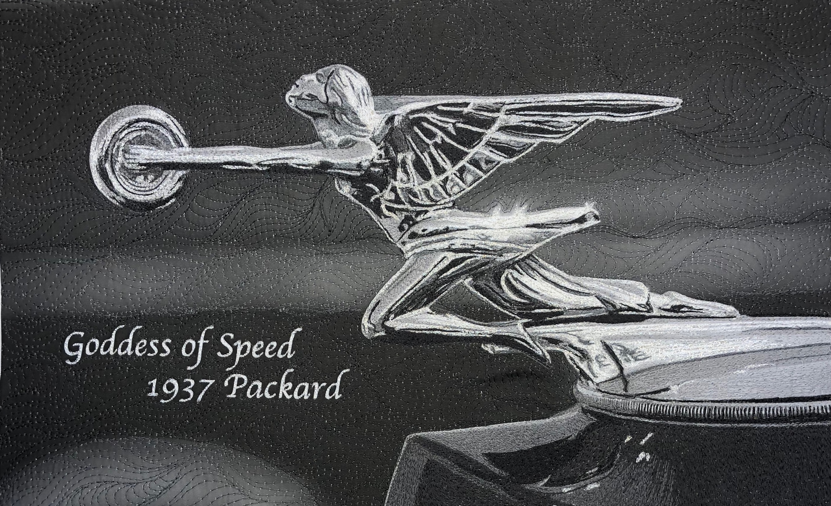

I used over 30 different colors of gray threads in each these two pieces. The gradations of color are minute, but necessary. This tutorial is a brief exploration of the process that melds the tones together to create Black and White art.

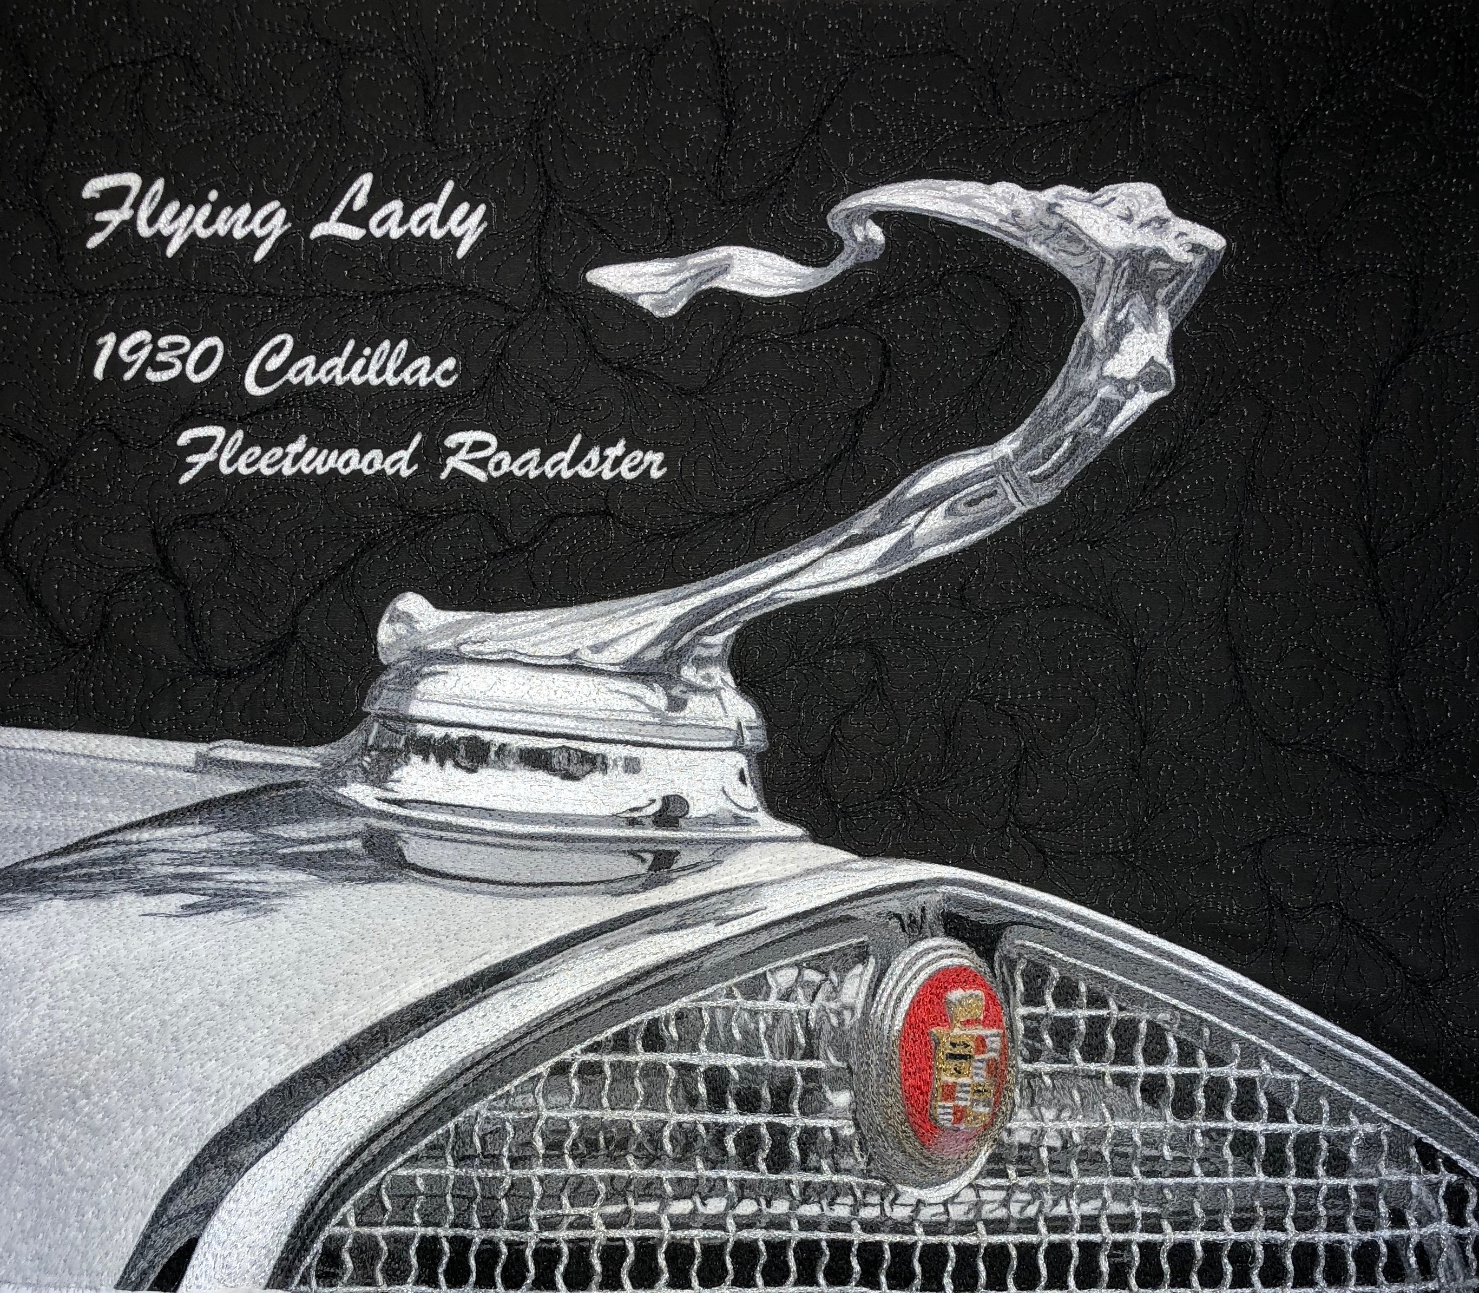

It is important when determining the size of the art to be aware of the concentration of detail. Although the width of a thread is very small, the at must be large enough to allow the detail not to be lost in its translation. I first began working on a Flying Lady piece of art that was 8’ x 11”. This was too small. I lost the definition of the tones in her face. I then began a new project hat is 14 x 16. This allowed me to capture the minute details.

I always work from darkest to lightest colors in my art. I began by placing just a few stiches of the darkest color in her eye. This was followed by a medium gray to accentuate the nose, mouth and cheekbones, continuing to her breast and flowing hair.

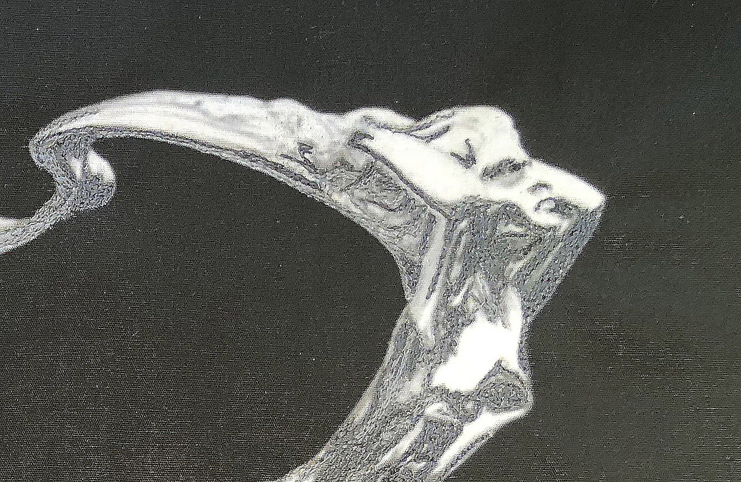

I did the same for the Goddess of Speed. I began the process by threading the darkest lines in her face first. Because this is a representation of the chrome of the hood ornament, there are dark and light areas based upon the angles of chrome.

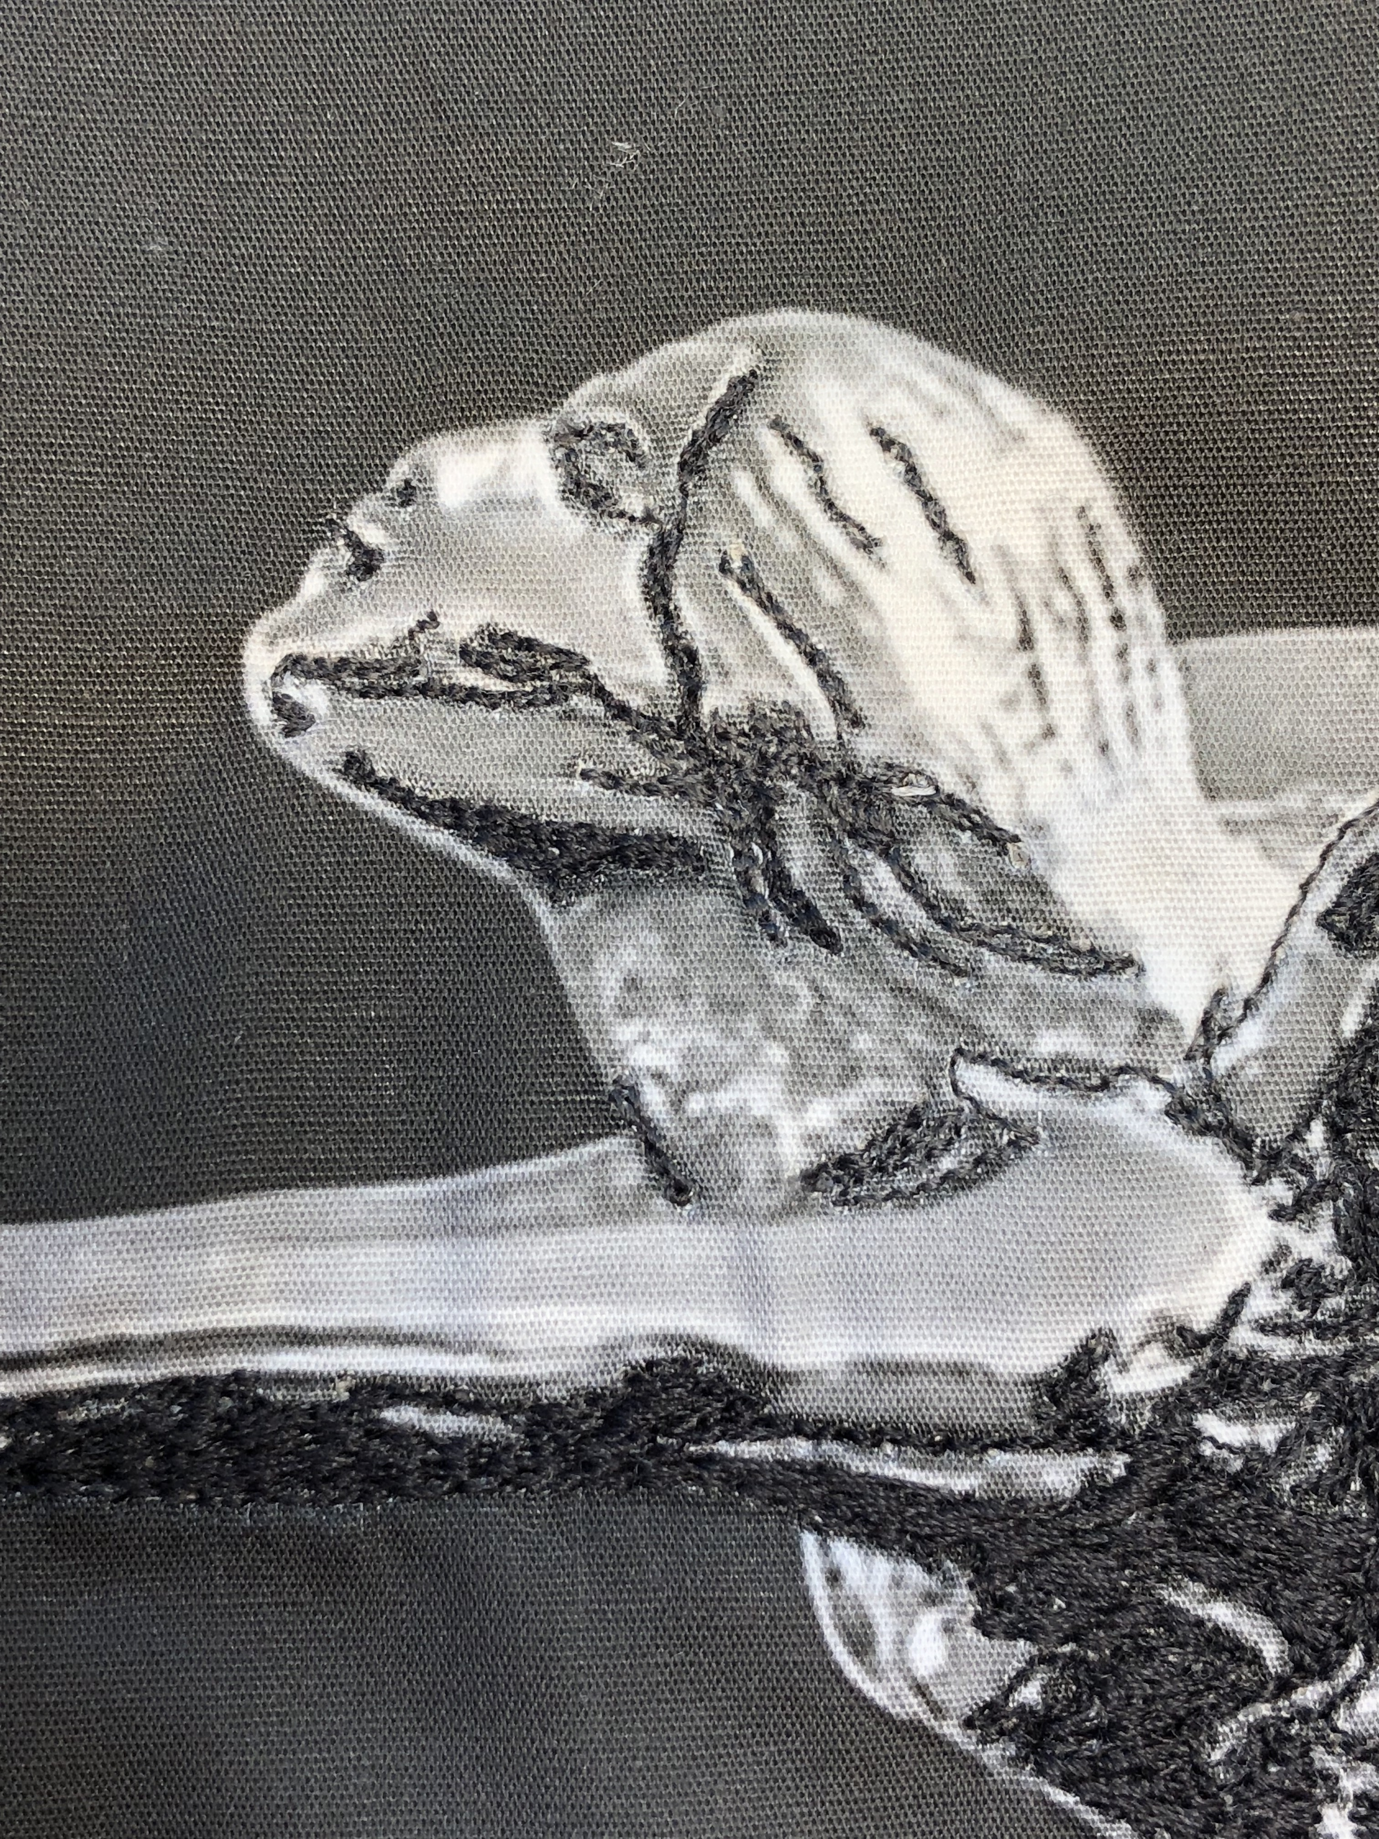

By placing the medium gray next to the dark thread at her eye, the dark color is softened, but still visible allowing one to see the eyelid.

The next step is to continue adding shades of gray to the contours of her face and body. I chose to continue adding thread, but if I had stopped at her cheekbones and the top of her arms, there would be a luminescence in these areas. Sometimes less is more. This is the artist’s choice.

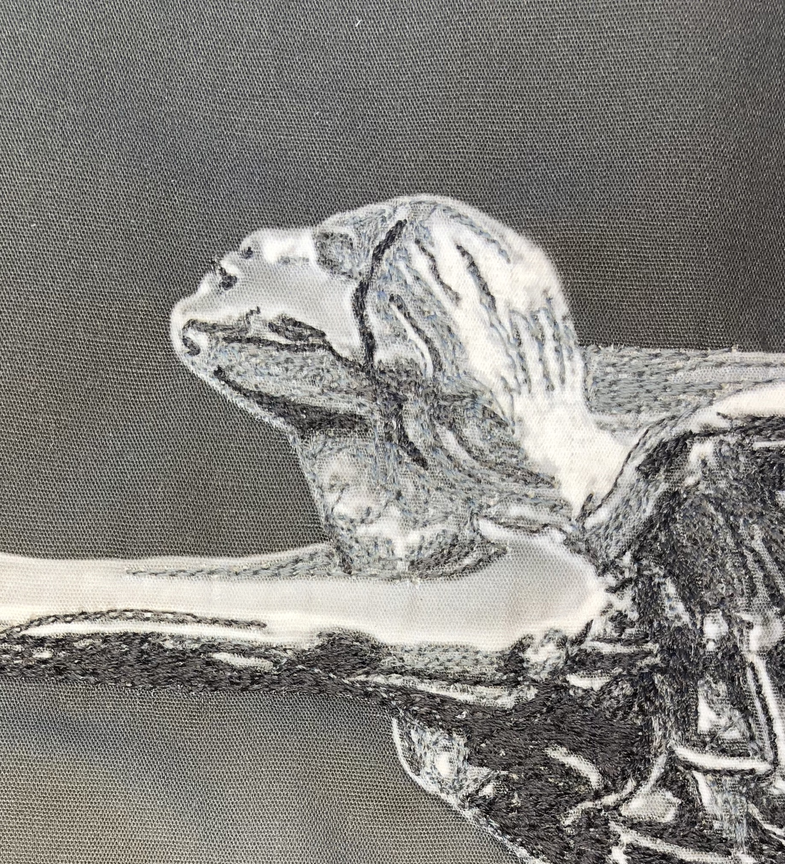

I added threads to her face and arms. I did not cover her entire cheekbone.

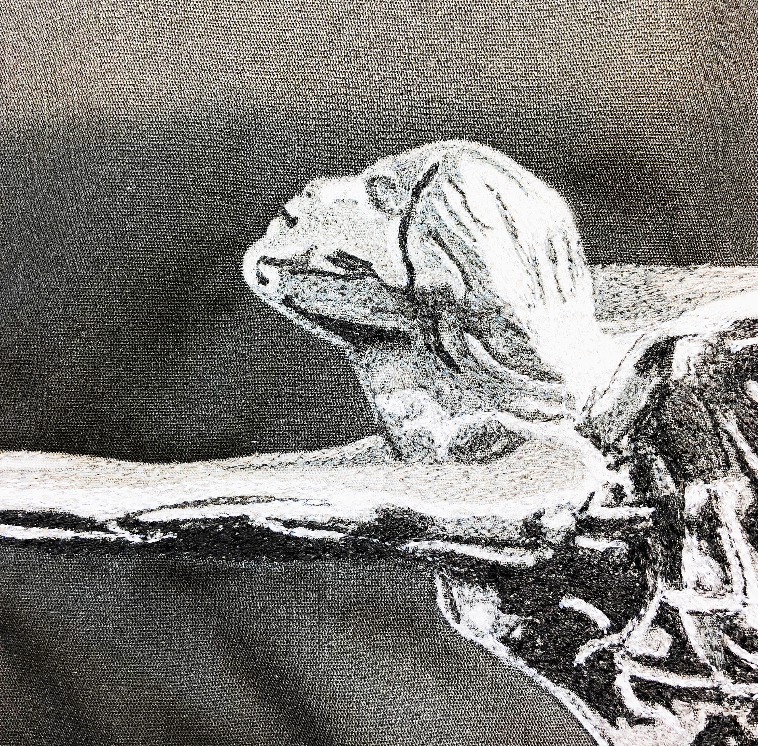

The next step is to add a white rayon thread to the highlights. I chose rayon to give a sheen to these areas to represent the reflection of light on the chrome. I want the edges to be specific, not blended. Tis creates an impression of harsh light.

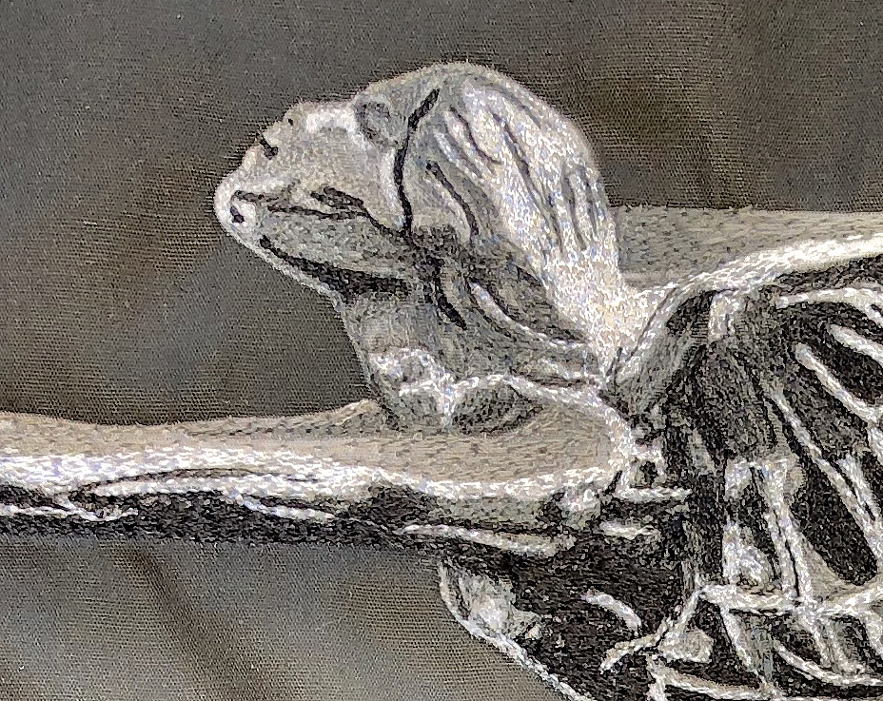

Then I added a silver metallic thread in the midst of the white. This is seen as a slightly darker thread tone. The silver shimmers in the light creating the image of Chrome. The photograph had a splash of light at the top of her dress. By using free motion embroidery, the soft shades of gray make the area glow.

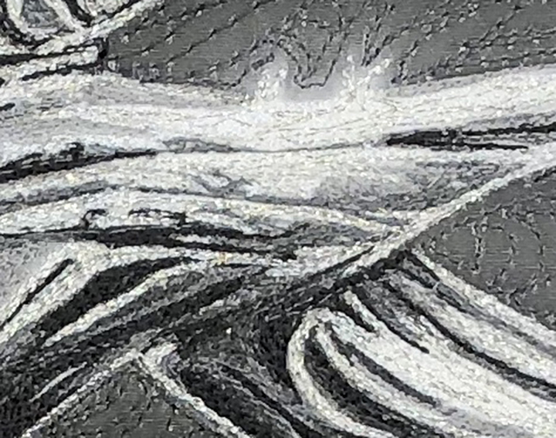

Her hands are slightly out of focus because of the natural light on the chrome and because the detail work on the ornament is not as pronounced in the hands and shield. Again, I began the process using the darkest thread first. I did not use a pure black in this piece of art. Pure black is too hash in the creation of monochromatic art. I am using the Gutterman Mara threads. This line is available through Wacom – www.wacom.com . The Mara line has 700 colors. There are 24 colors of black! The goal is to pick threads that blend.

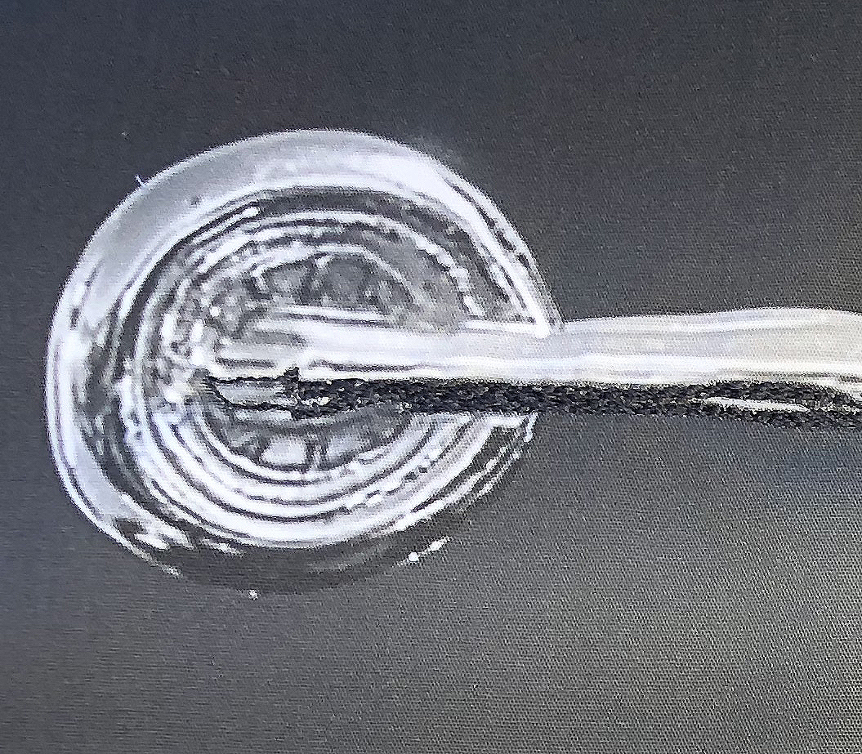

When finished the hands and the shield are a complex combination of threads. Only a single line of thread creates the space between the fingers. While working in such a tight space, it important to hang the art on your design board and step away from it. By doing so you will be able to see the depth of the detail to concentrate on.

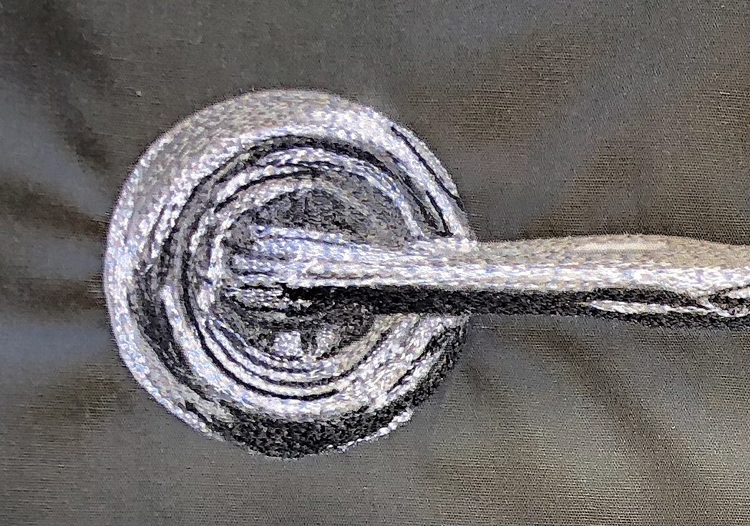

The final image of the shield is enhances by the free motion embroidery. I chose to use a slightly swirling movement to represent her flying through the art as the hood ornament on the vintage car.

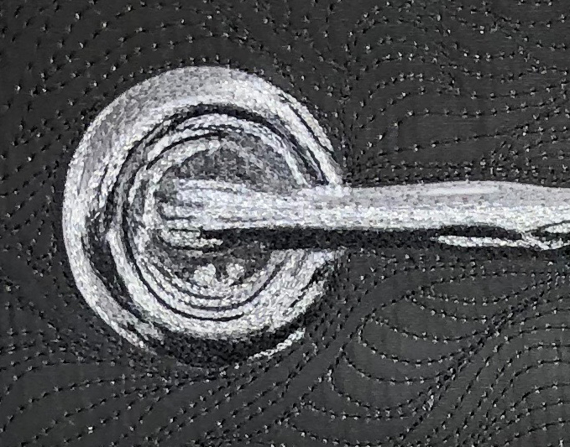

Similar attention to detail is paid to the Flying Lady. The grill is a well-blended area.

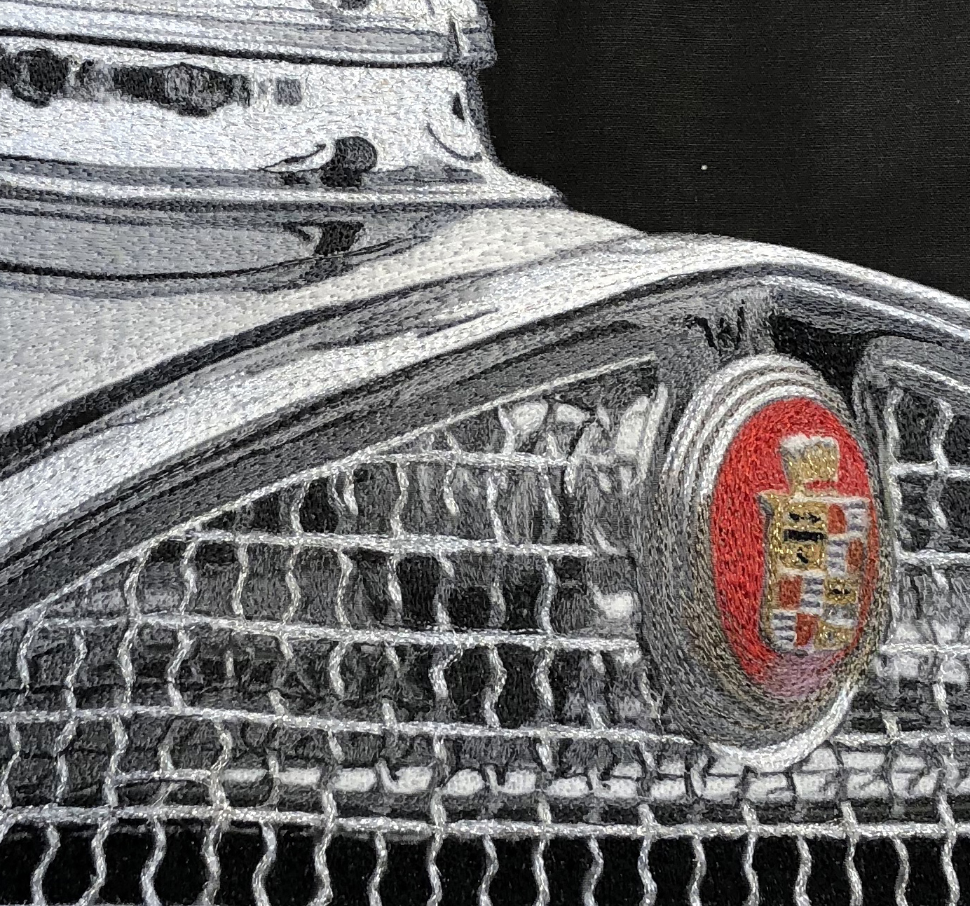

It is critical to pay attention to the very minute changes in color in a small area like this. The thread changes are vase. I start with the darkest color and can travel throughout the entire grill before changing to a lighter color thread. Thread covers thread, making the stitches in areas that are not needed disappear. The line of light stitching in the center of this image is a misplaced line, but when the viewer observes the art from 5 feet away it disappears.

The lines of color in the wire of the grill are not complete. This represents the play of light on the grill.

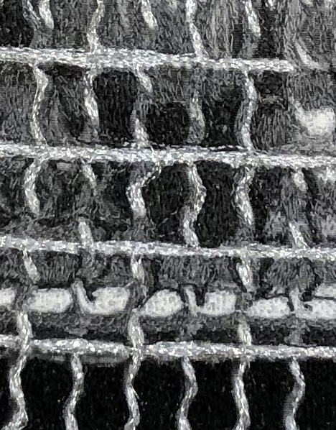

I also paid a lot of attention to the Cadillac emblem. The majority of areas are covered in only one line of stitching!! The addition of the gold metallic threads makes the image come alive and draws the viewer in. The shadow detail under the emblem in a pink tone gives the emblem depth.

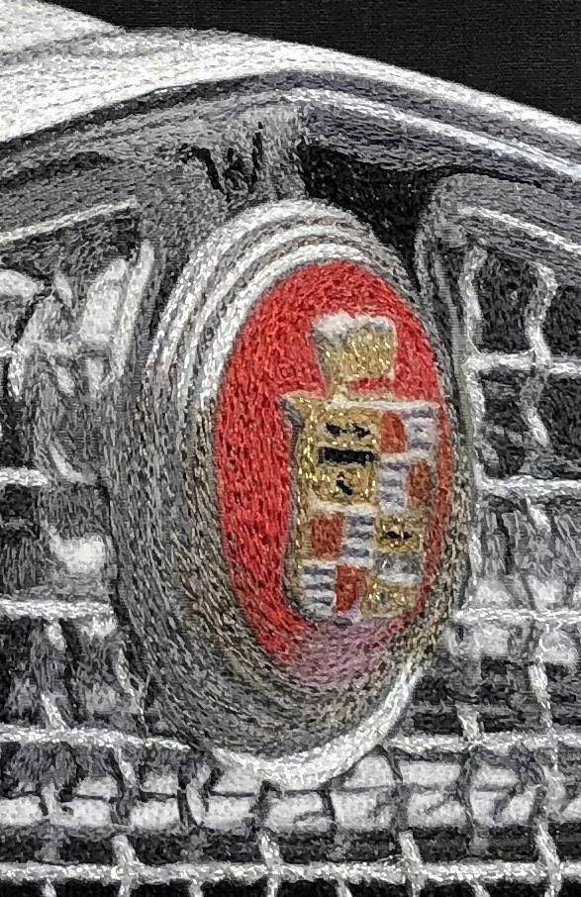

The addition of this bright spot of color in the primarily monochromatic piece of art gives the image excitement.

These are relatively small pieces of art. 16 x 14 and 16 x 16 inches in size. Because they are small, it did not take a great deal of time to finish them. Here is a time line for each:

Flying Lady

One hour, thirty minutes

first gray thread – body

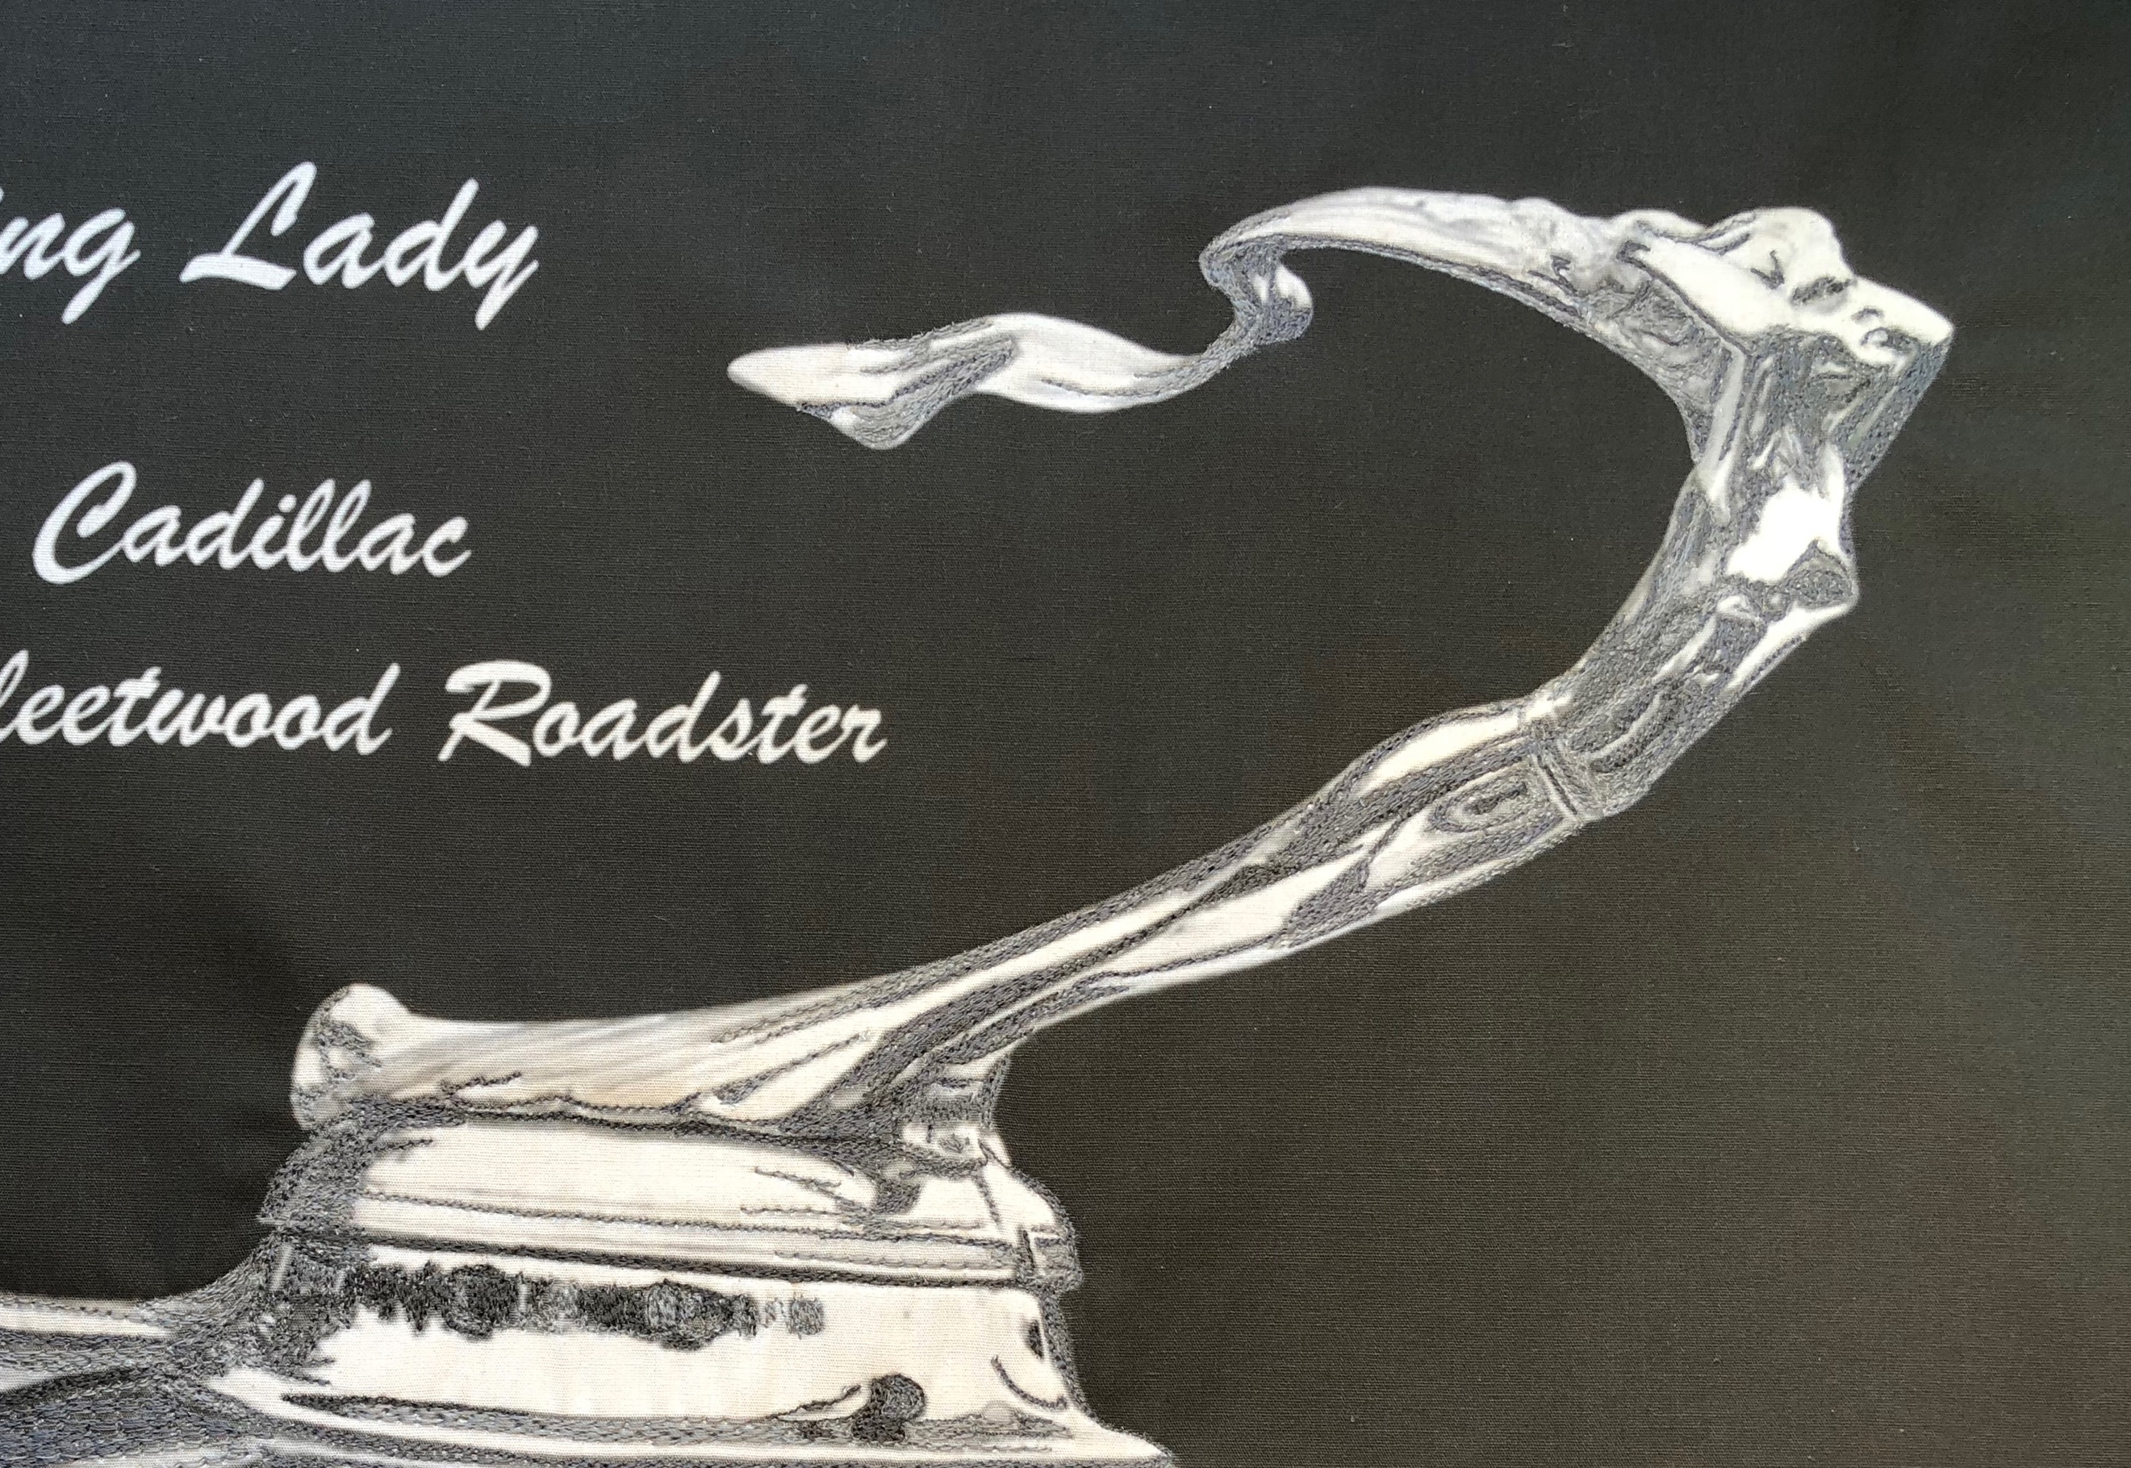

Two hours

top of the hood as well as all other color in the body, less the white threads indicating the reflection of light.

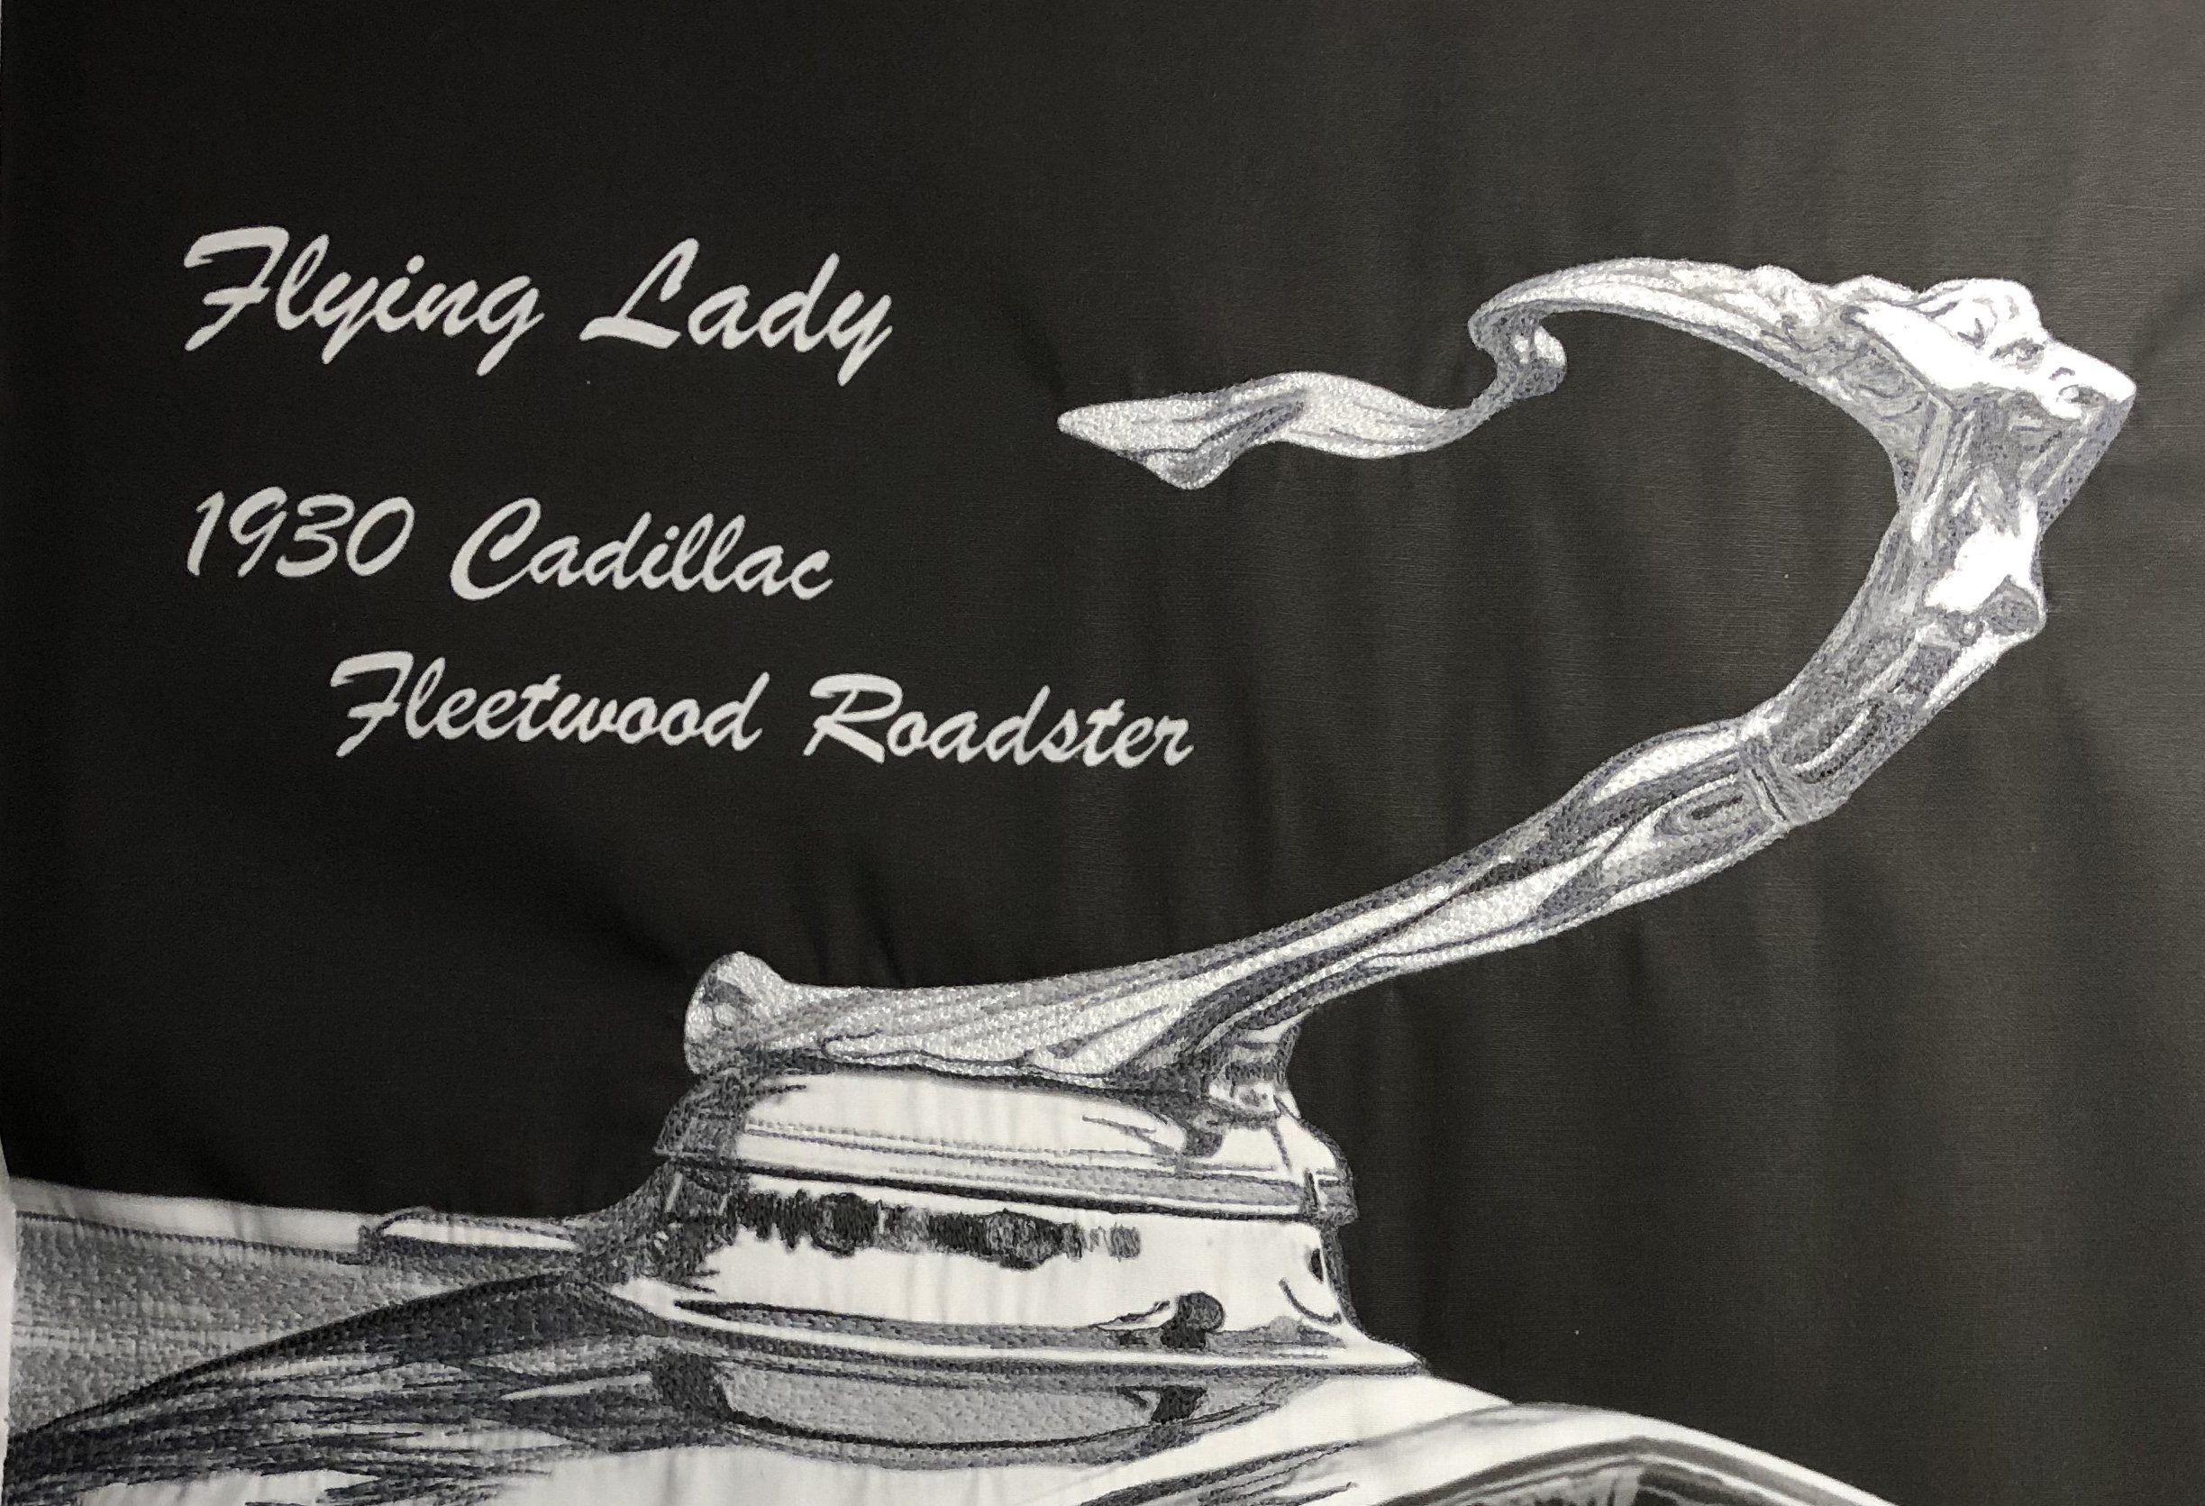

Four Hours, thirty minutes

Complete body and hood of car. Beginning detail in grill work

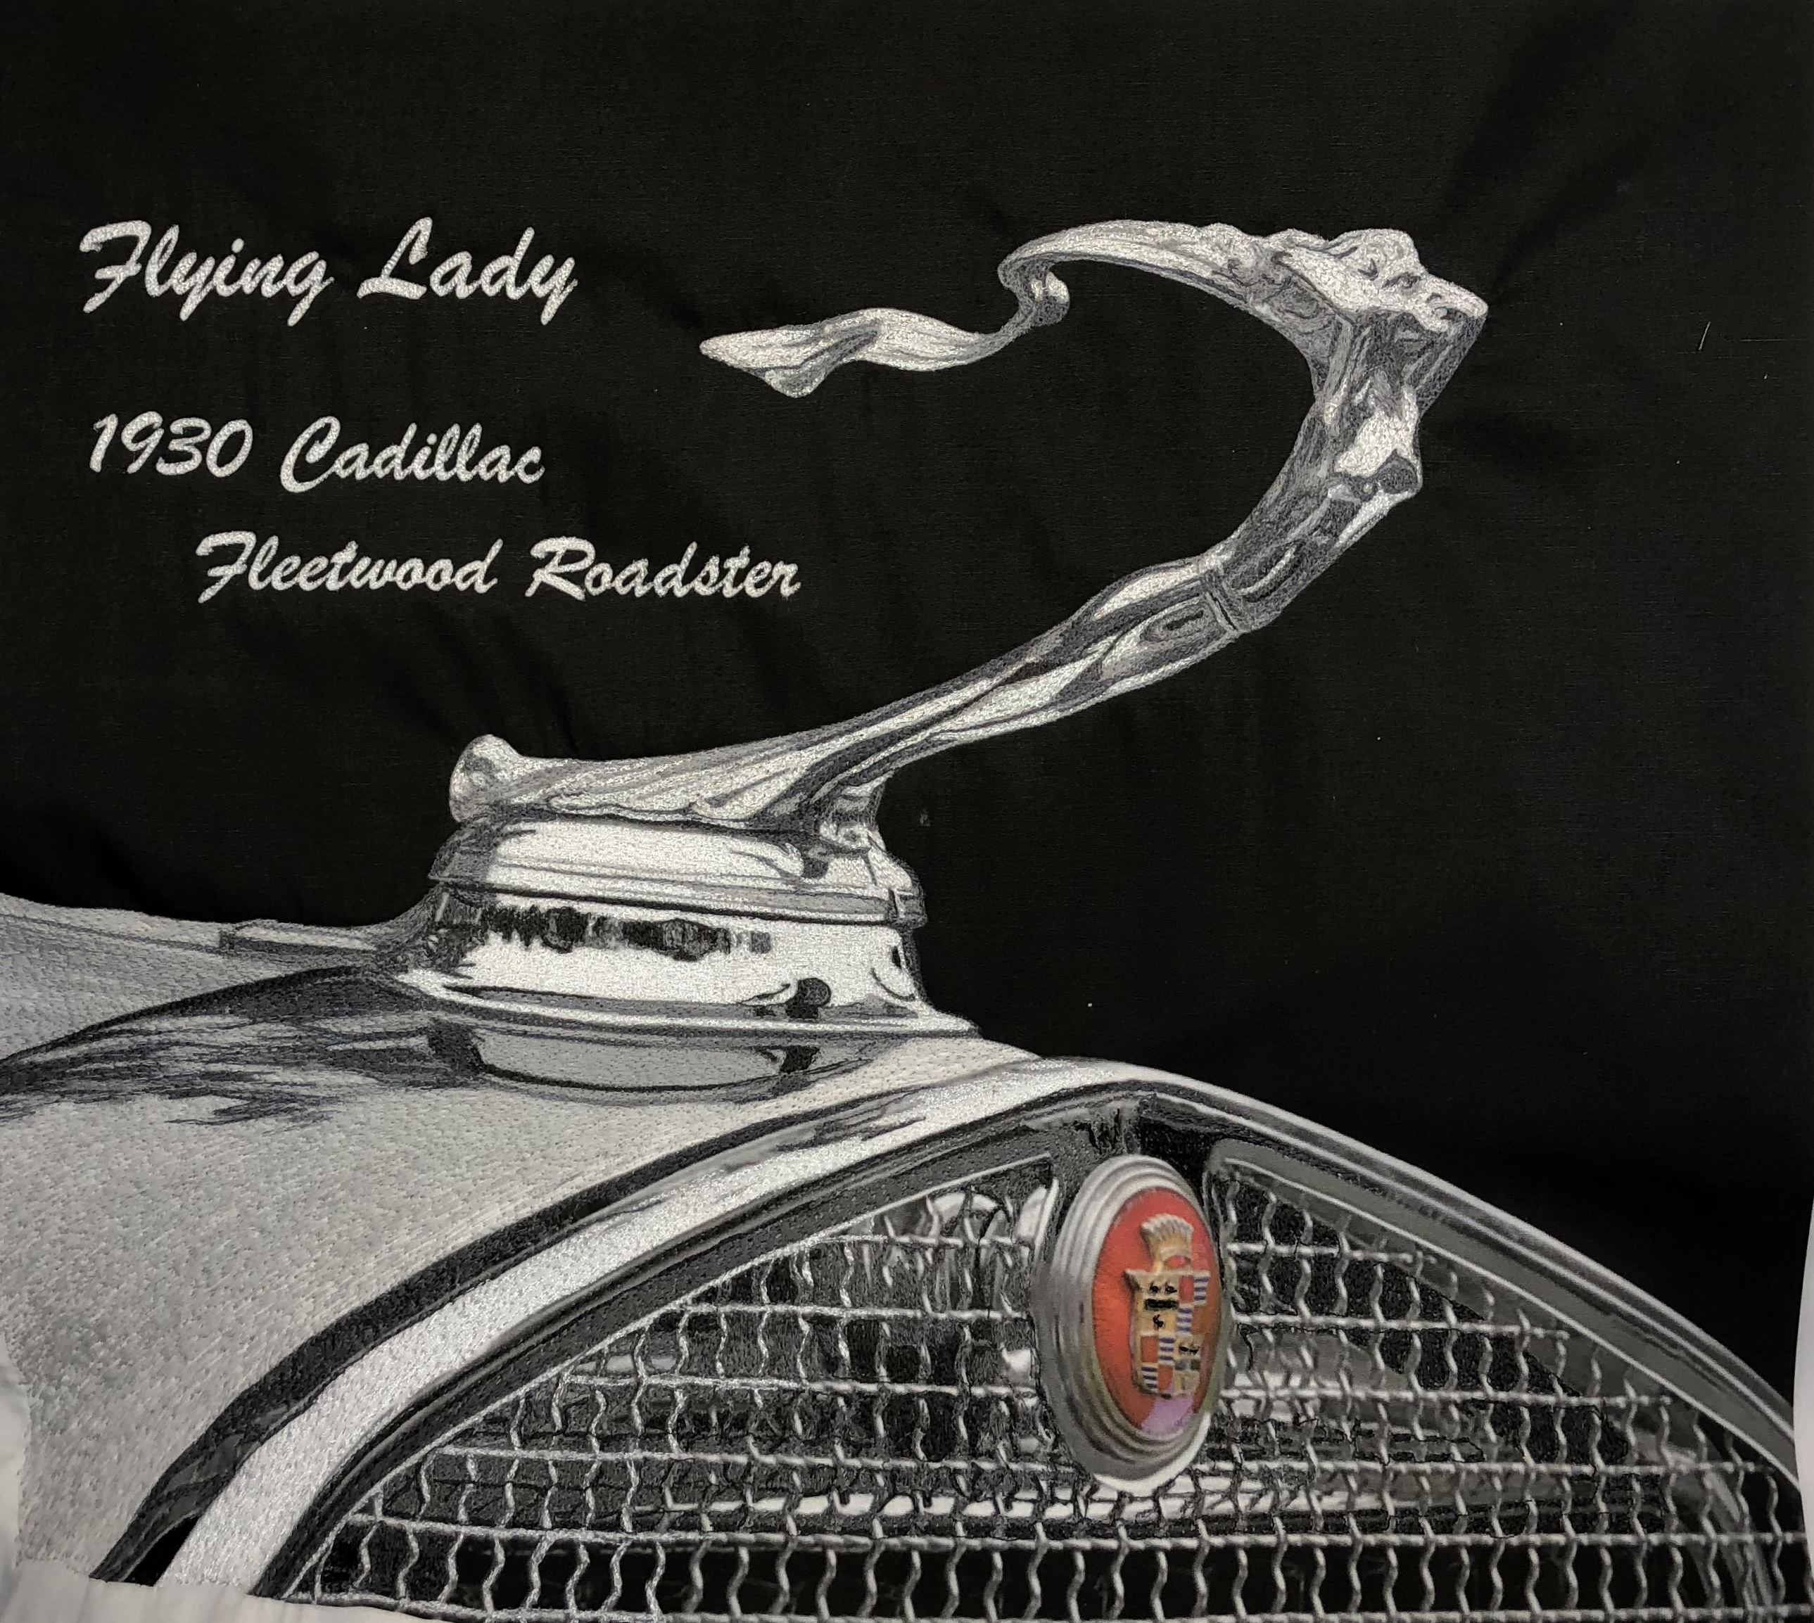

Six Hours

Completed Art

The entire background to the art is covered in free motion embroidery.

Goddess of Speed

One hour

Darkest threads are placed and second gray threads are added.

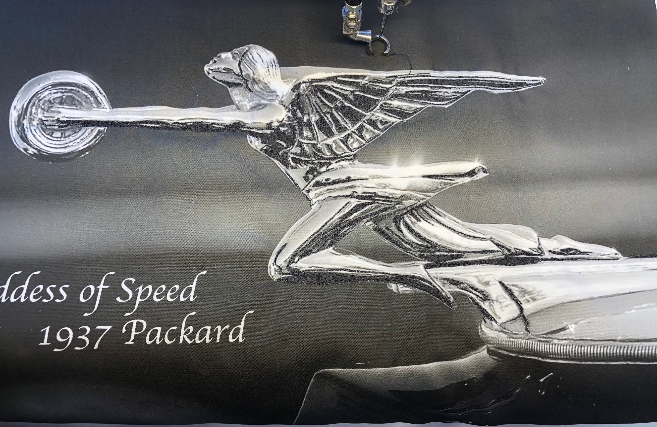

Two Hours, 30 minutes

The body is completely covered and the bottom of the hood ornament is finished

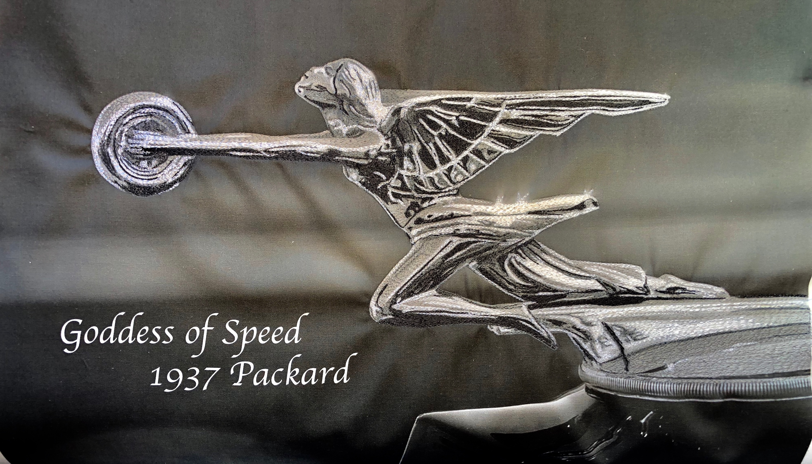

Four Hours, 30 minutes - Art is complete

The entire background to the art is covered in free motion embroidery.

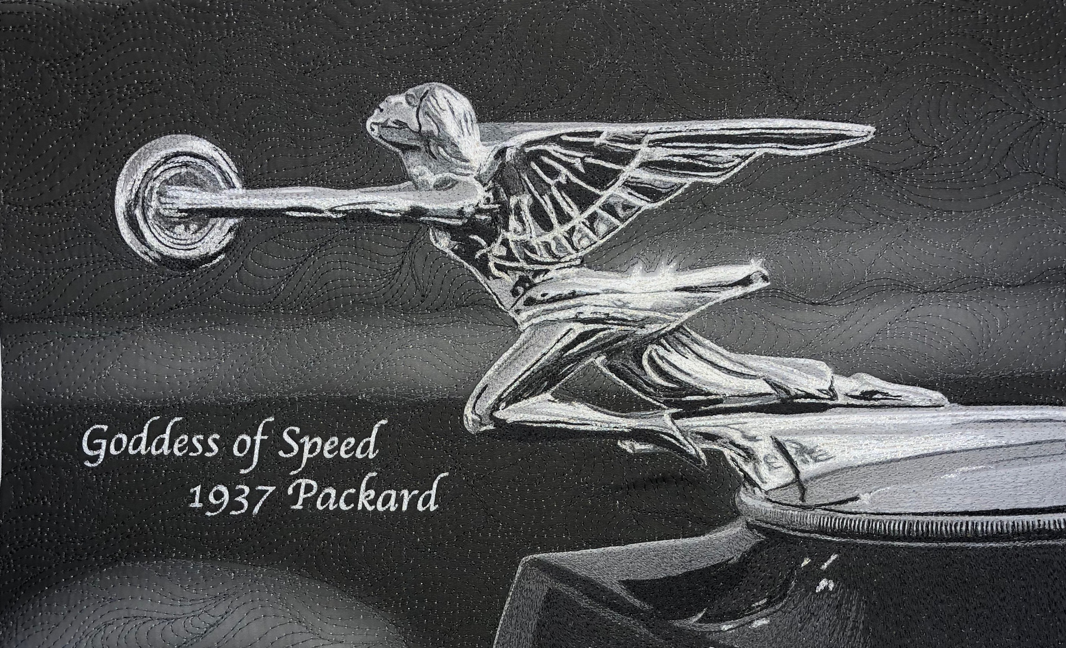

It is my hope that this tutorial will give a glimpse into the world of monochromatic art. It is a fascinating journey.

